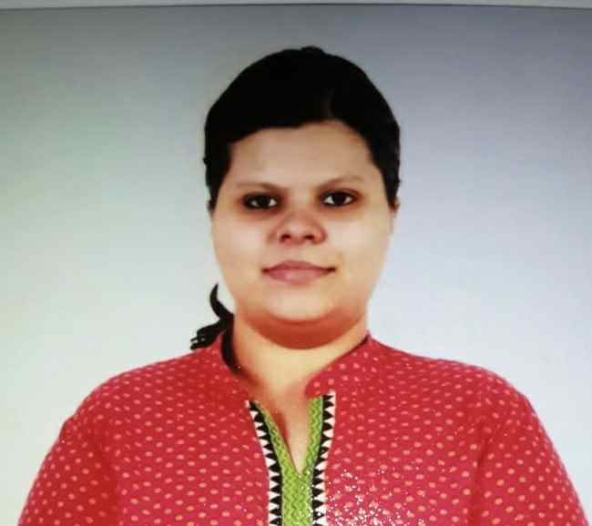
AE

Basic knowledge of Microsoft office excel, Microsoft office word and Microsoft office PowerPoint.

Fresher

SKILLS
Address: T.6.B imli lane railway colony
Near chest clinic
Moradabad (U.P.)-244001

Contact no: 7046465583

Email id: shrotriya.aishwarya50@gmail.com
CONTACT
EXPERIENCE
- Pursuing MBA from Symbiosis University.
- Passed M.COM from Shiats University in the year 2016.
- Passed Post Graduation Diploma in Banking Management from Times Pro Ahmedabad (Gujarat) in the year 2015.
- Passed B.COM from Mahatma Jyotiba Phule Rohailkhand University in the year 2014.
- Passed H.S.C from CBSE in the year 2011
- Passed S.S.C from CBSE in the year 2009

EDUCATION
An entry level position in a bank with the opportunity to grow along with the organisation and use my skills effectively to the growth of an organisation.

PROFILE

AISHWARYA SHROTRIYAARYA SHROTRIYA
CURICULUM VITAE

