THE CRYSTAL HIVE
CAROL (break up with photos)??
Original Swarovski Crystal Artwork
Handmade with love & genuine Swarovski Crystal
Hi I’m Carol
I’m from Manchester and I’m married to Lee. I have two gorgeous daughters and 2 Persian cats, Pandora and Willow (The cats not the daughters) I am happy to share this info as none of my passwords relate to them. I’m telling you this bit now to reinforce my GDPR compliance (there’s more about that in the Privacy & Policy bit on here somewhere)

I love a good wedding so combine this with my love of anything sparkly, in 2011 I decided to create bespoke bridal accessories such as lingerie, veils and shoes. Encrusting corsets and stockings with Swarovski Crystal to add even more sparkle to the occasion! I’ve had great feedback, especially from the enthusiastic Manchester City fan whose bride revealed City blue Swarovski Crystal lingerie.

I still do crystal bridal pieces on request, but for the last year or so I have been creating bespoke pieces of artwork, most recently the focus has been The Manchester Worker Bee. Clearly, the Manchester Bee is very visible right now and rightly so, although having worked for Manchester Council for 11 years I knew the significance of the bee & what it represented a long time ago.

I came to make the first Swarovski bee last summer, not long after the bomb went off in the Manchester Arena. I had planned to meet a friend for coffee and wanted to take her something, but I didn’t know what. What do you give to someone whose stepson has been killed in the attack?

So, the 1st little Swarovski Bee was made – She loved it and said she would treasure it. I had lots of interest after that & started to make them in various sizes and colours. Using anything from 150 on the little ones to 7,044 crystals for the largest one so far!

And so, The Crystal Hive was formed, making bees and other bespoke artwork commissions.

I’m often asked how I have the patience to produce my pieces, bearing in mind every crystal is applied by hand with tweezers. The answer is it’s my therapy, my happy place. It helps me forget (for a little while) the stress of having a daughter that has gone through 2 years of cancer treatment. Things are good now, so let’s crack on.

Since then my little bees have travelled to new homes across the UK (and Wales! which my friend insists on me mentioning) and have gone to live with Mancunian ex pats all over the world in Paris, Italy, Turkey, Boston USA, Australia & New Zealand

I make a donation for every Manchester Bee sold to the charity

Commissions are taken for the larger bees and company logo’s

The smallest versions can be seen and are for sale at Manchester Visitors Centre

HOW ARE THEY MADE
My artwork is a combination of laser cutting, crystal design & application, embossing mounts backgrounds and framing – smaller pieces are supplied in pre-made frames in a range of colours & sizes.
All larger pieces are professionally framed. We can discuss framing options including type of frame, frame colour and glazing options.
Glazing options – I can use regular glass, or you can have True Color SuperClear glass which is anti-reflective and protects your mounts from sun damage and fading. Obviously its more expensive but really worth it for the larger pieces. It’s really cool too, fingerprint marks show up as pink smudges, so they are easily seen for cleaning. This glass is used in galleries & museums. It’s almost invisible!
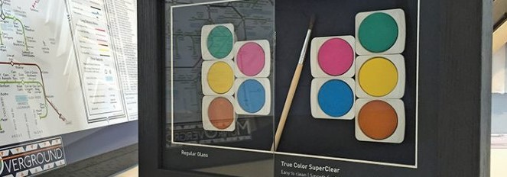

SWAROVSKI CRYSTALS
Swarovski crystals are man-made gems manufactured in Austria. In 1892, Daniel Swarovski invented a machine for making precision-cut, beautiful, high quality lead glass crystals using quartz, sand, and minerals. The exact proportions of these raw materials has remained a company secret.
Swarovski Elements is the brand name for the loose precision-cut Swarovski crystals used by the fashion, jewelery, and accessories industries.
All the products made in The Crystal Hive are made with genuine Swarovski Crystal Elements. My supplier, Bluestreak Crystals is an authorized Swarovski Partner.

GALLERY – COLLECTIONS
- THE MANCHESTER BEE (photos)
- THE FAIRY BLING MOTHER – BRIDAL COLLECTION (photos)

BLOG
Welcome to my blog
Search section? – should I have one?
Categories (Bees, other things, bridal)
Archives – other photos that don’t feature on main part of site but that are nice to show

CONTACT FORM – need to create?

Twitter: @crystalhive @cazbartram
Instagram (not got one set up for the Crystal Hive)
Contact: carol@thecrystalhive.com
Or call me on 07948 948666

GoDaddy
thecrystalhive.com 2 years to 9th Feb 2020
thecrystalhive.co.uk 2 years to 9th Feb 2020
Office365 Email Plus – one year to 9th Feb 2019

PRESS and PUBLICITY
Manchester Art Gallery
In May 2018 I was invited by the Chief Executive of Manchester City Council, Joanne Roney OBE, to show one of my larger bees at a private event for the relatives of those who died in the Manchester arena bomb, on the 1-year anniversary of the tragedy. It was such a privilege and I felt very humbled. A permanent exhibition is being planned for all the gifts that were left at the arena and St Ann’s Square following the attack.
I have gifted the bee to the City of Manchester and it will go on permanent display when the Manchester Art Gallery has found a new home for the memorial exhibition.

FSB
Article in FSB website

FSB member finds inspiration from Manchester tragedy
https://www.fsb.org.uk/first-voice/regional-voice/fsb-member-finds-inspiration-from-manchester-tragedy
Do we just use the link or the actual article?

Bluestreak Crystals

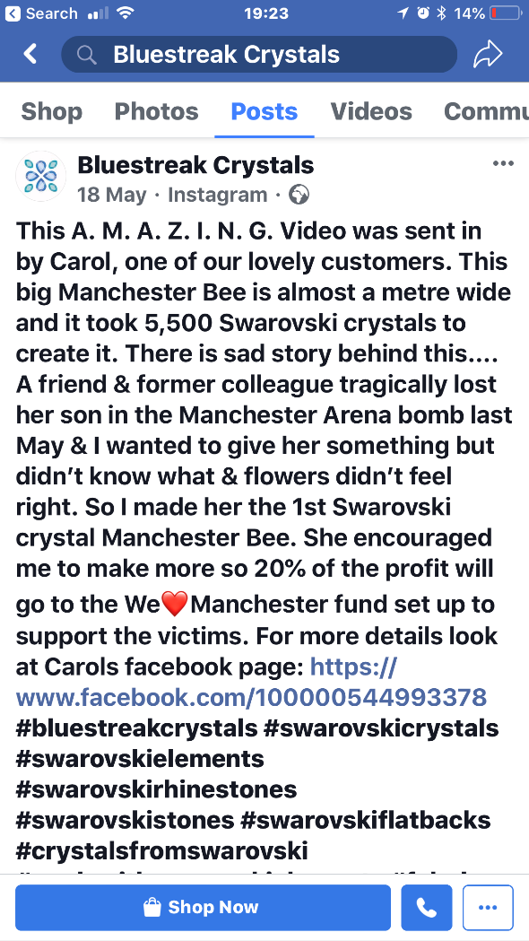

Insert video (of bee before framing)
Making this huge bee actually took 7,044 Swarovski crystals to complete – missed off a whole wing in the counting! Combination of glue induced headache and an extraordinary number of 5 bar gates (not the most scientific way to add up a crazy amount of crystals but I’m old school & you have to do it as you go otherwise it’s impossible – due to sparkle induced blindness)

Client Feedback
Ive got lots of messages & emails from buyers that I can add in.

PRICING
Unless the price is stated it will be calculated based on the following:
- The number of Swarovski Crystals used
- The time taken to produce the piece
- The cost of professional framing
I will always provide a quote for commissions
PAYMENT
50% of the price must be paid before I can start working on your piece. This will usually cover the cost of the crystals and framing, that way if you don’t pay the balance
HOW LONG WILL IT TAKE TO COMPLETE MY BESPOKE ARTWORK
That literally depends on how busy I am. Sometimes I have quite a waiting list, other times less so. I can advise you at the time of your enquiry.
The lead up to Christmas last year was insane. Get your orders in early!
DELIVERY OPTIONS
Small items will be posted by recorded delivery to your address.
Prices include 2nd class recorded delivery.
Larger items can be collected, or I can provide delivery (charges will apply)

PRIVACY POLICY
My Commitment to Your Privacy
Hello and welcome to my privacy policy (sounds important eh). If you’re reading this, you’re probably well into keeping information on yourself top secret/got super click happy whilst browsing my site/you’re a geek on data protection/just plain nosey. Whatever the reason, rest assured I am totally committed to keeping your privacy private… does that even make sense?!
Here is The Crystals Hive’s commitment to the GDPR:
What Information I Collect
You’re hopefully here in the search for some Swarovski Artwork or bridal bling and so if that’s the case I need a few details off of you to be able to get in touch so we can chat. My website doesn’t store any information on you so there’s no need to worry on that front. When you say hi through one of my contact forms on the website I ask for:
Name – this is always useful to know for when I write back to you unless you want me to make one up then that’s fine too;
Telephone number – usually so I can let you know by text that my email reply that I have lovingly composed has ended up in your junk folder or if I need to call you to let you know I’m on my way to meet you to discuss a commission.
Addresses – so I can deliver or send you stuff you’ve paid for afterwards;
Email – given this is probably the easiest way to reply to your original request I can use it to keep you up to date with how your order is progressing.
What I Do with This Information
Basically, sell it all to the highest bidder… only messing. I don’t have a fancy-pants system that stores all of your data yet (but will be sure that they are GDPR compliant when I do) so your details come through on an email which I access on my laptop or phone which are both password protected with something that isn’t either of my cat’s names. I have a spreadsheet (old school I know) where your details get transferred to and I mark off when you place an order with me, when I need to get in touch, so you can hand over your hard-earned cash, If your order/commission is the bees knees it may get some attention from artists and wedding blogs and they may ask to feature your piece/s. If that happens you would always need to agree to this happening, so you’ll definitely know about it.
If I’m feeling remotely organised and ahead of the game with orders I might even get around to sending you a promotional email about stuff I might be thinking of doing or offering to my clients, it might be something new that I’d like some feedback on or a discounted offer. However, you are more likely to find me sipping on a gin or off on holiday when I have spare time.
Right to Access, Rectification and Erasure
Your rights under GDPR and actually your rights from previous haven’t really changed. If you wanted to access what information I hold on you, you can get in touch and pop along to my home and check out what’s there. To be honest it’s not much and probably a huge waste of both of our time, but you can if you want. If you want me to amend or delete anything you’ll need to request this in writing, so I know what it is you want. You probably won’t ask me to do that though until you have received your new artwork or bridal bling! Once I’ve delivered your order you can of course ask me to bin you off. Just try and drop me gently please.
3rd Party Suppliers
I work with a few suppliers who sell some of my artwork at their events. Usually I get them to send everything to me first and then I send them back out but occasionally I may need to ask my suppliers to ship directly to you. I understand the suppliers I use are also compliant with GDPR and will not be signing you up to any dodgy websites.
GDPR Compliance
I try and keep up to date with the latest legislation (usually it’s when I see the mass panic in various groups I’m part of) and I’m proactively working towards being fully GDPR compliant. Obviously if the EU decide to change everything which means I must revisit this and make loads of changes, rest assured that I will.

