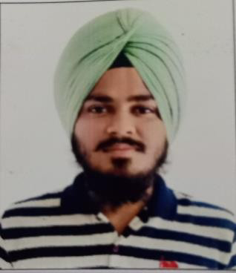
MANPREET SINGH
Mail:ms899176@gmail.com

CONTACT:-9877229159

Career Objective –

- Want to enhance my knowledge and skills.
- Aim become a Merchandiser of Textile.

Academic profile –

School/College | Qualification | Year | Percentage/CGPA
Guru Gobind Singh Public School, Barnala. | CLASS 10TH Affiliated to P.S.E.B. | 2016 | 71%
Punjab Institute of  Textile Technology, Amritsar | Diploma for textile  technology (weaving technology) | 2019 | 65%
Maharaja Ranjit Singh University  Dabwali Road | B.tech (textile engineering) | 2019-2022 | 64%

Experience: Fresher

Training:

- 16th June 2017 to 30th June 2017 training in Sharman Shawls Ltd for 15 days.
- 05th Jan.2018 to 25th Jan.2018 training in Aarti international limited Ltd for 20 days.
- 15th June.2018 to 25th July.2018 training in Sharman Shawls Ltd for 40 days.
- 26th Dec 2018 to 31th Jan.2019 training in Shingora Textile Limited Ltd for 35 days.
- 10th July 2021 to 10th Aug.2021 training in OCM Private Limited for 30 days.
- ${20}^{th}$ jan 2022 to 30 May 2022 internship in youngmen woollen mill priavte ltd 180 days.

Activities:

- Participated in quiz competition by textile department at MRSPTU.
- Member of NSS Camp (National Service Scheme).
- Participated in working Science Model Organized by Guru Gobind Singh Public school Barnala

- Participate in National Science day.

Computer skills-

- MS- Word
- MS- Excel
- MS- PowerPoint

Hobbies-

- Cooking
- Traveling
- Public Speaker

Additional skills-

- Responsible
- Good teams work as well as individual effort.
- Confidence and leadership quality
- Punctual

Personal Details-

- Father ‘s Name : S. Mangal Singh
- Mother ‘s Name: Manjit Kaur
- Date of birth: 1ST NOV1998
- Marital status: Unmarried Date-
MANPREET SINGH

