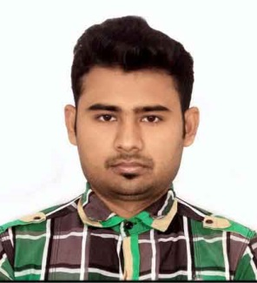
CURRICULAM VITAE

NAME : AKASH CHANDRA
ADDRESS : M.A.M.C, DT-26/1
DURGAPUR-713210
PASCHIM BARDHAMAN (WB)
CONTACT : 9093074322/7908996155
E-MAIL : akashchandra406@gmail.com

CAREER OBJECTIVE
LOOKING FOR A CHALLENGING CAREER WHICH DEMANDS THE BEST OF MY PROFESSIONAL ABILITY IN TERMS OF TECHNICAL AND ANALYTICAL SKILLS AND HELPS ME IN BROADENING AND ENHANCING MY CURRENT SKILL AND KNOWLEDGE.

EDUCATIONAL PROFILE

SECONDARY (10TH)
MADHYAMIK IN THE YEAR OF 2011,FROM MODERN HIGH SCHOOL, DURGAPUR-10
PASSING PERCENTAGE - 69.375%
HIGHER SECONDARY (12TH)
BIDHAN CHANDRA INSTITUTION IN THE YEAR OF 2013, DURGAPUR – 5
PASSING PERCENTAGE – 65%
UNDERGARDUATE
COLLEGE:-SANAKA EDUCATIONAL TRUST GROUP OF INSTITUTION’S – DURGAPUR 12
UNIVERSITY:- MAULANA ABUL KALAM AZAD UNIVERSITY OF TECHNOLOGY
STREAM: - MECHANICAL ENGINEERING
COURSE DURATION:-2013-2017

MARKS OF B-TECH (ME) – DGPA -7.68

SEMESTER | SGPA | YGPA
1ST | 7.59 | 7.70
2ND | 7.79 | 7.70
3RD | 7.13 | 7.05
4TH | 6.96 | 7.05
5TH | 7.18 | 7.65
6TH | 8.15 | 7.65
7TH | 7.52 | 8.13
8TH | 8.86 | 8.13

PROJECT
To Study the design and analysis of Lattice Boom by using solid modeling and drafting software for analysis and production drawing
TRAINING EXPERIENCE
DURGAPUR PROJECTS LIMITED (DPL),DURGAPUR – 02, WEST BENGAL
TRAINING PERIOD – 28 JUNE 2016 – 27 JULY 2016

EXTRA CURRICULAR ACTIVITIES

AN ACTIVE PARTICIPANT AND VOLUNTEER IN THE TECH & CULTURAL EVENTS IN COLLEGE. RUNNER UP AT “ROBO TREK” IN TECHFEST “ABHIYAAN” IN 2016. PARTICIPANT AND VOLUNTEER AT “ABHIYAAN” IN 2016.

TECHNICAL SKILL

ACTIVE ON MACHINE OPERATION AND WORK SHOP MACHINE WORKS FUNCTIONAL KNOWLEDGE OF MS EXCEL, MS WORD, POWER POINT.

DIPLOMA IN AUTOCADD [2D & 3D]

KEY STRENGTH AND SKILLS

A GOOD TEAM PLAYER.
GOOD LISTENER.
STRONG COMMITMENT AND DEDICATION TO WORK.
WILLINGNESS TO LEARN & POSITIVE ATTITUDE TOWARDS LIFE.

PERSONAL DETAILS

NAME : AKASH CHANDRA
FATHER’S NAME : SASTI PADA CHANDRA
MOTHER’S NAME : SHEFALI CHANDRA
DATE OF BIRTH : 02-10-1995
NATIONALITY : INDIAN
CATEGORY : GENERAL
GENDER : MALE
HOBBIES : READING BOOKS, PLAYING CRICKET, LISTENING MUSIC,
TRAVELLING
LANGUAGES KNOWN : BENGALI, ENGLISH & HINDI

STATEMENT OF INTEGRITY

I , AKASH CHANDRA DECLARE THAT ALL THE INFORMATION GIVEN ABOVE IS TRUE TO THE BEST OF MY KNOWLEDGE AND BELIEF AND I HAVE SUBSTANTIAL PROOF TO SUPPORT TO SUPPORT THEM .

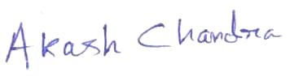
DATE:-24.05.19
PLACE:- DURGAPUR -----------------------------------------
(AKASH CHANDRA)

