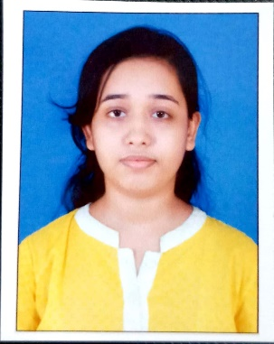
ANGANA CHATTOPADHYAY
Address – Noapara Manasatala Road,
Barasat, North 24 pgs,
Kol - 700124
Mobile - 8961657521
Email id – 4chattopadhyayangana@gmail.com
Personal Details :
Date of Birth : 22/08/1994 Nationality : Indian
Known Languages : Bengali,Hindi,English Marital Status : Single

CAREER OBJECTIVE :
Looking for an oppurtunity to teach High school Mathematics ,Physical Science. Use effective and efficient methods of teaching while focusing on the individual needs of each student.

CURRENT STATUS :
Completed Final Semester of M.SC in Applied Mathematics from UNIVERSITY OF BURDWAN.

KEY SKILLS :
- Ability to handle children of different age groups.
- Good written and verbal communication.
- Good presentation.

EDUCATION :
Percentage Year of passing

UNIVERSITY OF CALCUTTA 47.25% 2016
B.sc ( Mathematics Honours )

WEST BENGAL COUNCIL OF 69% 2012
HIGHER SECONDARY EDUCATION
Higher Secondary

WEST BENGAL BOARD OF 74.25% 2010
SECONDARY EDUCATION
Madhyamik

INTERESTS :
I am fond of music.I have completed second year on Nazrul Geeti.

TECHNICAL SKILLS :
I have completed a course in Computer Fundamental, MS-DOS, Windows, MS-Office,Internet & e-mail.

PERSONAL STRENGTHS :
- Communication Skills
- Attentive Learner
- Self Confidence
- Positive Attitude
- Maintain Attendence

CERTIFICATES :
- COMMUNICATIVE ENGLISH from THE BRITISH INSTITUTES, BARASAT .
- A course of study in Computer Fundamentals, MS-Office from THE BRITISH INSTITUTES,BARASAT.

