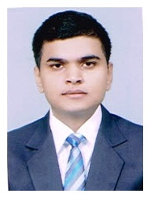
CURRICULUM VITAE

ADIL BERI
78/107, Vikas Vihar,
Malwal Road,
Ferozepur City (152002), Punjab
Contact No.: +91-7888591794
E-mail: adilberi0.ab@gmail.com

OBJECTIVE
To perform the given task with utmost sincerity and dedication so as to achieve the required goal with perfection by which I can contribute to the organization.

EDUCATIONAL QUALIFICATION
- Completed High School from P.S.E.B. with 75% Marks.
- Completed Intermediate (Commerce) from CBSE Board with 74% Marks.
- Completed bsc in hospitality from ihm dehradun/IGNOU with 73% Marks.
- Pursuing post graduation in educational management from ignou
HOBBIES:
- Playing Cricket & Table Tennis.
- Reading Newspaper.
ACHIEVEMENTS:

- Certification of Merit in 1st year for securing 2nd position in Academics at IHM, Dehradun.
- Certificate of Appreciation for participating in Dinner Party Hosted by Vidhan Sabha Uttarakhand.
LINGUAL ABILITY:
- English, Hindi & Punjabi.

PERSONAL DETAILS

Father’s Name : Mr. Sanjeev Beri

Date of Birth : 04/01/1994 Religion : Hindu Sex : Male Nationality : Indian

Marital Status : Single

DECLARATION
I hereby declare that all above stated information and details are true to the best of my knowledge and belief.

Date: (Adil Beri)

Place:

