RESUME
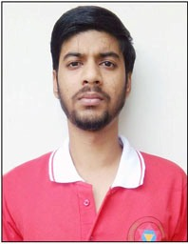
Alok Panthari

Email: alokpanthri@gmail.com

Cell: +919634109945

OBJECTIVE

Seeking a challenging profile to meet my competencies, capabilities, skills, education and experience with a progressive organization to fulfill the organization goals.

ACADEMIC CREDENTIALS

- 2016 - Completed Graduation from H.N.B Garhwal University (Srinagar) Uttrakhand.
- 2011 - Intermediate from GIC, Srinagar (Garhwal) (Uttrakhand Board).
- 2009 - Matriculation from GIC, Srinagar (Garhwal) (Uttrakhand Board).

WORK EXPERIENCE
One Year work experience in MPS Pvt. Ltd. Dehradun as a Pre-Editor.
One Year work experience as a Freelancer (Reasoning Subject).

Hobbies:
  - Reading Politics Articles.
  - Watching Cricket match

About Myself

Good Computer Knowledge, Internet, Typing, MS Word, MS Power Point Adobe Photoshop, video editing.

Personal Profile

Father’s Name : Mr. Vipin Chandra Panthari
Mother’s Name : Mrs. Asha Panthari
DOB : 22 October 1994
Language proficiency : Hindi, English
Marital Status : Single
Nationality : Indian
Permanent Address : Aadrash Vihar
Canal Road
P.O.-Harrawala
Dehradun, Uttrakhand
Pin-248001

DECLARATION
I do hereby declare that the above-mentioned information is true to the best of my knowledge.

Place- Dehradun Date- 12-Dec-2021 (Alok Panthari)

