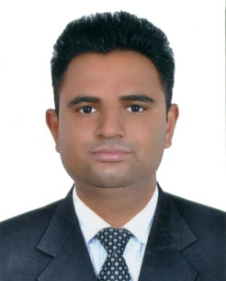

AMANDEEP KUMAR
+91 97818-99772
Email: amandp648@gmail.com
OBJECTIVE:

I am hard working and just want to grab the opportunity to show my ability and skills. I am down to Earth.
STRENGTH
- Self Confidence
- Adaptable tochanges
- Good at teamwork
WORKING EXPERIENCE:

- Three Yearsexperience of computer operator (Data entry, MS office, Typing, Internet, Designing-Photoshop, CorelDraw&etc.)at Puran Overseas Employment Bureau,C-1 Main Road,Sundarnagar ,Nakodar, Jalandhar, Punjab (India) (from 23-01-2015 to 17-05- 2018).
- Five years experience of Data entry operator in World security, Dubai (UAE) (from 1-1-2019 to 10-04-2024).
- Six months experience of Data entry operator on MS dynamic (ERP) in MBD Group at supply and receipt Item, focal point, Jalandhar. (from -11-11-2024 to 10-05-2025).

EDUCATION QUALIFICATIONS:

- B.A (Arts) (2013-2016) from University: G.N.D.U Amritsar (Punjab),India
- P.G.D.C.A from University : G.N.D.U. Amritsar,Punjab,India.
- Three Month Course in AccountsTally.
- HSC certificate from Punjab,India.
- Secondary School leaving certificate from Punjab,India.
PERSONAL DETAILS:

DateofBirth : 20-Dec-1994
Gender : Male
MaritalStatus : Single
Nationality : Indian
Languages : English, Hindi and Punjabi
DECLARATION:
I hereby declare that all the statement made in this format are true and correct to the best of my knowledge and belief.
Place- Amandeep Kumar
Date -

