ARJUN BAJAJ 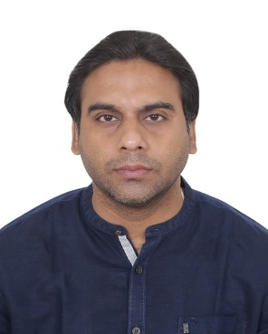
Mobile: - 9041624177
Email: - arjun_bajaj16@yahoo.co.in
Date of Birth: 16th November 1987
Address: EK-208, Phagwara Gate, Near Bhagat Singh Chowk, Jalandhar City

Profile Summary
To work in challenging and highly comparative environment which suits the best of my professional abilities, technical and analytical skills, which will help me to update my current skills and knowledge, where I can have good scope for learning new skills. A position that would allow me to utilize my skills and knowledge in different areas.

Areas of Strength
Operational Skills, Backend Operation, Knowledge of Microsoft Office and Internet, Basic Accounting, Basic Excel Usage

Academics
- B. Com, bachelor’s in commerce from Apeejay College of Fine Arts in 2009.
- Senior Secondary in Commerce from Innocent Heart School, Jalandhar in 2006.
- Higher Secondary from Innocent Heart School, Jalandhar in 2004.

Computer Proficiency
- Efficient in working with operating system, Windows 98/2000/xp.
- Working skills in Microsoft Office (word, excel, internet & E-mail)

Personal Strength
- Able to work under optimal supervision.
- Good communication skills.
- Able to work effectively and efficiently in a matrix environment.
- Very amicable, enthusiastic to learn.
- Can work effectively in team as well as individually.

Declaration
I hereby declare that all the information given above is true to the best of my knowledge.
Place: Jalandhar Arjun Bajaj Date:

