RESUME
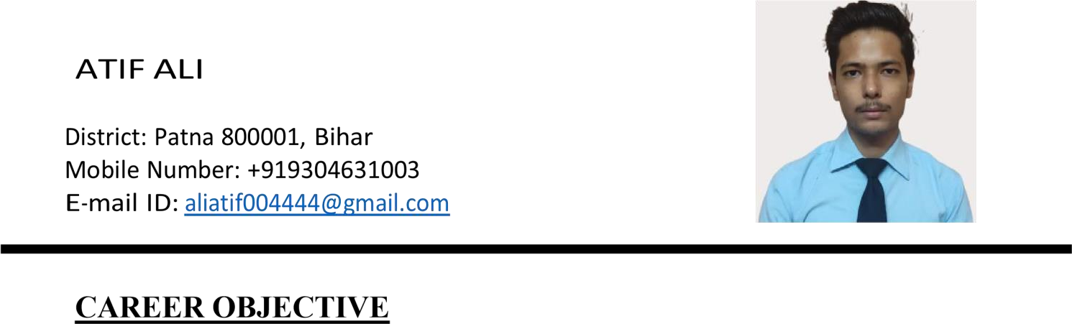
Seeking a challenging position in corporate companies, providing a highly motivated, progressive, friendly environment, encouraging the pursued carrier and to prove my knowledge and skills.

ACADEMIC QUALIFICATIONS

Level Exam | Year Passed | School/ College | University/ Board | Division
GRADUATION | 2021 | ARCADE BUSINESS COLLEGE | PATLIPUTRA UNIVERSITY | 1st
INTERMEDIATE | 2018 | KRISHNA PUBLIC SCHOOL | CBSE | 2nd
MATRICULATION | 2016 | RED CARPET HIGH SCHOOL | ICSE | 1st

EMPLOYMENT HISTORY (WFH Internships)

- Careers360/ Content Writer (March 2021-May 2021)
I was responsible for handling queries of aspirants preparing for competitive exams. It was my responsibility to connect with them via an app, clear their doubts by answering queries and to give career advice

- Collegedunia/ Content Writer (December 2021-May 2022)
Took the charge for writing articles based on competitive exams such as GATE IIT-JEE, NEET, and CAT, that involves complete analysis and research

- College Aftermath/ Content Writer (January 2022-May 2022)
I was supposed to write articles without any grammatical errors, related to offered products and services by several American companies. Post Writing, I had to proofread the articles and update as per the requirement of the company

- Testbook/ Content Writer (May 2022-June 2022)
I had to write, proofread as well as update the articles dedicated to several government job exams. Besides government job exam articles, I had to write articles based on several entrance examinations
PERSONAL INFORMATION
Name : ATIF ALI
Father’s Name : ASIF ALI
Date of Birth : 01-02-2000
Gender : MALE
Martial Status : Single
Nationality : INDIAN
Languages Known: Hindi, English, Urdu
PRESENT ADDRESS
KADAM KUAN, RAJENDRA PATH, PATNA

PERMANENT ADDRESS
KADAM KUAN, RAJENDRA PATH, PATNA

DECLARATION
I do hereby declare that the above mentioned information are true to the best of my knowledge and belief that I bear the responsibility for the correctness of this particular information.

Name: ATIF ALI
Place: PATNA

