BIO- DATA
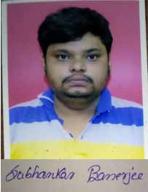
Name – Subhankar Banerjee
Father’s Name – Dipak Banerjee
Gender – Male
Date of Birth – 21/09/1987
Marital Status – Single
Nationality – Indian
Permanent Address:-
C/o – Dipak Banerjee Vill – Rabindrapally
P.O. – Raiganj Dist – Uttar Dinajpur
Pin- 733134 Phone – 7432931466
E-mail - subhankar90144@gmail.com
Educational Qualification:-
Examination  Name | Board/  University | Year of Examination | Full Marks | Marks  Obtain | (%) of Marks
MP | WBBSE | 2004 | 800 | 456 | 57
HS | WBCHSE | 2006 | 1000 | 483 | 48.3
B.Sc. (Hons.)  Math | NBU | 2011 | 800 | 353 | 44.12

Extra Qualification:-
CITA- from Raiganj Youth Computer Training Center, in the year- 2011
Work Experience:-
- Faculty of Mathematics of GSCE for 1 year.
Teaching Experience :-
- Competitive Mathematics for all level (10th Standard).
- SLST, WBCS, IAS- Mathematics (Optional Subject)
- GK: History & Polity.
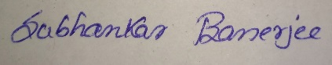
- Current Affairs.
Place – Raiganj
Date – 20/07/2019 Signature

