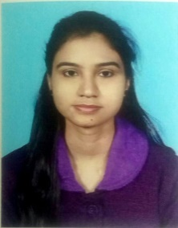
Curriculum Vitae

Name : SUBHOSREE GHOSH
Father’s Name : VIVEKANANDA GHOSH
Mother’s Name : KALPANA GHOSH
Address : ISHA APARTMENT, 2ND FLOOR, UNIT 2B,
VIVEKANANDA PARK, BAMUNARA, PURATAN
HATTALA, DURGAPUR,
P.O- BAMUNARA, P.S- KANKSA,
DIST- WEST BURDWAN, PIN- 713212
Date of Birth : 28/02/1995
Sex : FEMALE
Cast : GENERAL
Nationality : INDIAN
Religion : HINDUISM
Marital Status : UNMARRIED
Language Known : BENGALI, HINDI & ENGLISH
Mob. No. : 7063132645
E-mail id : subhosree.udl@gmail.com
Educational Qualification:-
Level | Exam passed/ Degree | Division/Grade  % of Marks | Year of  passing | Board/ University
10 | Secondary Examination | 82.62%  1st Division | 2011 | W.B.B.S.E
10+2 | Higher Secondary Examination | 68.20%  1st Division | 2013 | W.B.C.H.S.E
10+2+3 | B.sc Honours  (Computer Science) | 71.50%  1st Class | 2016 | The University of Burdwan
- | M.sc (Computer Science) | 71% | 2018 | The University of Burdwan

Extra Qualification : DIPLOMA IN IMPACT FROM WEBEL INFORMATICS
LIMITED- KOLKATA.

DECLARATION
I do here by declare that all the above information is true for the best of my knowledge & belief.

DATE: Signature

Subhosree Ghosh

