CURRICULUM VIATE
Name: Rajarshi Sinha 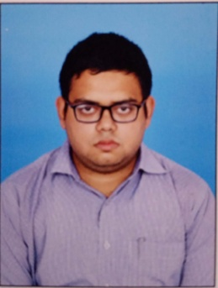 Date of Birth: 19/09/1994 E-mail id:rajarshisinha17@gmail.com / sinharajarshi1994@gmail.com Address: M.I.G(U)-17/3, Birati Abasan, M.B.Road, P.O- Nimta, Birati, Kolkata-700049 Contact No.: +91-9123803475/+91-6289534839
- Qualification Details:
Degree | Board/University | Percentage | Year
SSC(10^{th)} | WBBSE | 79.75 | 2011
HSC(12th) | WBCHSE | 79.00 | 2013
B.Sc(Hons)(Mathematics) | CALCUTTA UNIVERSITY | 56.00 | 2016
M.Sc(Statistics) | WBSU | 66.20 | 2018

- Computer Skill: I have basic computer skill like MS office, Using the internet, e-mail, SAP(Basics) etc.
- Hobbies: My hobbies are travelling , reading Bengali detective novels, watching crime thriller series, action movies and listening music.
- Experience: I worked as Operation Assistant in MRF Ltd. in Asansol from 18.02.2019 to 06..05.2019
- Interest: I have keen interest in the field of operation management, supply chain management, logistics operation, warehouse operation, inventory

- Personal Details:
Father’s Name: Kallol Sinha
Mother’s Name: Rajarshi Sinha
Gender: Male
Nationality: Indian
Marital Status: Unmarried
- Acknowledgement:
All the information given above is true and best of my knowledge.
Place: Kolkata Date: Signature:

