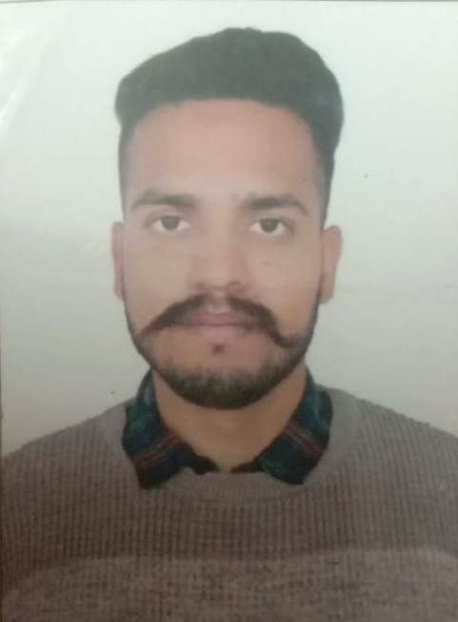
CURRICULUM VITAE
HARPREET KUMAR
H.No.2523 Gali No. 1
Dhapai Road, Amritsar
Punjab<143001 E-Mail- ravikumarsj2@gmail.com
Contact No. +19-9465851568

OBJICTIVES
- To work willingly in as environment where comes through creativity, hardworking,
Sincerity, honesty, timing and duty. Counseling and maintain good relationship with other employes.
EDUCATIONAL BACKGROUNG
- Matriculation from PSEB
- 10+2 from PSEB
- Art & Creft Diploma Two Year
- Graduation khalsa college Amritsar
- One year diploma computer
COMPUTER SKILLS
- Basic Knowledge of Computer
- Internet
STRENGTH
- Hardworking
- Quick learner
- Good Communication Skills
- Punctual
- Team Management
LANGUAGES KNOWN
- English
- Hindi
- Punjabi
PERSONAL DETAILS

Father’s Name : Sh. Pawan Kumar
Date of Birth : 13-Aug-1996
Gender : Male
Nationality : Indian
Hobbies : Travelling , Listening Music
Marital Status : Unmarried
DECLARATION

I hereby confirmed that above give information is true to the best of my Knowledge and I Assured you if you give me a chance to serve, I Will do my level best.
Date:-
Place: Amritsar:- Signature

