RESUME
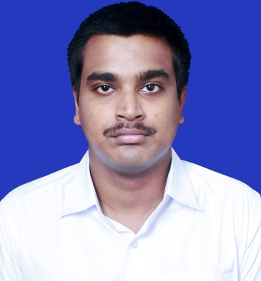
SUSOVAN DE

ADD: PURULIA TOWN
Mob. : 7384865185 / 7679343992
Email ID: susovan12.de@gmail.com

CAREER OBJECTIVE

Sir,
I was ex-student of your Institution at IBT KOLKATA . I have qualified Tier 2 in SSC CGL EXAMINATION 2018 & Waiting for TIER 3 Results. I have also qualified some examinations like SSC CGL 2019 TIER 1, PSC CLERKSHIP PART 1, WBPSC WORKS ACCOUNTANT PART 1 But I am not finally selected till now. So, I want to engage myself as a Competitive Math Tutor in any of Your Coaching Centre. I have acquired the ability to teach Competitive Maths during my preparation but I am also able to teach GI, GK & CURRENT AFFAIRS. If I get this opportunity in Teaching in your Institution, I shall give my best to the Students.

ACADMIC QUALIFICATION

Sr.No. | CLASS | BOARD/UNIVERSITY | YEAR | DIVISION/PERCENTAGE
1. | MADHYAMIK | WBBSE | 2009 | Ist Division / 80.375
2. | H.S | WBCHSE | 2011 | Ist Division / 82
3. | B TECH | MAKAUT | 2016 | Ist Division / 72.6

STRENGTH FACTOR
I can solve Competitive Maths in very quick time in right way. I am very fond of teaching Competitive Maths and GI.
WORKING EXPERIENCE
I am engaged in Competitive Math’s Teaching during 2 years in my locality.
PERSONAL PROFILE
Father’s Name : SWAPAN KUMAR DE
Date of Birth : 03/05/1993
Marital status : Unmarried
Gender : Male
Religion : Hindu
Nationality : Indian

DECLLERATION
I do hereby declare that the statements made in this document are true to the best of my knowledge and belief.
Place: PURULIA

Date: 22/08/2020 (Susovan De)

