Name: Vargab Chakraborty
Mobile No: 9062064471, 9875524584
Email-id: vargab90@gmail.com
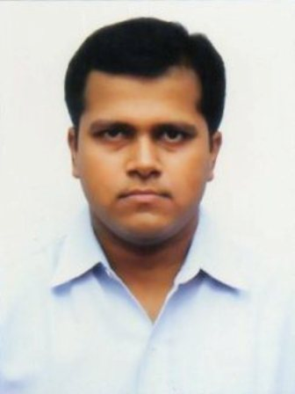

Educational Qualification
Examination | University/ Board | Institute/ School | Year of Passing | Marks (%)
MBA | WBUT | FBS | 2013 | 64
BBA | WBUT | FIEM | 2011 | 64
Higher Secondary | WBCHSE | Sarada Vidyapith | 2008 | 62
Secondary | WBBSE | Sarada Vidyapith | 2006 | 80

Selected for Interview round in IBPS CLERK 2014, IBPS PO 2015, IBPS RRB OFFICER SCALE-1 2016, LIC HOUSING FINANCE LIMITED ASSISTANT MANAGER 2017, LIC ADO 2019.

Projects Done: 1. Apprenticeship in sales for seven days from BIG BAZAAR, Highland Park
2. Financial Health Analysis of WEST BENGAL STATE ELCETICITY DISTRIBUTION COMPANY LIMITED

Computer Knowledge
Certificate in Microsoft Word, Excel, Power Point from Brainware.
Certificate in Tally from Youth Computer Training Centre.

Personal Details
Father’s Name: Late Rammoy Chakraborty
Address: SO: Late Rammoy Chakraborty, Aghore Sarani, Barendrapara, Behind Shanimandir, PO: Rajpur, PS: Sonarpur, South 24 Parganas, PIN_700149
Date of Birth: 01-01-1990
Marital Status: Unmarried
Sex: Male
Nationality: Indian
Religion: Hindu
Caste: General
Language known: Bengali & English ( ability to read, write and speak), Hindi ( ability to speak)

Declaration
I do hereby declare that the statements made above are true to the best of my knowledge.

Date: 03.01.2020
Place: Sonarpur Vargab Chakraborty

