CURRICULUM VITAE
Surya Mukherjee | 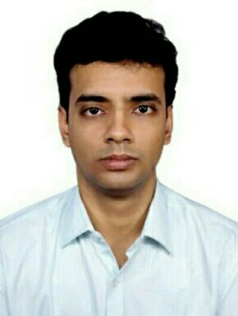
799/1,#AJIT ALOY
SAHEED HEMANTA KUMAR BASU SARANI
JAWPUR ROAD
KOLKATA-700074
Contact no- 9733051777/8240285229
Email Id –mukherjeesurya9593@gmail.com

CAREER OBJECTIVE
Seeking a position in a renowned educational institute where I can utilize my skill and abilities that offers professional growth in teaching sector while being resourceful, innovative and flexible.

PROFILE SUMMARY
- A Young professional completed MBA Degree in Human Resource Management from West Bengal University Of Technology.
- Have graduated in Bachelors of Science(Hons.) in Computer Science from Burdwan University, West Bengal.
- Self-motivated & hardworking team-player with strong communication, analytical, organizational and relationship management skills. Successful in accomplishing assigned project modules within agreed timelines.

ACADEMIC PROFILE
Examination Passed | Board/University | Year of Passing | Marks
MBA  (HRM) | West Bengal University Of Technology | 2015 | 6.82 DGPA
B.SC(Hons. In Computer Science) | Burdwan University | 2013 | 70.63%
Higher Secondary (10+2) | WBCHSE | 2009 | 66.57%
Secondary (10) | WBBSE | 2007 | 84.38%

Professional certifications
Having experience of taking classes in Imperial Competitive Institute(Belgharia)for bank exams.I have a sound knowledge of Banking GA,Current Affairs,Static Gk.
I will teach students each and every topic from the current to the static with some excellent tricks.

PERSONAL PROFILE
Father’s Name | Nanda Dulal Mukherjee
Date of Birth | 29-03-1992
Gender | Male
Marital Status | Unmarried
Nationality | Indian
Language Known | English, Bengali,Hindi

EXTRACURRICULAR ACTIVITIES
- Activities involved in decision making, organizing events and selection of participants for Inter departmental & Inter College Cultural Shows.

HOBBIES :
- Net Surfing
- Reading Story Books
- Playing Chess and Cricket
- Listening Music

Strengths :
- Confident, Hard Working & always willing to learn
- Resourceful, Innovative, Tactful and Flexible
- Performance Oriented, Excellent verbal & written communication skills
- Good analytical & logical skill
- Dedication
- Adaptability

DECLARATION: I hereby declare that the information furnished above is correct to the best of my knowledge and belief
Date: 22/02/2019
Place: KOLKATA (Signature)

