

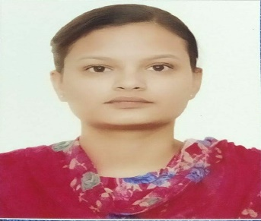
Management Professional

HARJOT KAUR
Harjotsaggu1234@gmail.com

+91-8427489813
ABOUT ME
I am energetic, ambitious person who has developed a mature and responsible approach to any task related with Management. I am a dependable team member and strive for both personal and team success. I am great when I am put to test for my management skills as these allow me to learn ever under pressure.
AGE
22

Education

Master, Business Administration Pursuing, 2019
Lovely Professional University
Phagwara, Punjab
Bachelor, Business Management Passed, May 2019
GNA University 70%
Phagwara, Punjab
10+2 Passed, March 2016
Guru Nanak Khalsa girls collegiate sen. Sec. school 70.6%
PSEB Board
Sang Dhesian, Punjab
10th Passed, March 2014
liberty Public School, 71.2%
PSEB Board
Goraya, Punjab

Professional Qualifications and Affiliations

- Participated in international Equanimity Olympiad in Guru Nanak Khalsa girls collegiate Sen. Sec. school, 2015
- Participated in I.Q Olympiad in Guru Nanak Khalsa Girls Collegiate Sen. Sec. school,2015
- 3rd position in AD Mad competition, GNA UNIVERSITY, 2018
- Participated in poster making, GNA UNIVERSITY ,2018

Job Experience

- Company : The Knowlegde Academy, Jalandhar.
Job Role : Digital Marketing Executive
Time Period : March 2019 – Januray2020


Project/Work Highlights

- After completing my 4th semester I joined my summer internship training in IDBI federal life insurance co. It is a govt. owned bank and I learn many new things during the training sessions and make a project on the consumer behavior in relation to insurance product.


Skills

- Good knowledge of basic computers and internet

- Excellent knowledge of core subjects
- Creative

- Ability to do work under pressure


Languages


- English, Hindi, Punjabi
Personal Interests

Watching movies
Playing games
Listening to music
Inquiring about new technologies


Personal Details

Father’s Name: S.Manjit Singh Marital Status: Single
Birthday: October09, 1998 Nationality: Indian
Gender: Female
Declaration
I, Harjot Kaur, hereby declare that the information contained herein is true and correct to the best of my knowledge and belief.

________________________ Phagwara , Punjab
Harjot Kaur

