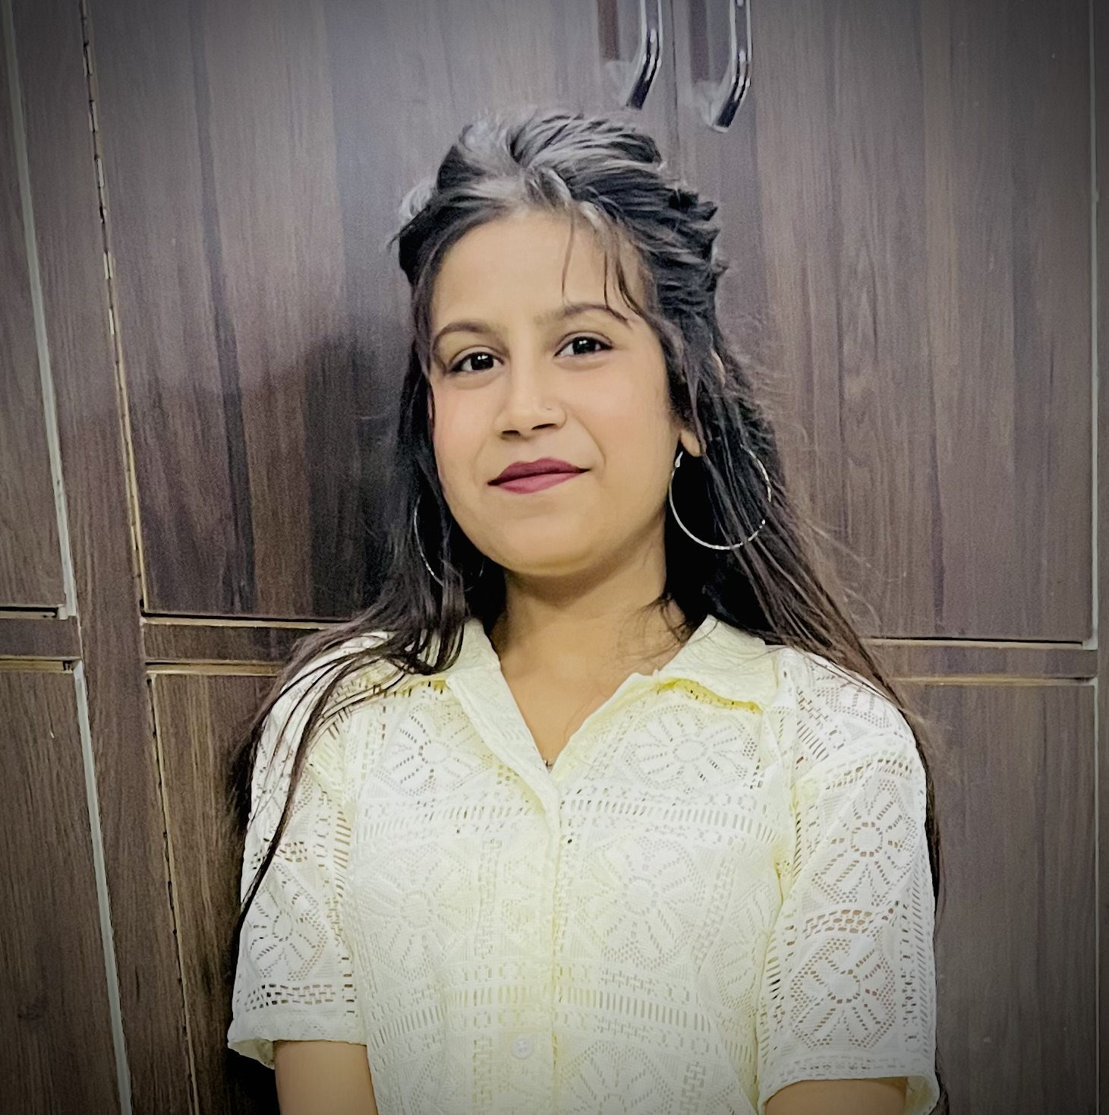 |  |  |  | CurriculumVitae  Isha Thakur
Career Objective
Seeking an exciting and challenging position as an Assistant Accountant in a company where my skills and knowledge can be utilize for me and Company’s growth also.
Educational Qualifications
- Passed 10th from PSEB with 76% marks.
- Passed 12th from PSEB with 73% marks in NON-MEDICAL stream.
- Pursuing BBA
Career Experience
- 3 Years experience of accounts in Metro Milk Products Ltd. Jalandhar.
Skills
- Ability to find solutions quickly.
- Self Motivated.
Strength
- Hard working
- Honest
Hobbies
- Listening to music
- Reading Books
Computer Skills
- Basic knowledge of Computer.
- Basic knowledge of Accounting Software like Sapphire.
Languages Known
- English
- Hindi
- Punjabi
Personal Details
- Father’s Name:-Sh. Shiv Kumar
- Mother’s Name:-Smt. Reena
- Gender:- Female
- D.O.B:-28/Dec/2003
- Marital Status:-Unmarried
- Nationality:- Indian
Declaration
I hereby, declare that the above mentioned details are true to
the best of my knowledge and belief.

Isha Thakur

 |  | New Raj Nagar,Near Chunna Bhathi, Jalandhar, Punjab
 |  | M:-90416-57160
 |  | Ishathakur4307@gmail.com

