CURRICULUM VITAE
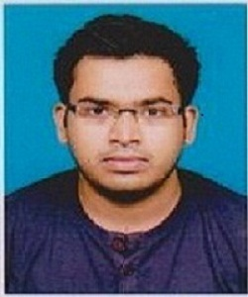
- NAME : SAIKAT DIAS

- FATHER’S NAME : MR. BONIE EDGAR DIAS

- MOTHER’S NAME : MRS.SEPHALI DIAS

- PERMANENT ADDRESS : 17,BAGMARI LANE BRS10,
KANKURGACHI,
KOLKATA- 700054

- MOBILE NUMBER : 8240344978 / 9051798285

- EMAIL ADDRESS : diassaikat25@gmail.com

- GENDER : MALE

- MARITAL STATUS : UNMARRIED

- NATIONALITY : INDIAN

- DATE OF BIRTH : 25/01/1991

- ACADEMIC QUALIFICATION:

EXAM | BOARD | MARKS | DIVISION | YEAR
MADHYMIK | WBBSE | 73.25% | 1ST | 2007
HIGHER SECONDARY | WBBHSE | 71.20% | 1ST | 2009
B.Sc (Chemistry)  (HONS) | CU | 52.50% | 2ND | 2014

- OTHERS: DIPLOMA IN COMPUTER APPLICATION FROM MOULALI YUVA KENDRA (MS OFFICE, VISUAL BASIC AND FOXPRO)
I hereby declare that the above stated information is correct to the best of my knowledge.
 (SAIKAT DIAS)

