Satish Kumar Bablani  19 Sahyog Apartments  Behind Road no 44 Local Community Center/M2K Cinema  Near Sant Nagar, Rani Bagh, Pitam Pura  Delhi 110034  Hand Phone: 8860757757  E Mail:skbablani@gmail.com | 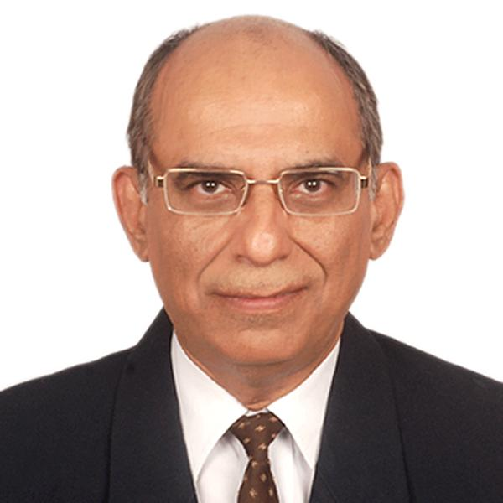

OBJECTIVE |  | To share knowledge and expertise acquired during my 44 years of International Finance & Trade and Commercial Banking experience in the areas of Trade Finance & Services, Treasury , Banking Operations, with a reputed upcoming dynamic Financial Sector organizations and advise them in this regard & help them achieve their corporate Goals.
SUMMARY OF EXPERIENCE : TOTAL 49 YEARS PLUS OF WHICH
- 6.5 years’ experience as a Consultant in Retail Trade & Forex vertical with HDFC Bank Ltd India
- 2.5 years’ experience with Crane Bank Uganda as Ex. Director and Ag. Managing Director
- 6 Years’ experience as Head Trade Finance and RTFX .in CBOP and HDFC Bank
- 11 years experience as Head Trade/International Banking Business Operations
in Crane Bank, Bank of Baroda, Bank of Punjab Ltd Delhi
- 5 years ,Correspondent Banking, NRI, Foreign Resource Raising and Operations management

EDUCATION :
M.M.S. Finance - Pune University - July 1995 high First Division with aggregate over 75 % marks
M.A. Economics and M.Com -1976/1984 - Himachal Varsity Shimla 2nd/First Division
respectively Specialization : International Eco and Trade
B.Sc.-Calcutta University 1971 with Distinction Major in Physics Chemistry and Mathematics
CAIIB Indian Institute of Bankers 1979

COMPUTER SKILLS
 | Software: MS Office 2010, Open Office Internet, Aqura Accounting package, Finacle, Internet and Email, etc.
RELEVANT EXPERIENCE
Currently working as a freelance trade and forex consultant on assignment basis
Trainer cum Consultant : Retail Trade and Forex - Vertical -HDFC Bank Limited , Since October 2015 till March 2022
- Responsible for undertaking training in Retail Trade and Forex processes and products of HDFC bank for the nominated Managers/ Sales Staff in Sales, Retail Banking pan India.
- For providing opinions on complex FEMA related complex issues of Retail Trade and connected allied matters. Giving inputs on the processes of the bank on specific requests by product team.
- Providing inputs to the Trade Vertical in an independent manner, with a view to enhance sales effectiveness in full compliance of RBI/FEMA and internal regulations .
- Preparing the candidates for the CFE examination of IIBF Mumbai

Executive Director – Operations and Services—Crane Bank Limited Uganda from February 2013 to August 2015
- Responsible for Overseeing and developing sound and compliant operational processes of the Bank in Banking Operations including treasury and foreign business . Was director in-charge of IT operations too and successfully migrated the CBS from Bank Master system to T 24 Core Banking Software of Temenos ,
- Was responsible-for Branch supervision, for growth of compliant business, All HR matters, policies and negotiations During my tenure the bank doubles its branch network and was declared as the best managed private sector bank in Uganda by Bankers Magazine UK during 2013 and 2014 in succession.

Head Operations – Book My Forex Private Limited , Gurgaon, a ecommerce and FFMC
Since July 2012
- Responsible for organizing the process for error free operations with a team of 6 people and monitoring the Sales Team, for the results achieved vis a vis agreed targets.
- Formulate policies for guidance and providing training for Sales Team.
- Managing , Finance and Accounts along with day to day Administration with long term contracts for management of AMCs, ensuring timely procurement of stationary, doing follow up for collections , and overseeing all the aspects for a profitable operations dept., which is cost effective and efficient .

Consultant and Advisor to Dhanlaxmi Bank Ltd on Trade and Advisor =On contract from Oct 2011 till April 2012
- Responsible for advising the Sales Team on the strategy to be adopted for Generation and achievement of Revenue and Business.
- Formulate strategic guidance and act as a Coach/trainer for a Sales Team of 12 branches in Delhi for creating a focus and 32 professionals.
- Provide effective solutions for trade related needs of the clients .and to contribute on ideas for providing better service, generation of revenues and adopting strategies for increasing sales of the Trade and Forex Products

Vice President and Regional Sales Head Retail Trade & Forex – North Region 2/3 --HDFC Bank since merger with CBOP in May 2008.- till Sept 2011.

- Responsible for Generation and achievement of Revenue and Business Volumes as per Corporate Goal in the Retail Segment of Bank together with a team of 4 Territory Sales and 28 Sales Managers.
- Responsible for training /Mentoring Sales Team of 32 professionals.
- Provide effective solutions for trade related needs of the clients.
- Provide ideas for new products , help in testing and introduction thereof
- Redress Grievances on Ops and Service Issues and provide effective Solutions

Regional Head Trade Finance & Vice President ,
Centurion Bank of Punjab Ltd Delhi Since Oct 2005 Till April 08
- Generate business leads and acquire new clients.
- Formulate strategic guidance and act as a Coach/trainer for a Sales Team of 12 professionals.
- Provide effective solutions for trade related needs of the clients .
- Provide ideas for new products , help in testing and introduction thereof
- Achieve the agreed Business Revenue Targets.
- Redress Grievances on Ops and Service Issues and provide effective Solutions

Head, Global Banking Division and Vice President February 2000 – Sept. 2005
Bank of Punjab Ltd Delhi
- Responsible for achieving agreed Trade and International Business related Revenues.
- Compliance with FEMA and RBI rules and procedures in conducting International Business across branches in whole country.
- Management of Correspondent relations, new product formulations and NRI business.
- Instrumental setting up the Representative Office in Canada
- Set up and managed Centralized Trade Operations in New Delhi

AVP UTI Bank May 1999- Jan 2000
Trade and Retail Ops: Green Park Branch
- Responsible for Trade operations and management of the International business and revenues at the branch .

Head , International Division March 1996 to Feb 1999
Crane Bank Ltd Uganda.
- Responsible for setting up the entire vertical of Trade and Foreign Exchange Business of the newly incorporated Bank
- Responsible for error free operations and management of the International Division business and revenues.
- Management of Correspondent relations and Non Resident Banking
- Managing the treasury (forex) operations and Overseeing the treasury dealers and forex trade Team.

Dy. General Manager IFCI Ltd Jan 1992 to Feb 1996
- Head of Foreign Currency Resources and Ops
- Taking care of raising of resources, disbursements and Foreign Position management.
- Raised syndicated Foreign Currency Loans

Sr. Manager -Jan 1973- December 1991
Bank of Baroda
- 19 years varied experience in the area of Forex Operations, Credit Management and Branch Management with a stint of 1.5 years in London office of the Bank.

Achievements
- Outstanding Leadership, Successful Execution of approved business decisions & with a excellent service record in all the organizations served by me.,
- Created new landmarks in sales and business revenues and achieved very high quality standards for accurate and reliable services in foreign operations in the organizations served by me.
- Achieved the targeted Business Volumes and Revenues consecutively in last 6 years of full time career prior to retirement in the Trade Sales Vertical
- Excellent Communicator with ability to transfer knowledge, experience and skills in class room /web meetings.
- A very Positive person , Coaching the entire team to achieve higher results ,without compromising on integrity, ethics , and internal /external compliances

Personal details :
Date of Birth :15.0.1951
Nationality : Indian
Marital Status : Married – 3 Children, married and well settled
Hobbies : Banking Subjects Training ,Reading and Public Speaking & Cricket,

