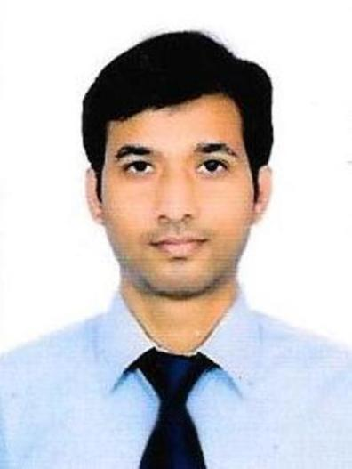
Chandershekhar sinha
Contact no- 8825794306
Email- chandu12032@gmail.com
Applying for - Faculty of Quantitative Aptitude

Career Goal

Seeking a position in professional and dynamic organization to utilize and upgrade my knowledge, Contributing for growth of Organization and as well as carry my passion for teaching.
It would be a true pleasure, if I can give back my knowledge to our young minds which I have received during my preparation of civil cervices. Also , maintaining the same level of satisfaction which our young minds are already getting in your institute, is my desire.
It is well said that “service to mankind is service to god”. I believe service through educating our ignited mind would be best service to mankind. It would be honor to be part of such a team which is highly dedicated towards a noble goal of serving and enlightening people through education.

Adept at identifying student needs and fostering an environment where students are encouraged to participate in the learning process. Dedicated to create positive learning environment and making a difference in student’s life.

Work Experience

July 2014 to present – Working in National Insurance Company at post of Administrative Officer.
Qualified in SSC CGL 2012 and 2013 in Prelims .

June 2012 to June 2014 - Teaching in a ssc/banking coaching centre located at patna
Jan 2016 to Dec 2018 - I took weekend class at Race coaching during my posting in Chennai.

IN NICL ( 5 years since 2014 )
- Worked in my office(NICL) where 15 employees and more than 25 agents,with all ages reports daily. I have build a strong organizational as well as managerial skill. Proper interaction with different persons with all ages was a special thing to learn.
- Took classes for project trainee on “Basic of Insurance learning”

IN TEACHING
- Developed creative classroom presentations to encourage student engagement.
- Prepared academically challenging and compelling lesson plans.
- Worked with other teachers and staff to develop innovative learning programs.
- Held classroom discussion sessions after each chapter to ensure comprehension.

Educational qualifications

- B.tech-2010, Electronics and communication, smit, smu
- Licentiate paper in insurance knowledge
- Certified by British Council in spoken English( Upper Intermediate course).

Skills and ability
- Highly interested in Arithmetic for SSC level.
- Strong familiarity with SSC and Banking exams.
- Substantial knowledge of Polity, Geography History, Economics.
- Ability to engage students with creative lessons
- Adept at identifying and overcoming learning challenges
- Ability to establish effective communications with students
- Good interactive and organizational skills.

Location preference
- As per requirement

Personal Details
Date of Birth- 28th February 1987
Languages known- English, Hindi

