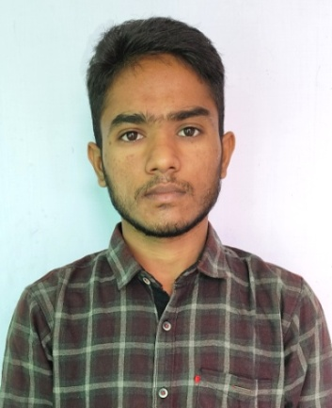
CV/ Rahul Singh (22 Y)
E-mail – rahulsinghrawat850@gmail.com
Contact No. – 9521107585
Applying for –All administrative services, Staff support services.
Dear Madam/ Sir,
I recently completed my graduation with B.Sc.(Hons.) Mathematics from University of Delhi. I am applying for all administrative services. I am interested to work with people to make my small contribution for your organization’s vision. Kindly take a view on my qualifications.

Educational Qualifications
S.No. | Standard | Institute | Marks | Year
1. | 10th | RBSE | 81.83% | 2015
2. | 12th | RBSE | 93% | 2017
3. | Graduation | Delhi University | 8.365 CGPA | 2021

Other Qualifications
S.No. | Name | Description
1. | JEE Mains qualified | JEE Mains qualified and appeared for IIT JEE Advanced 2017
2. | Inspire Award winner | Inspire scholarship by Department of S&T Govt. of India
3. | RS-CIT | Computer course

Personal skills
- Good communication and interaction with people
- Analytical and creative thinking
- Computer proficiency
- Self improvement and new things learning
- Best writing and reading
- Personality development
These are some my qualifications. I believe that if once I guided about rules and regulations of organization then I can do my work with fully efficiency and honesty.

