CARRICULUM VITAE

- Personal Detail- 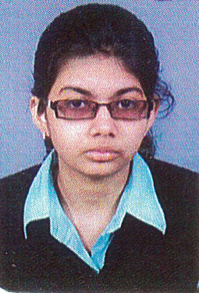
- Name-Dhrity Saha
- DOB-01/05/1992
- Mobile No-8961647778
- Email Id-dikshitasaha@gmail.com
- Address- 1A, Kumartuly Street. Kolkata-5
P.O- Hatkhola Landmark- near Sovabazar metro station
- Objective-Seeking a position of an Office Staff utilizing excellent office management and organisational skills and a profound ability to handle multiple tasks simultaneously.
- Key goals-
- Demonstrated ability to manage common office tasks such as filling and record keeping.
- Special talent for office correspondent management.
- Good knowledge of posing as a first point of a contact and managing the front desk.
- Reduce potential problems in service delivery.
- Educational Qualifications:
- Masters of Arts English Literature, R.B.U, 2015
- Bachelor of Arts, C.U, 2013
- Higher Secondary, W.B.H.S.C.E, 2010
- Secondary, W.B.S.E, 2008
- Certifications:
- Certification in Spoken English, Ramakrishna Mission Swami Vivekananda’s Ancestral House & Cultural Centre, 2010
- Certification in Basic Computer (Office Management Course), Srimati National Techno Institution, 2012
- Computer Knowledge:
- Good knowledge of Microsoft Word, Microsoft Excel.
- Ability to prepare and present presentations on Microsoft PowerPoint
- Capable of browsing the internet through different browsers like, Internet Explorer, Mozilla Firefox and Google Chrome.
- Social media sites
- Typing speed- 30WPM
- Language Known:
English, Bengali and Hindi
- Hobbies:
Reading, writing, singing and listening to music
- Professional Skills-
- Good communication skills.
- Good team playing capabilities
- Work Experience-
- Working as a Back Office Executive in Royal Research for one year (2015-16)
- Working as a Home Tutor since 2011
- Working as a Staff in George school of Competitive exams 2016-2020
- References furnished upon request-
- Mrs.Swati Mondol-Professor of Vidyasagar Evening College.
- Mr.Arun Ghosh-Professor of Gurudas College.
Signature-
Date: 06.03.2020 