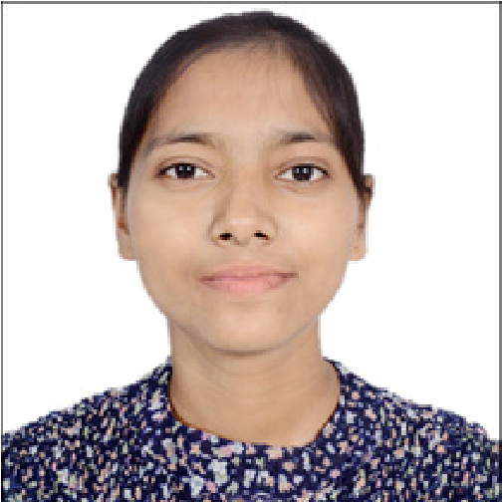
+918427630652
ninderkaur22720@gmail.com
MEHATPUR, NAKODAR (JALANDHAR)

SKILLS
Ability to quickly evalunates
Alternatives
Quick Learner
Problem-Solving Abilities
Efficiently Managing Time and
Resources to Maximize

- Productivity and Achieve Sales Targets

LANGUAGE
English
Hindi
Punjabi
NINDERJIT KAUR

DEDICATED AND MOTIVATED INDIVIDUAL WITH A BACHELOR OF COMMERCE . EAGER TO APPLY STRONG PROBLEM- SOLVING
SKILLS A PROACTIVE ATTITUDE , AND A AN ENTHUSATIC, PUNCTUAL & CAREER MINDED INDIVIDUAL WITH EXCELLENT CUMMUNICATION AND INTERPERSONAL SKILLS.

PROFESSIONAL PROFILE
Name :- Ninderjit Kaur
Father Name :- Balbir Singh
Mother Name :- Charanjit Kaur
Date Of Birth :- 06/07/2003
Marital Status :- Unmarried
Gender :- Female
Nationality :- India

PERMANENT ADDRESS :-
Village Raipur Araian Ummarwal Billa,
Tehsil Nakodar, Dist Jalandhar
Punjab India -144041

EDUCATION
BACHELOR OF COMMERCE (Hons.)
SATYAM INSTITUTE OF MANAGEMENT AND
TECHNOLOGY, (NAKODAR)

12th
Govt. Girls Senior Secondary School Mehatpur,
(JALANDHAR)
10th
Govt.Senior Secondary School Baghela,
(JALANDHAR)
- Work Experiencce

2 Years of computer Operator

- Technical Proficiency
LANGUAGE C, C++, JAVA
Operating System : Windows
MS Word, Excel, Powerpoint, Web Designing

- Hobbies & Interests
Learning new Technologies and Software Skills
Traveling and exploring different cultures
Engaging in problem-solving and analytical tasks
Listening to music for relaxation

