 | Dev karan  dev210506@gmail.com  Ph: 9565770822 | 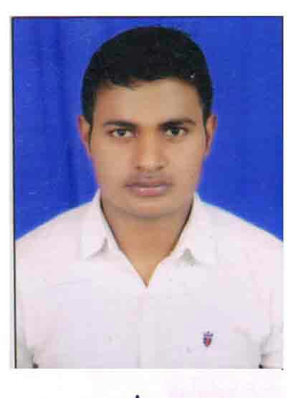
-------------------------------------------------------------------------------------------------------------------------
 |  | OBJECTIVE |  | : To obtain a position in Service Sector that will enable me to use my strong organizational skills, operations background, and ability to work well with people.
 |  | EDUCATION  Organization |  | : B.Sc (Science)- from Bundelkhand University Jhansi .  : 10+2 from U.P Board (First Division).  : Class 10 from U.P Board (First Division).  : Zaneka drugs Pvt Ltd.
 |  | SPECIAL SKILLS |  | : Certificate in COURSE ON COMPUTER CONCEPTS(CCC)  : Confident, adaptable and hardworking.  : Good communication and interpersonal skills.  : Ability to work in any situation.
 |  | INTERESTS |  | : Playing Football and Cricket.  : Helping the helpless and needy.  : Traveling.
ACHIEVEMENTS : Selected in INDIAN AIR FORCE in 2016.
(RN- 1603132012 Technical trade )

DATE OF BIRTH 3rd Feb , 1997

FATHER’S NAME Mr. Chhote lal

POSTAL ADDRESS Vill. Post Muskara Dist. Hamirpur (210506) , Uttar Pradesh

Date:

 |  | Place | Dev karan

:

