ROhit Ranjan Thakur
Mob . 6200439764
Email rrtpatna1@gmail.com
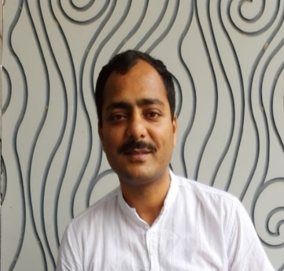
DOB : 06 – 12 – 1978
Nationality : Indian
Marital status: Married
Address : kali Mandir road , Sanjay Gandhi Nagar
Kankarbagh , Patna - 800026
Bihar

Objective
TO prove my self an asset for the company .

Experience
Associated with different academic institutions since 2007
Banking service Chronicle (BSC ) , TIME , Career Power , Chanakya IAS Academy , Patanjali IAS Academy ( Patna )
Faculty: General studies ( Indian Constitution and polity, Indian Economy ) for UPSC , BPSC ,SSC and other Examinations
Faculty: Indian Constitution and polity , Indian Economy , International relations ( UPSC / BPSC Mains Examinations )
Faculty : Optional paper - SOCIOLOGY
Faculty : Banking and Economics , General awareness - Bank PO / Clerk examinations
Faculty : Group discussion and Personal Interview .
- Medium : English and Hindi

Education
Post Graduate - Political science ( IGNOU New Delhi )

Awards and Acknowledgements
- Awarded at college level for extracurricular activities .
- Cleared upsc pre 3 times .
- State civil service ( UPPSC , BPSC , MPPCS ) 7 times .

