IBT India Website Improvements

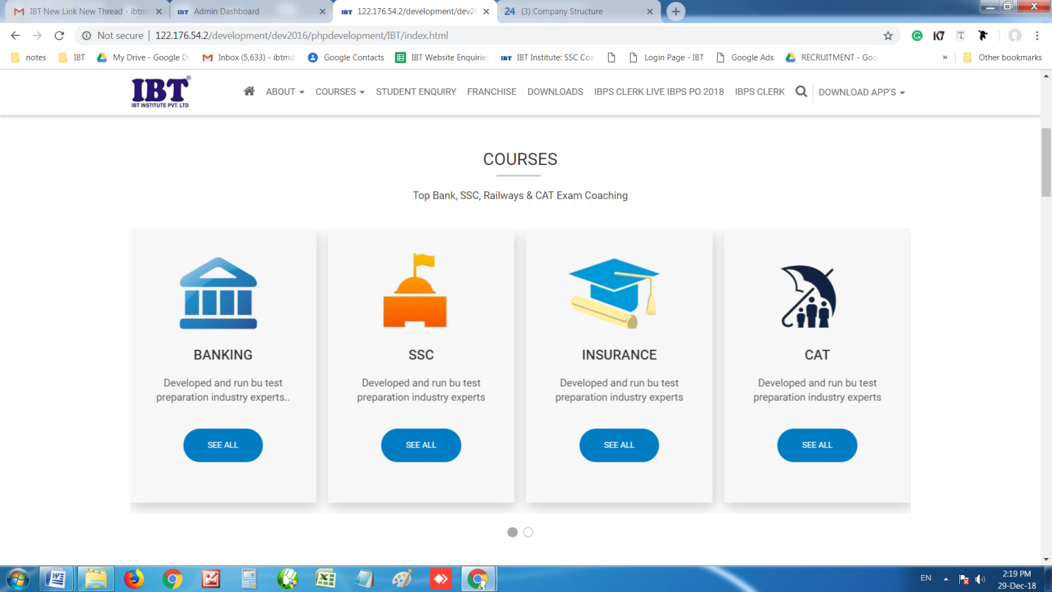
Make it reverse
Make the animation same as of it - https://www.samsung.com/in/
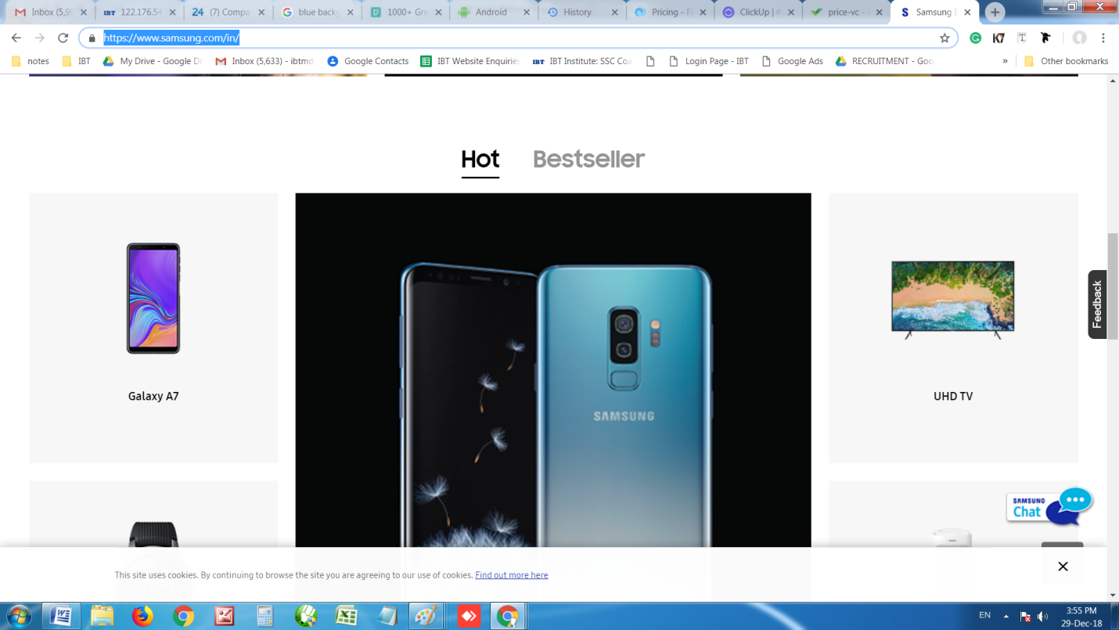
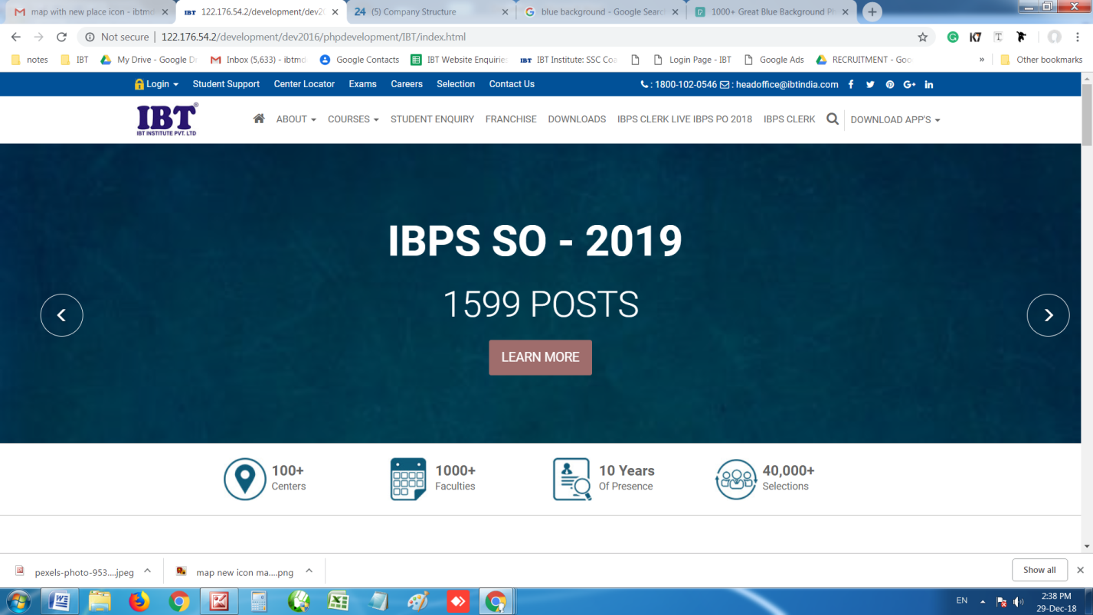
SPECIAL NOTE : Give an option to upload .png file image everywhere as of now its not in scope.
Don’t blur the banner image.

Give an option in admin to change font color
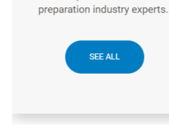
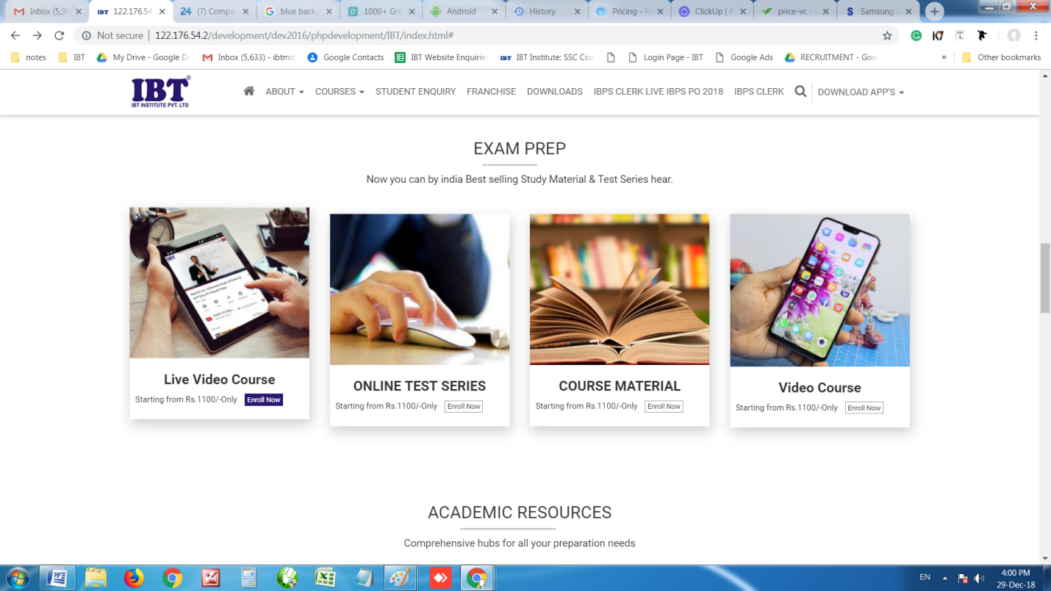
Make it in blue color once cursor comes colors

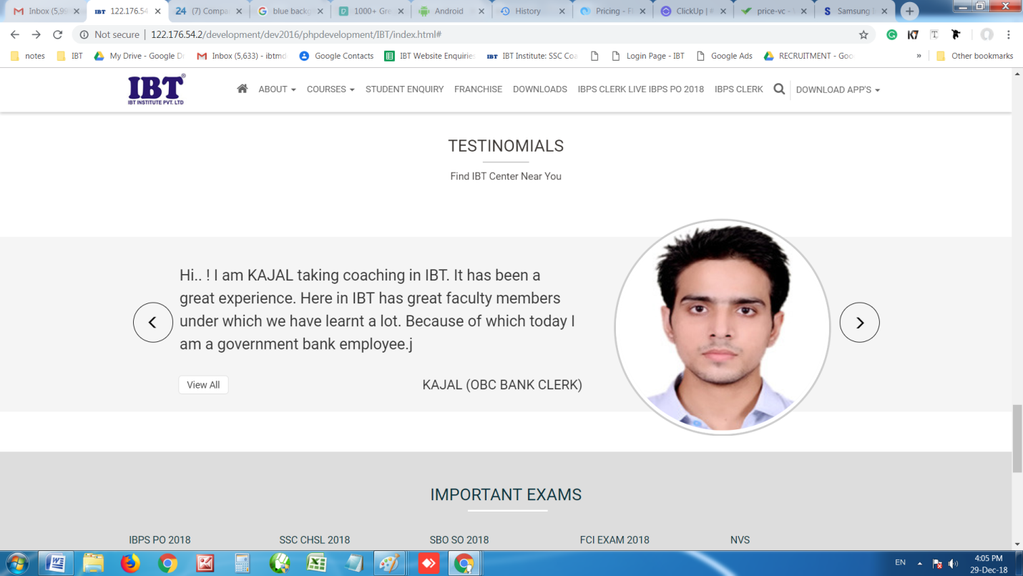
Share the image size of testimonial of display it should look perfect
Reduce font size and make it same as shown below.
Keep it same. Don’t it its font size
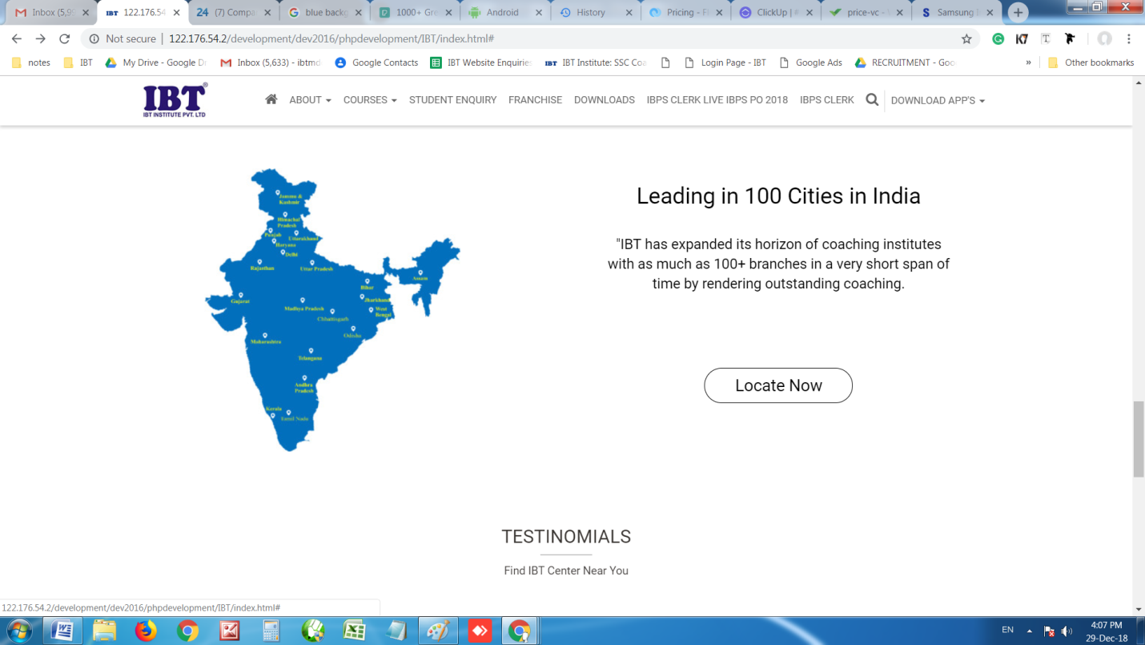

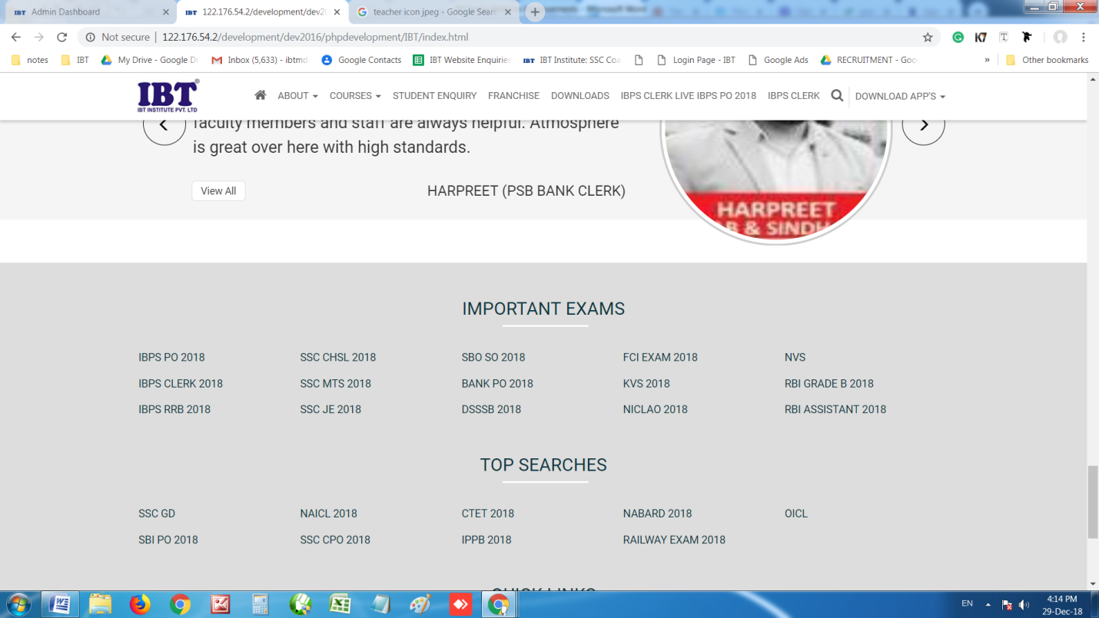
By Default make it light and once cursor comes make it dark. Reference (Footer)
https://clickup.com/#section-pricing
Put same color in footer
Make line light black

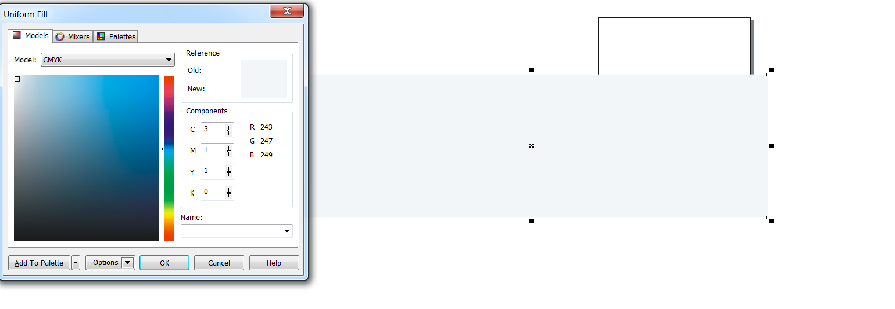

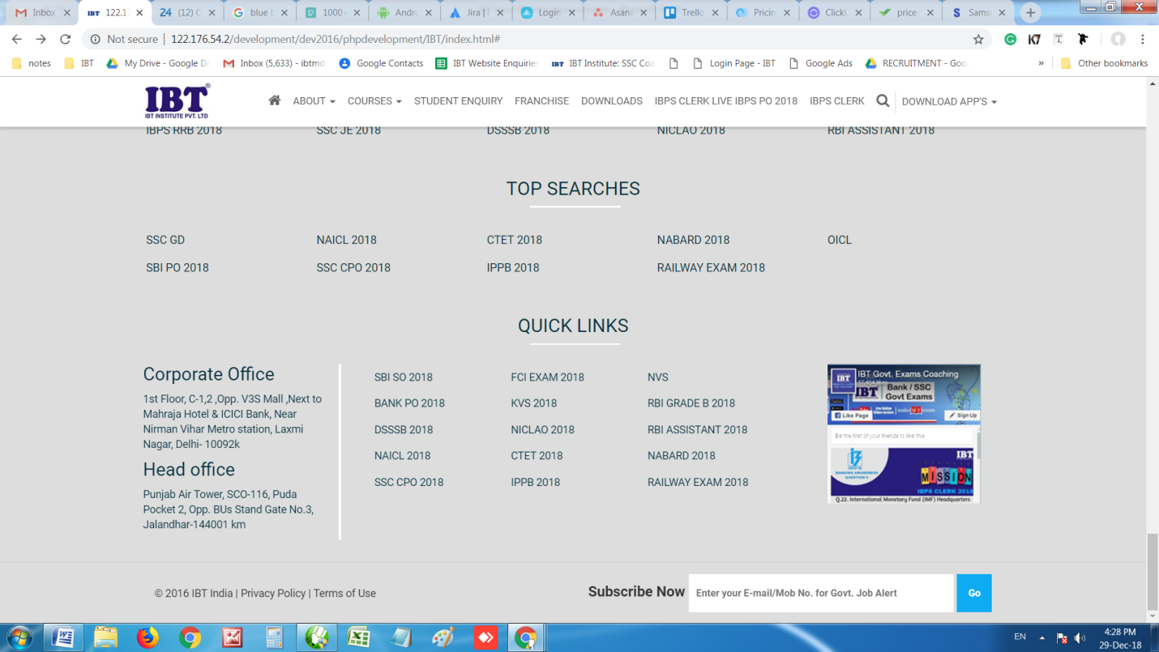

Make it light Black

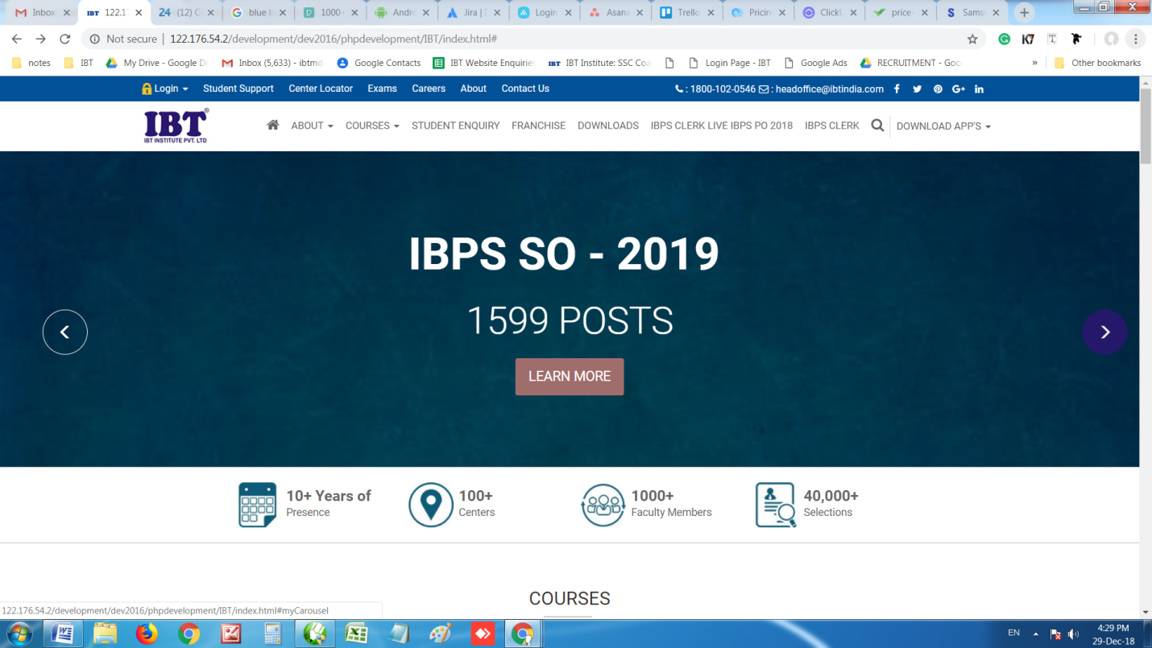
Make it like this once cursor comes
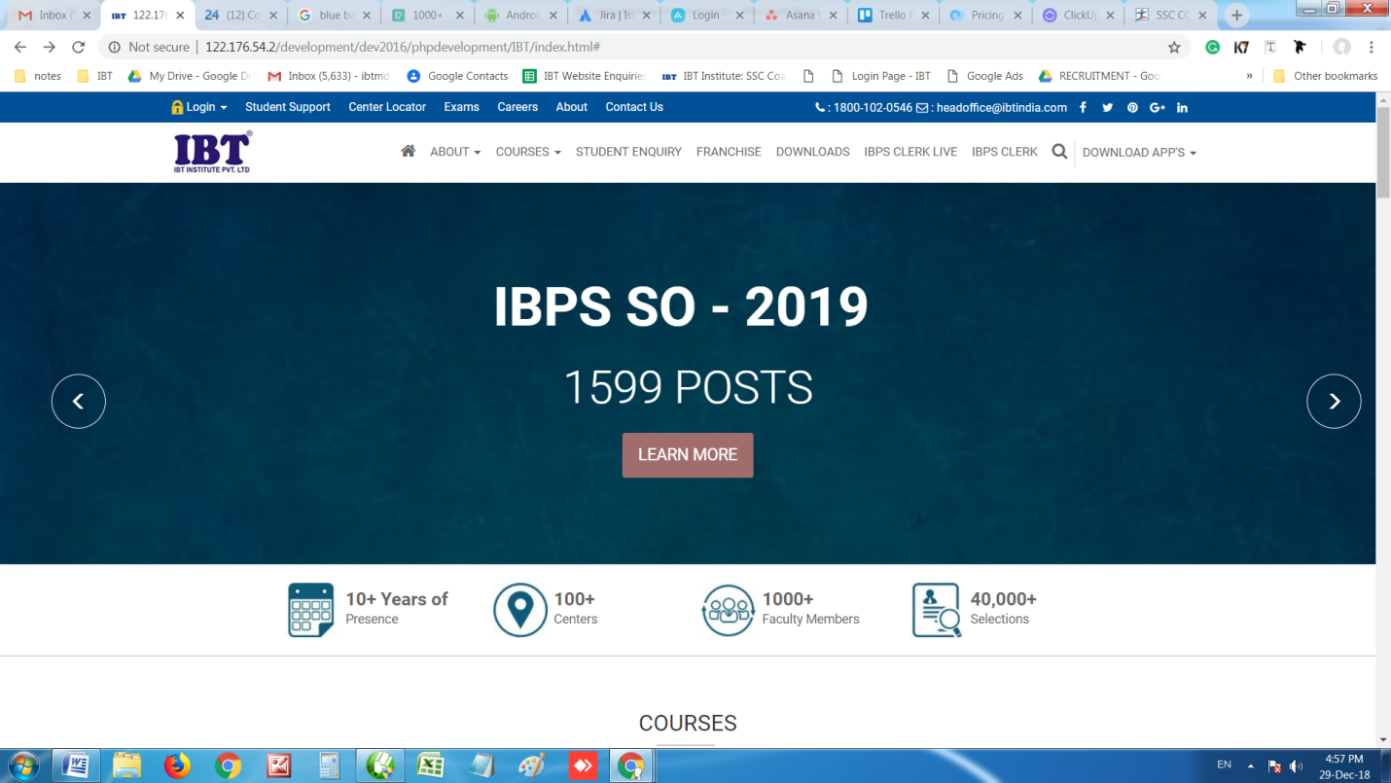
- Give an option to make any menu as new. See below image for reference
- Give a option to highlight any menu. See below image for reference. https://www.wifistudy.com/

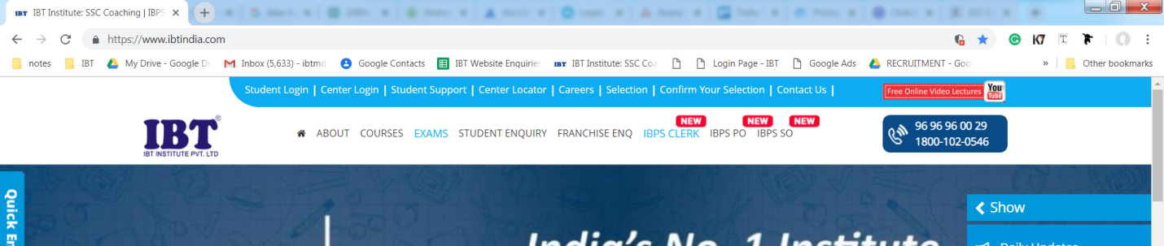
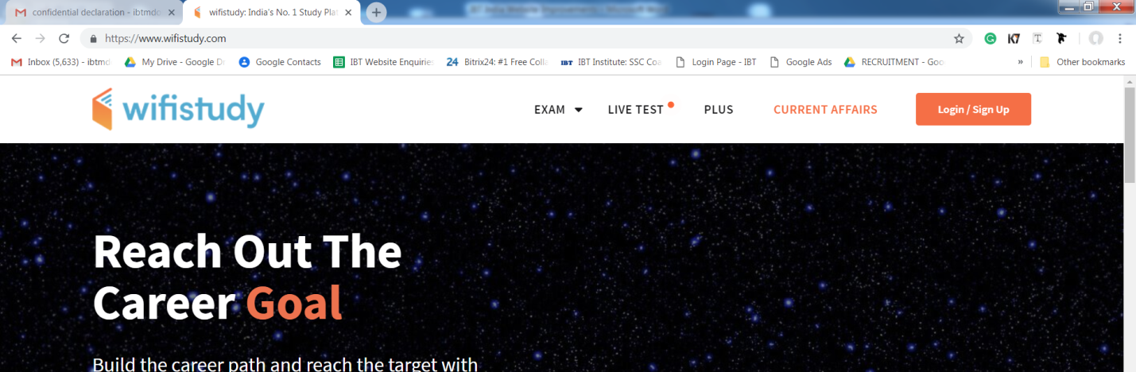
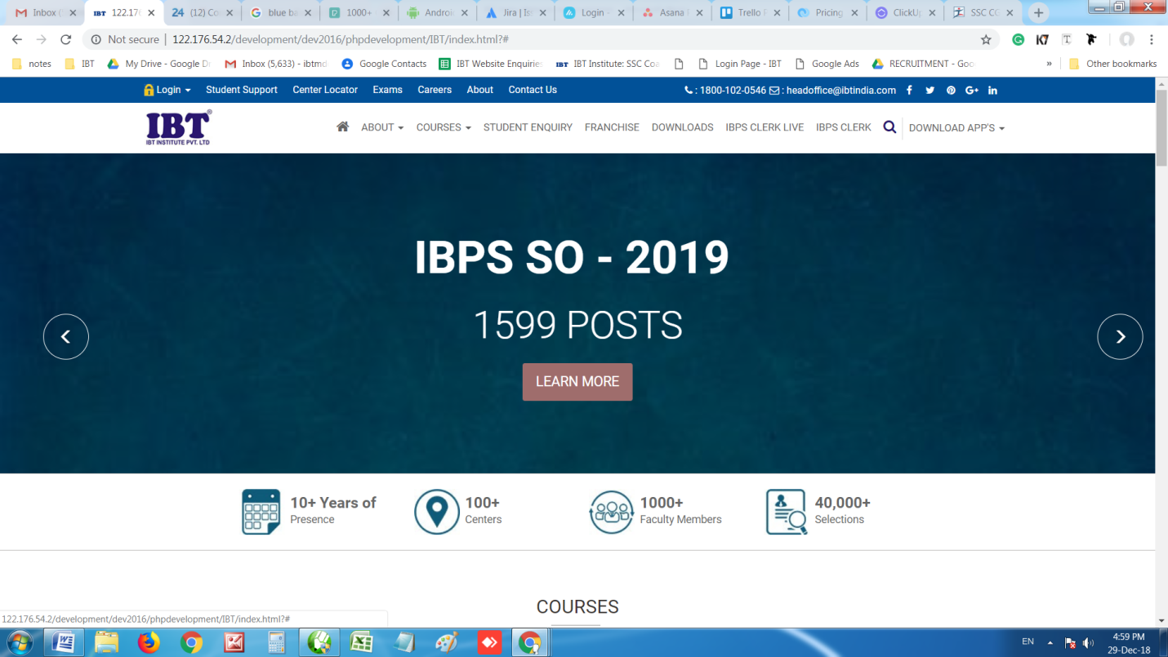
Search not working

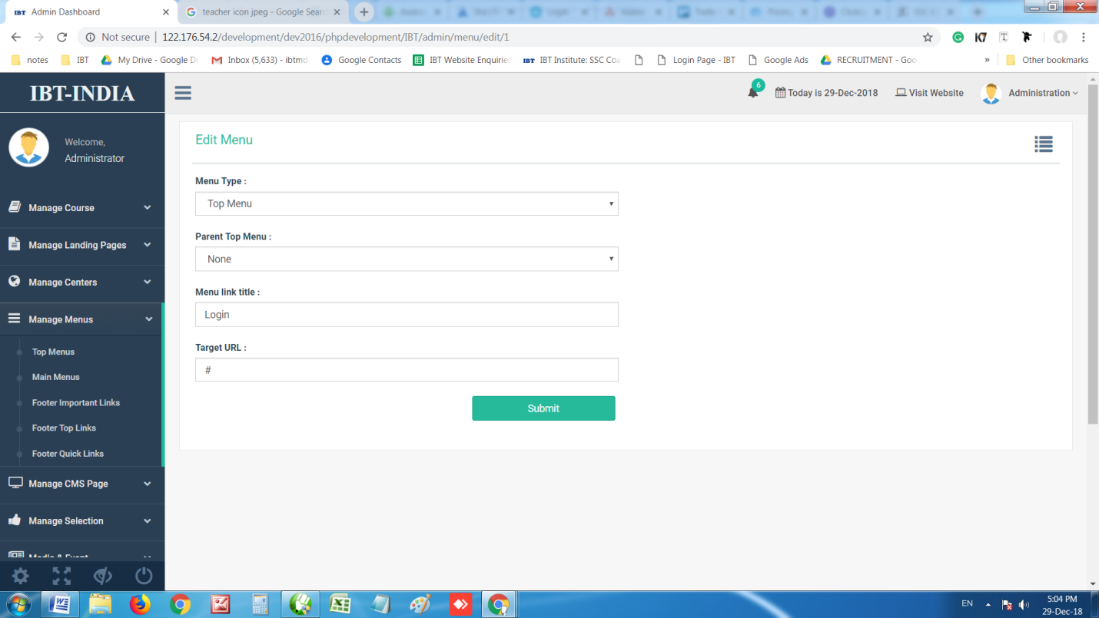
Create an option to decide landing location. For eg. Open page in new window or existing window. Do this everywhere we have an option to put URL. You can take reference from below image
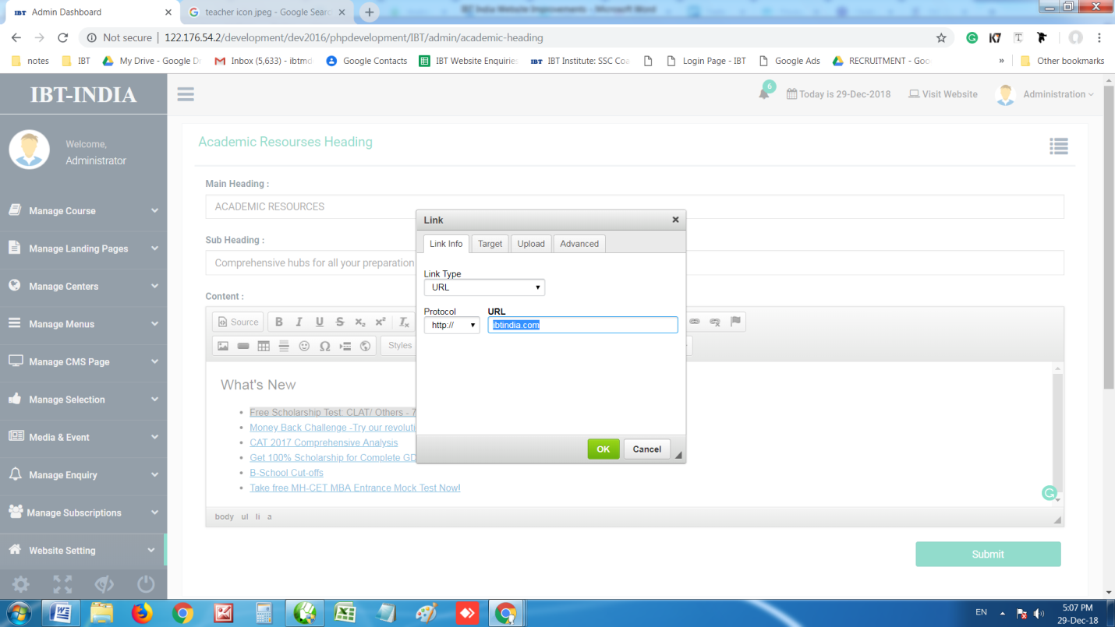

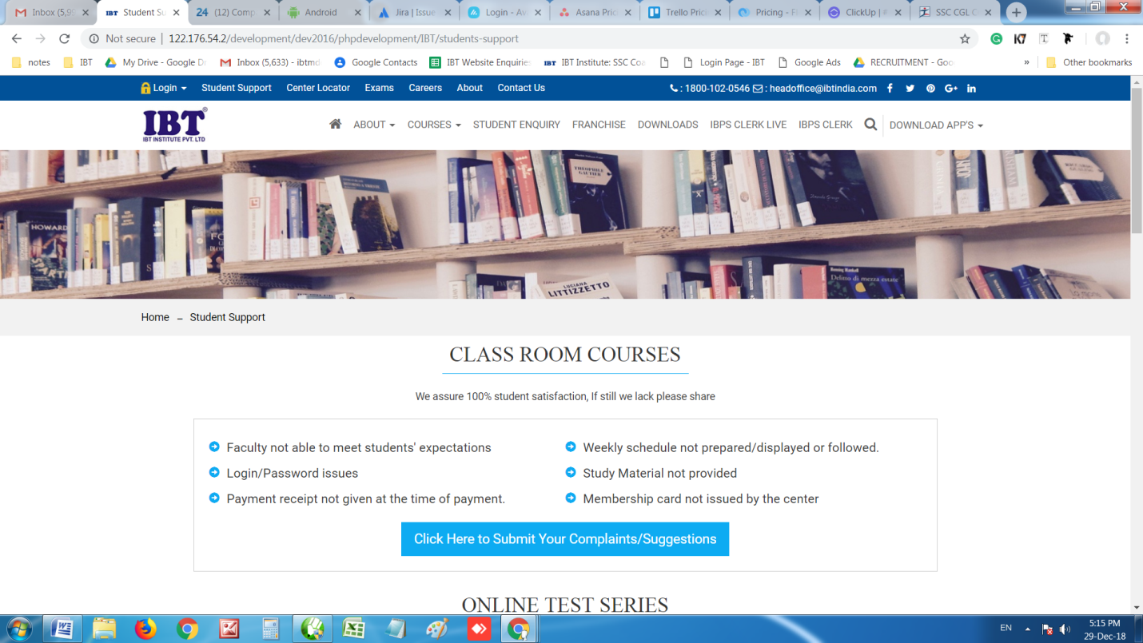
Change font style to roboto on full page

Use submit buttom theme for box as shown below. URL : http://122.176.54.2/development/dev2016/phpdevelopment/IBT/contactus

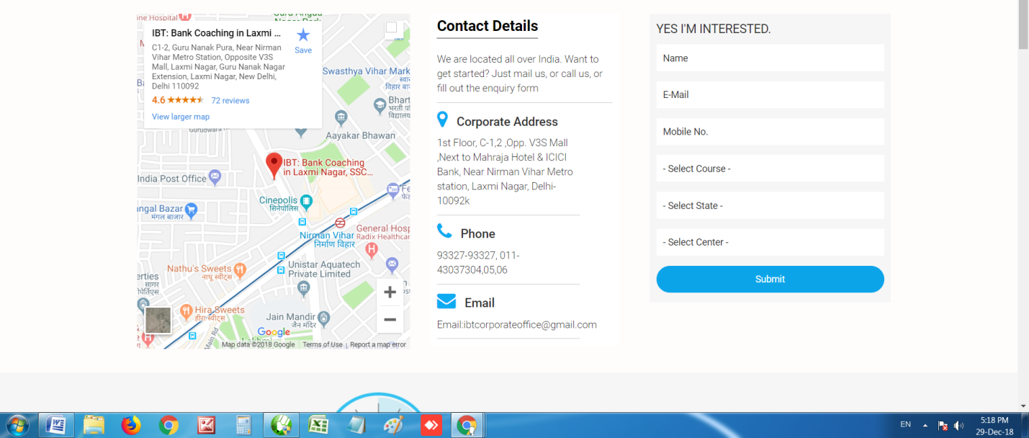

Online Test Series
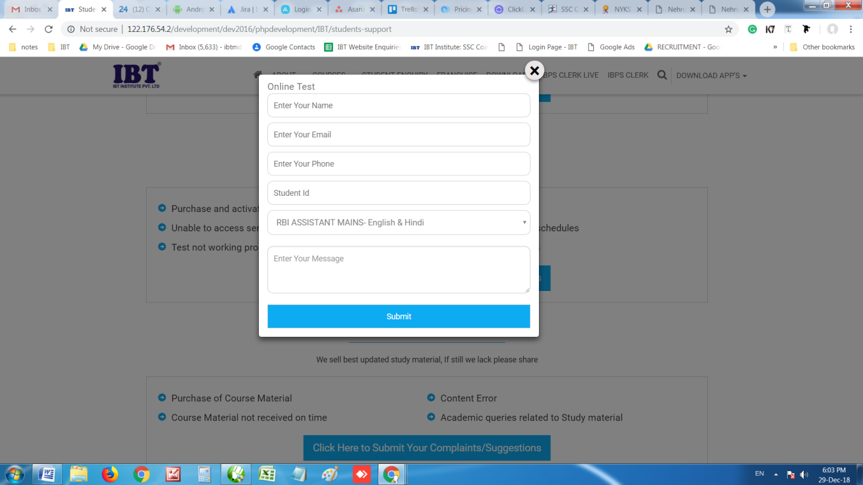
Remove list and put “Test Series Name”. Student has to type himself

Course Material

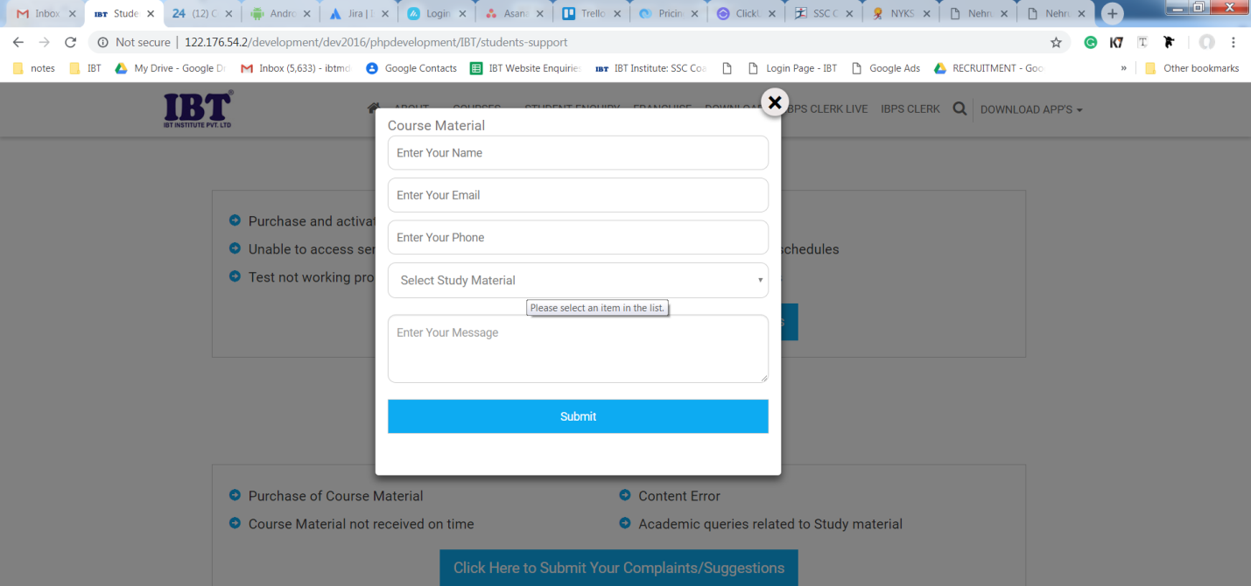
Remove list and put “Course Material Name”. Student has to type himself
Correspondence Course
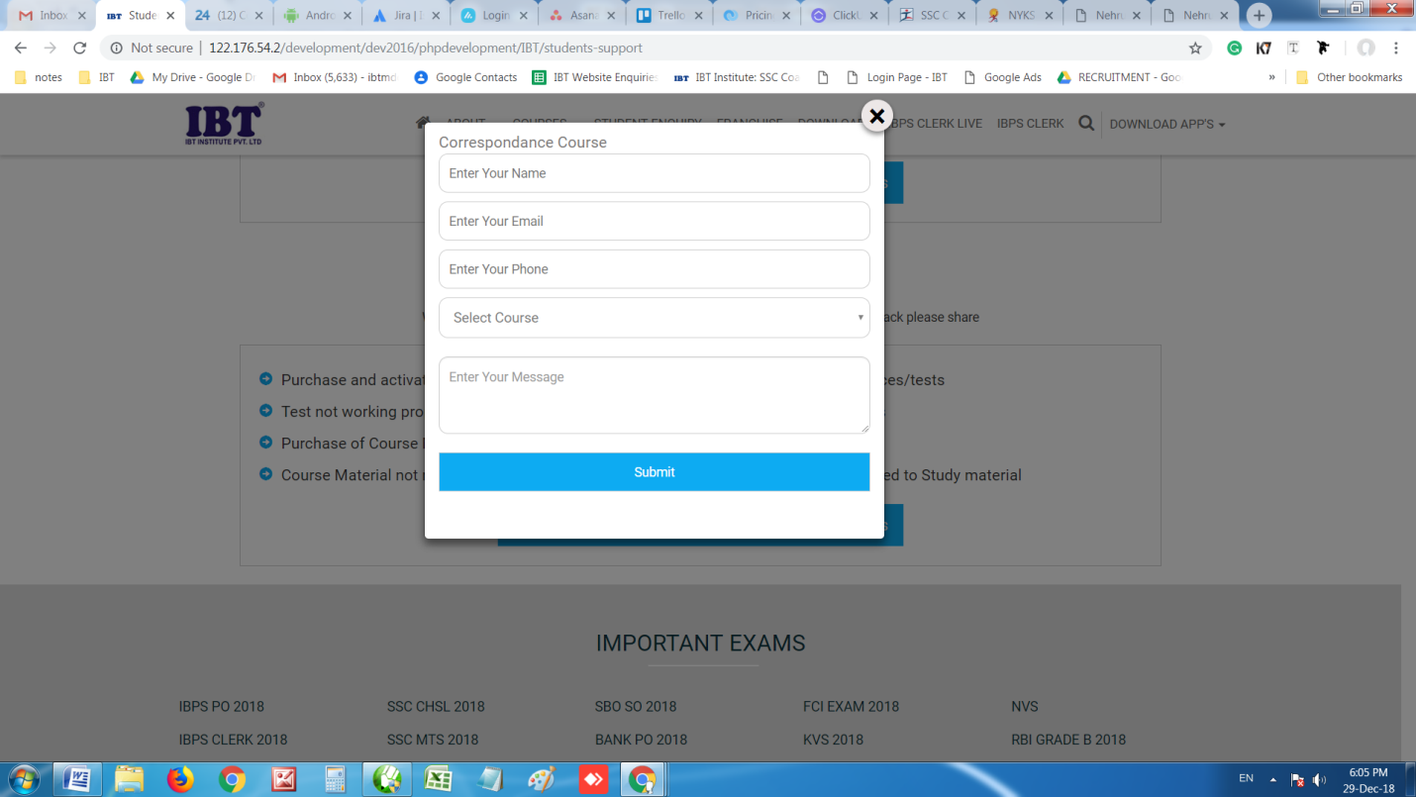
Remove list and put “Correspondence Course Name”. Student has to type himself

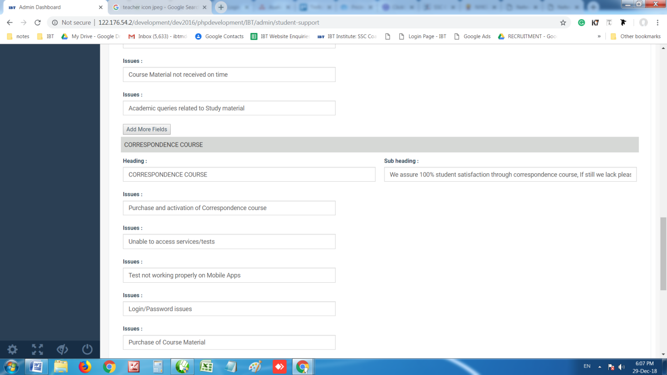
Give an option to add new Head.

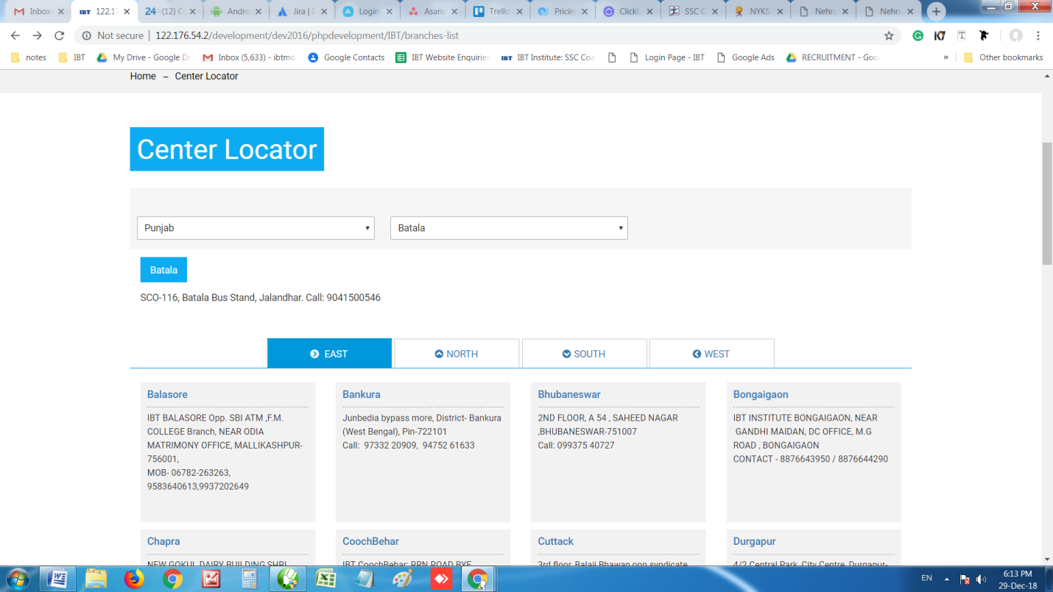
Call action is not working
Put State name after center name this way “Balasore - Punjab”
Make it this way
Reduce Font & Box Size

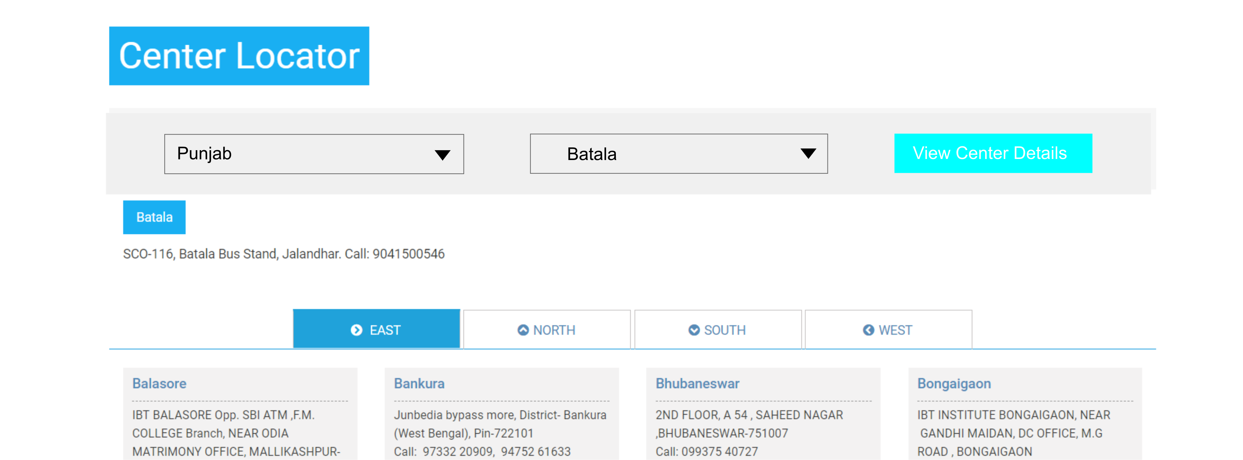
Put text in box “View Center Details” and link it to URL

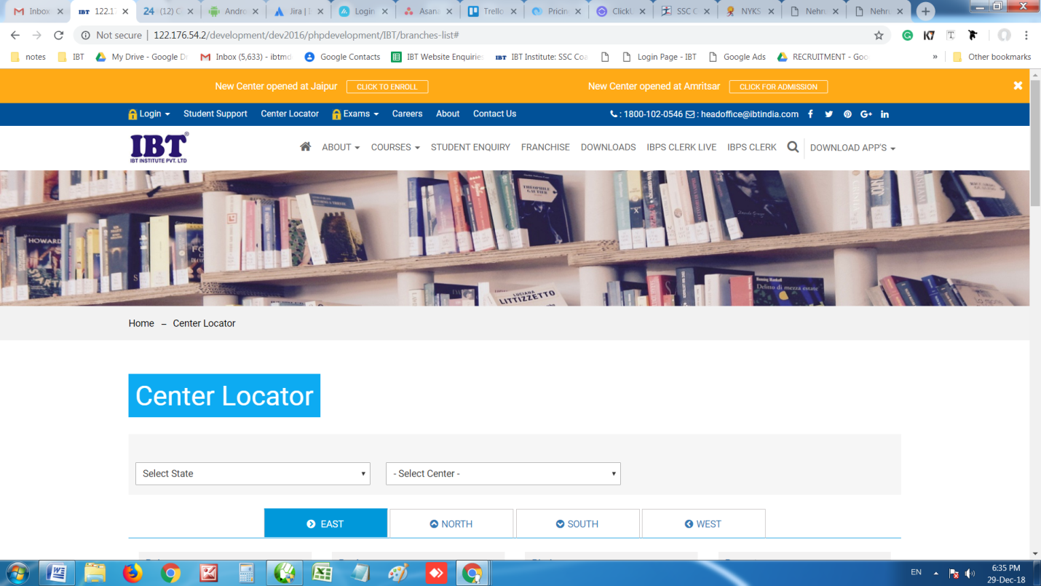
Whenever we are adding any subcategory its coming with lock icon. Do remove it
There is no option to add/ Remove banner

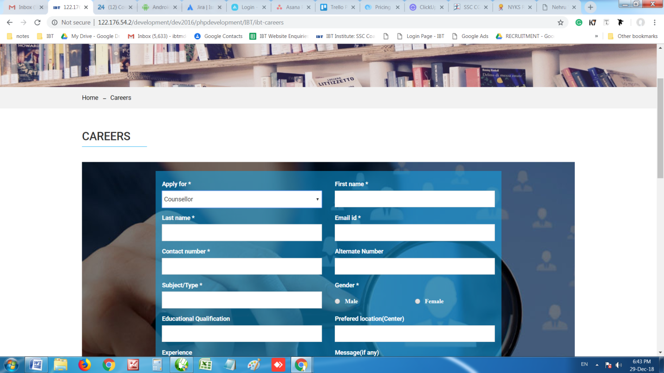
Backend is required as we need to add catagories”Apply for”.
Do send an email at ibthrd@gmail.com for every resume upload or page submitted
Do give resume and submitted form list in admin

Make the frontend same as of ibtindia previous site. URL : https://www.ibtindia.com/ibt-careers

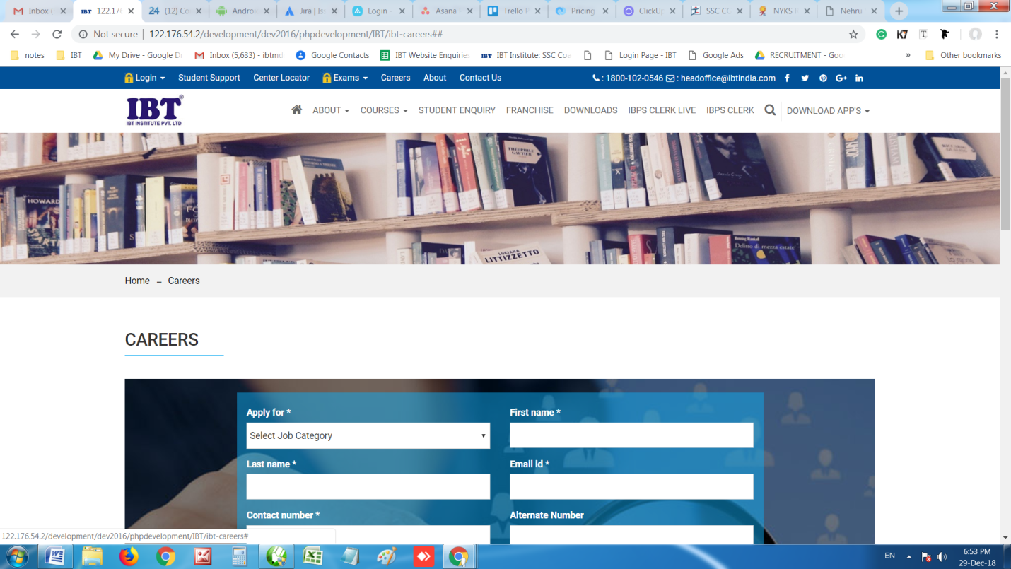
Call action and mail action not working
There is no option to manage banners for these pages

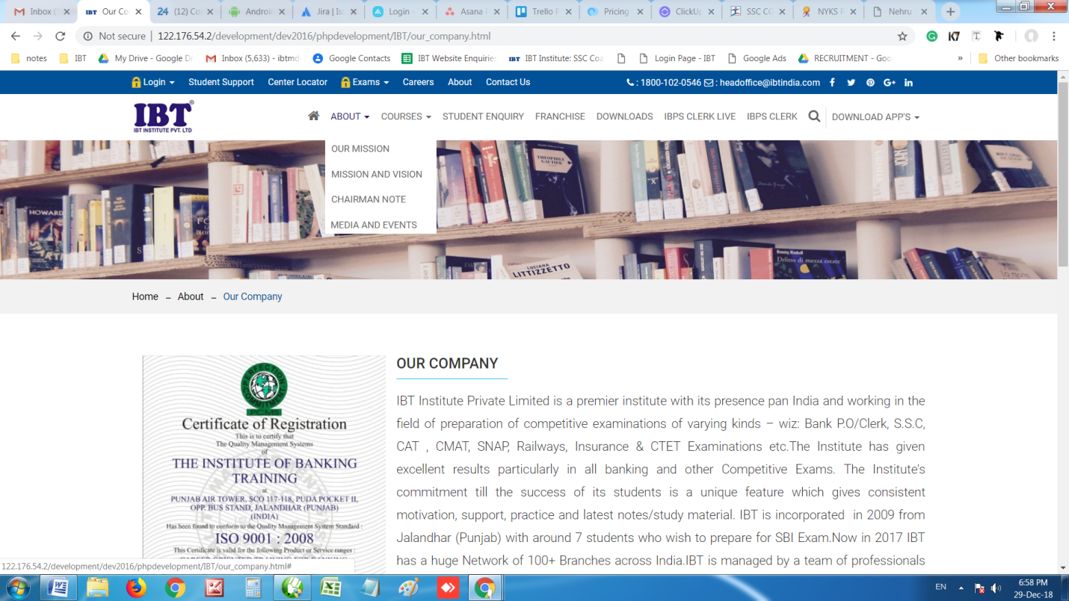

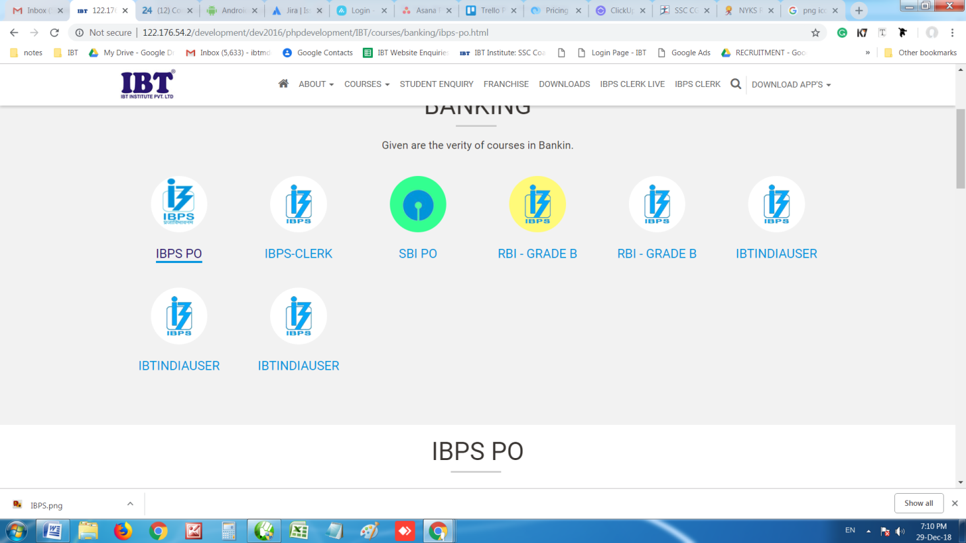
Make the font color black by default

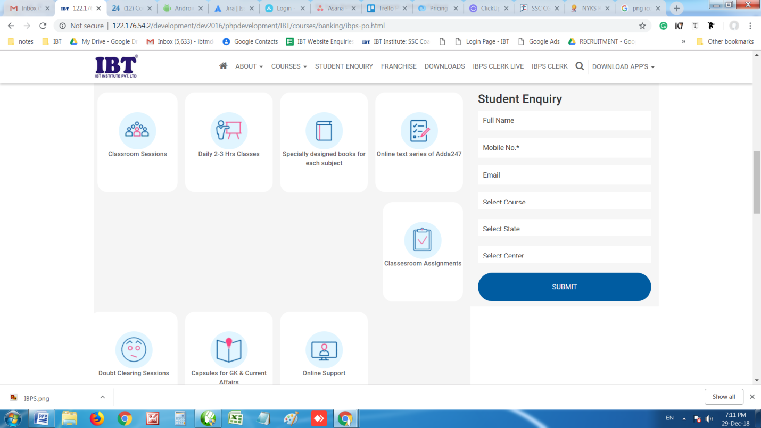
Alignment not proper

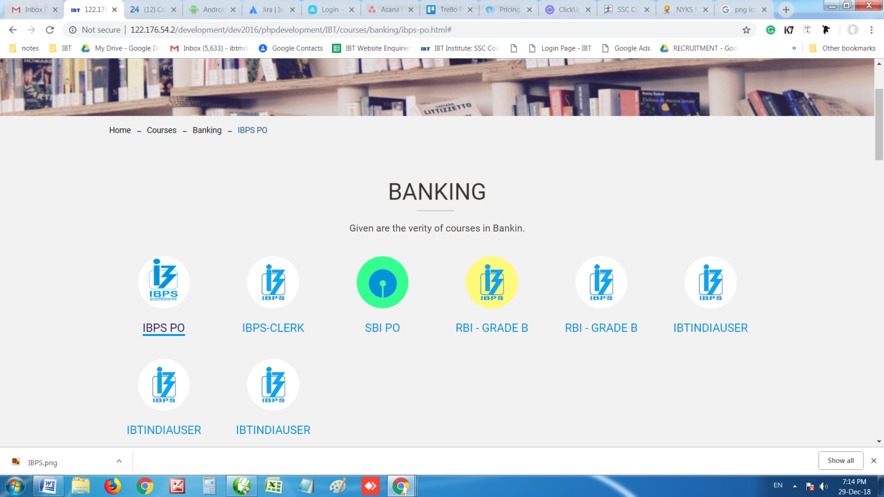
Reduce Space
Reduce Font size

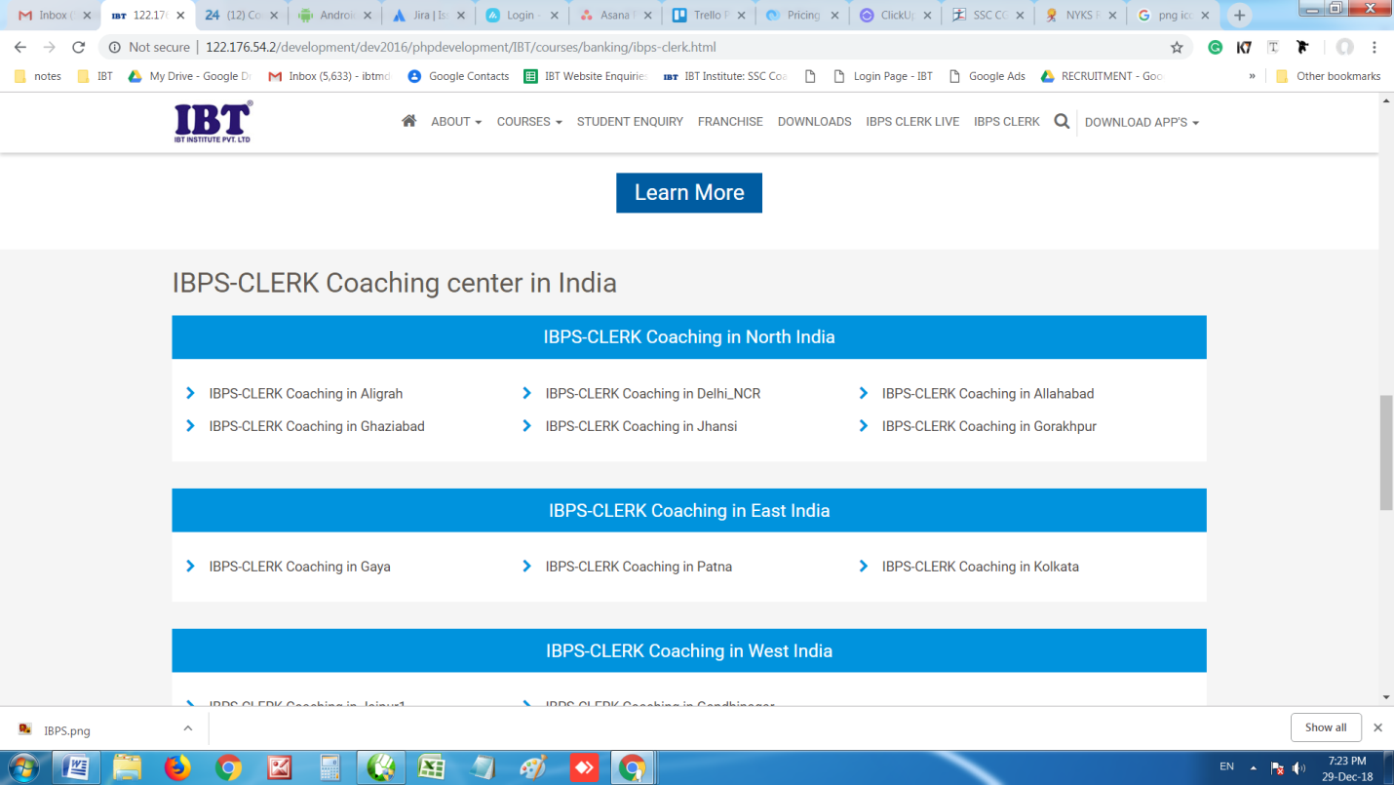
There is no option to manage these links
Round the edges of box and reduce box and font size
There is no option to put URL for landing page

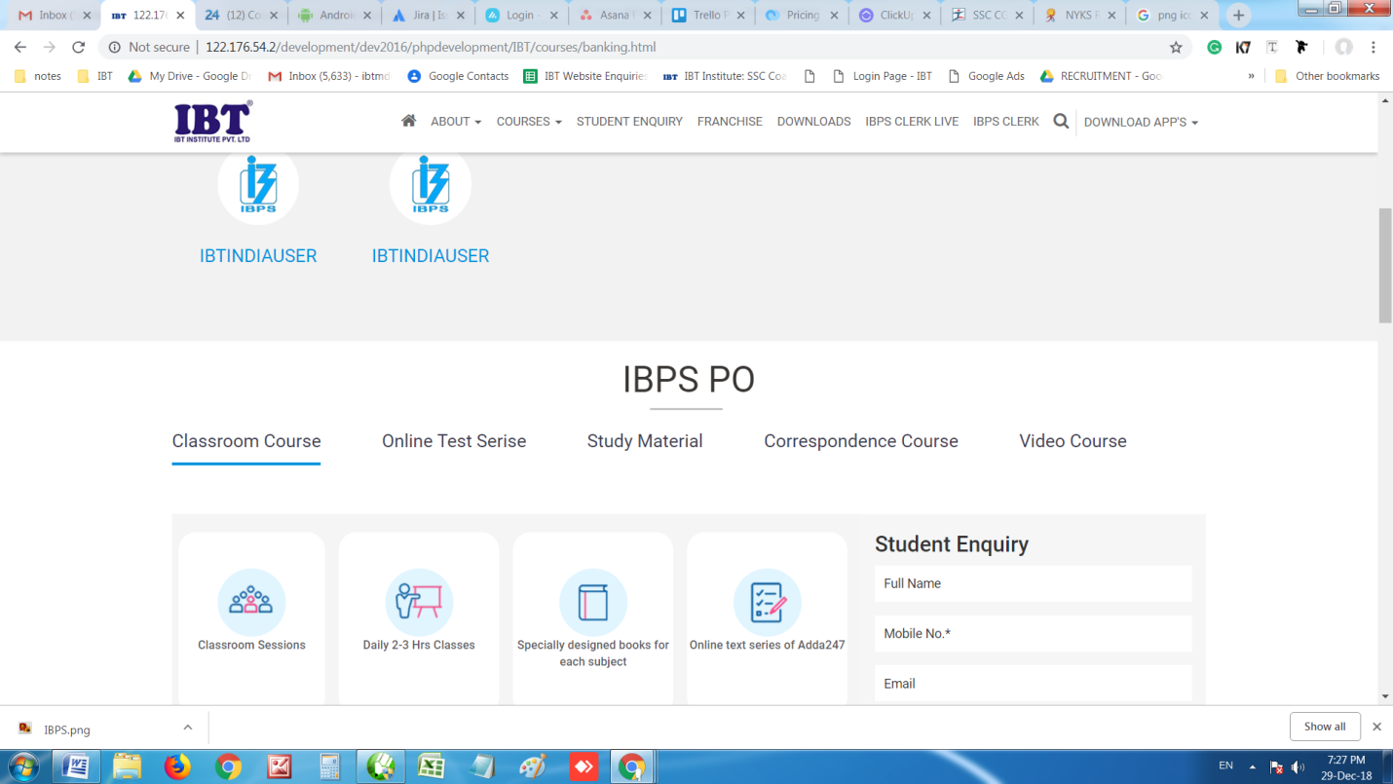
Reduce Font size by 1 point

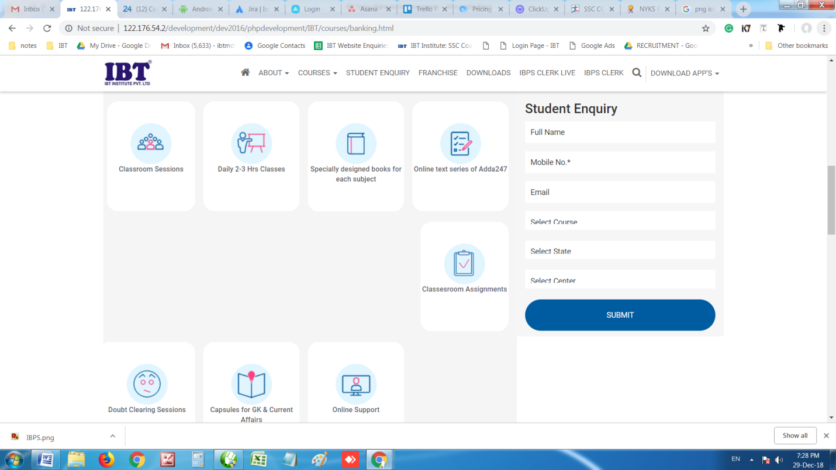
Matter is cutting

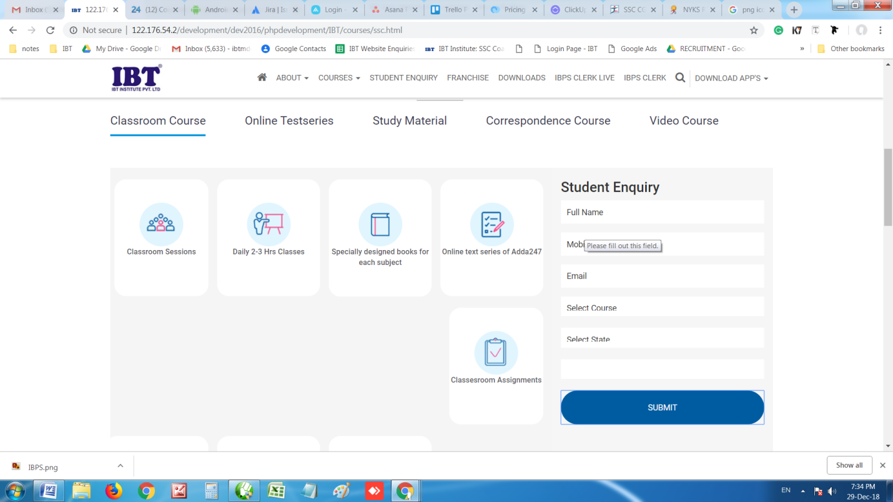
No message is coming once enquiry is submitted. Kindly show given message.
“Thanks for submitting an enquiry. We will contact you shortly”
Put same success template

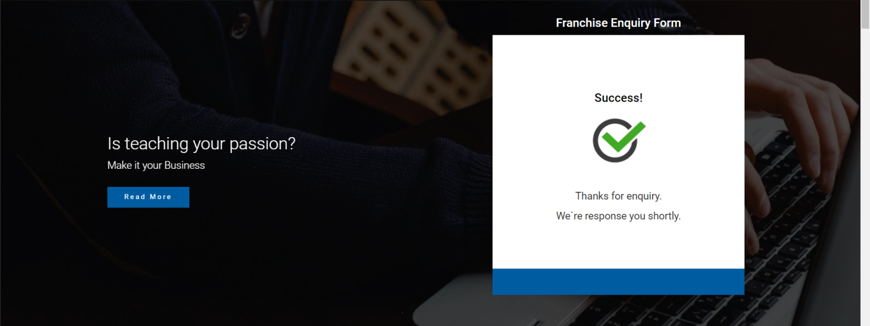
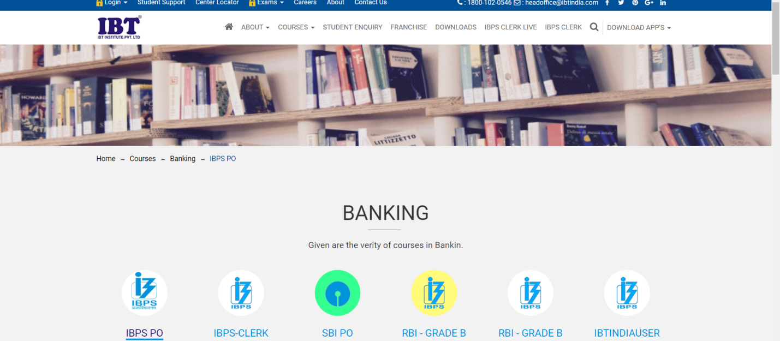
Make home banner size same as of home page

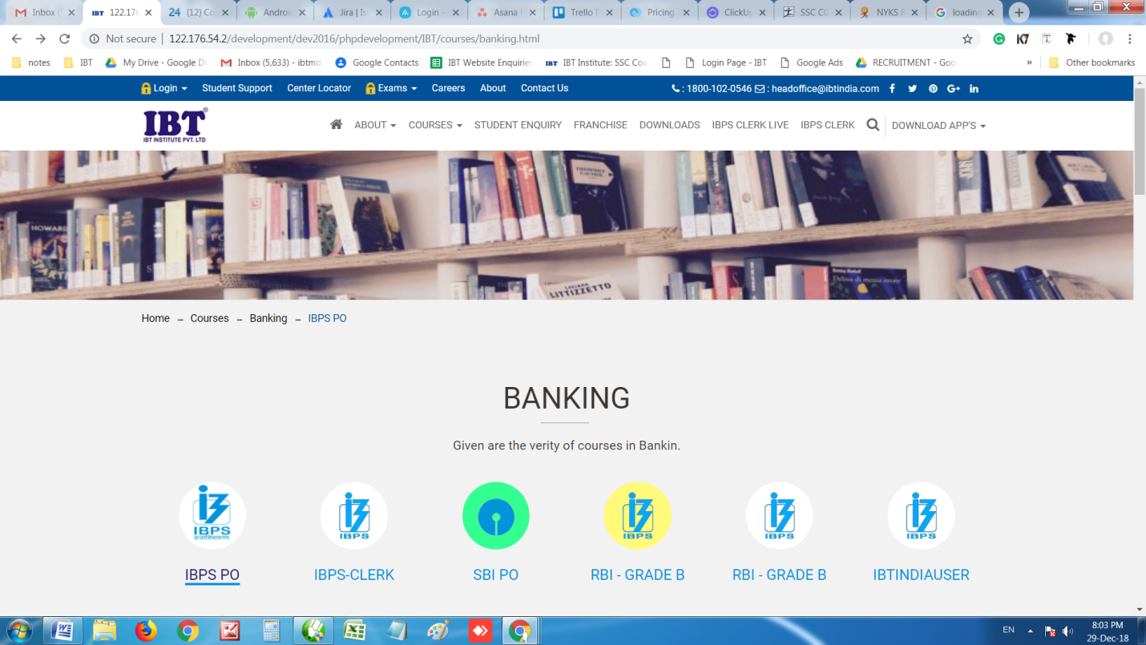
URL’s not working. I am directed no where once click on it

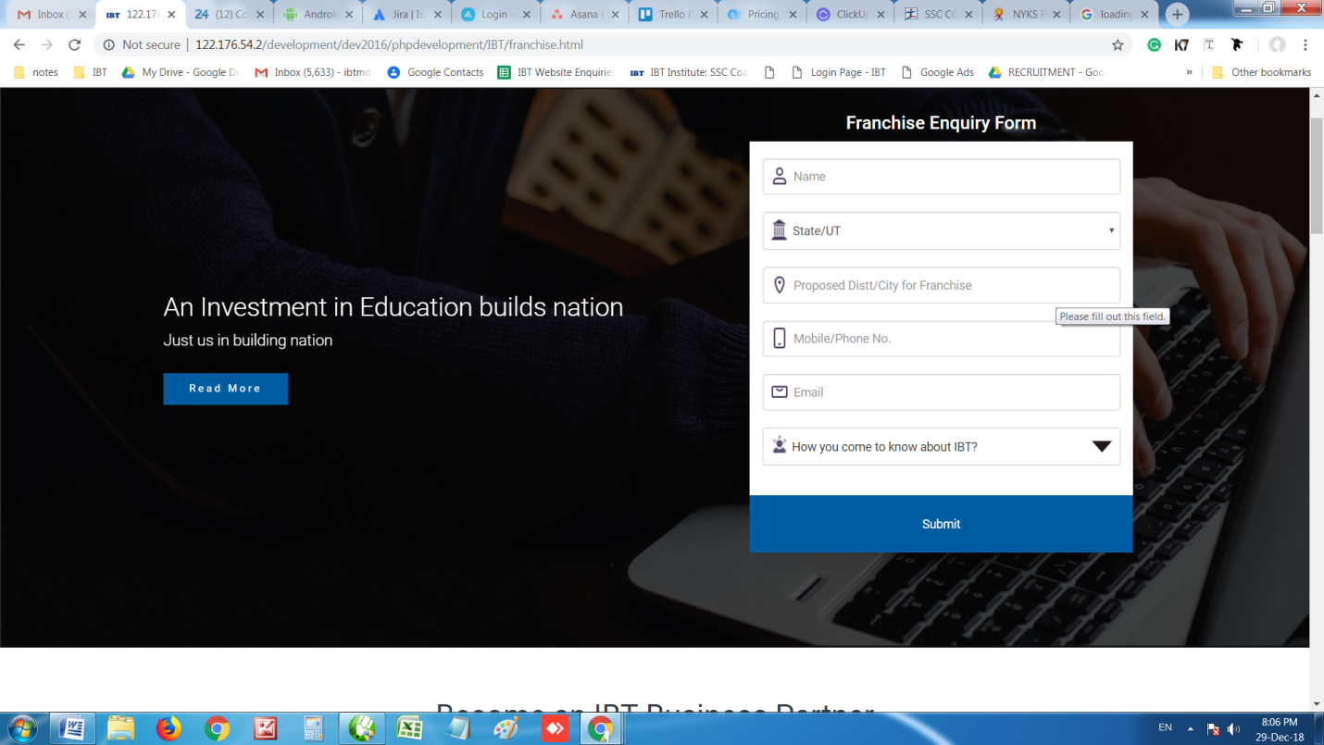
Make it left aligned

Increase size

Reduce size

Put space between matter and box

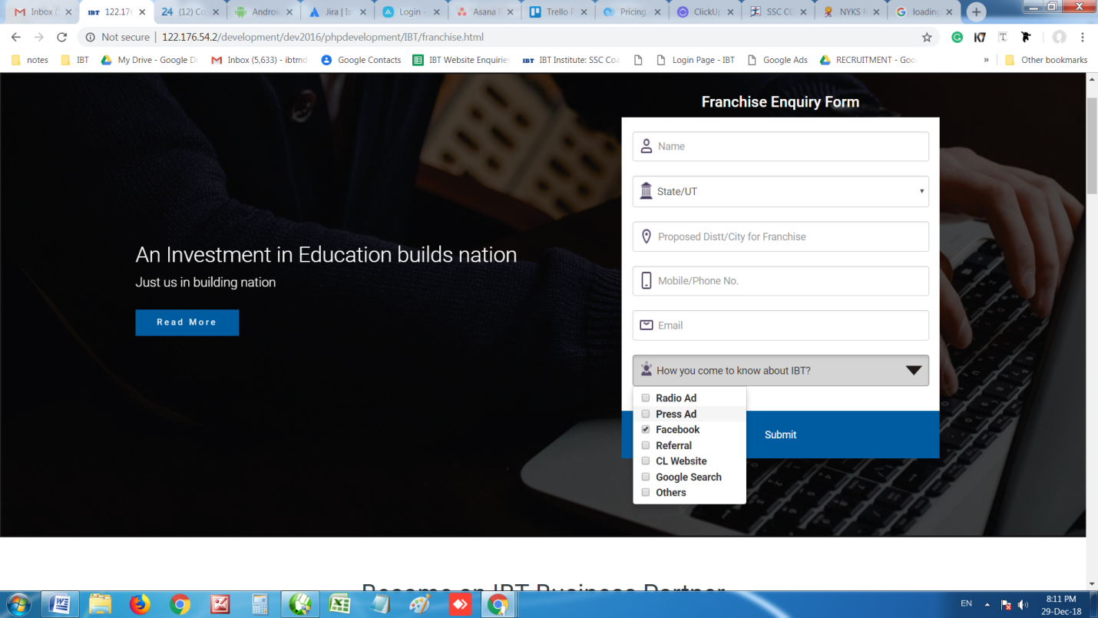
Give single selection at once time and show the selection in box once selected

All fields are compulsory

Increase space

Accept only valid email id

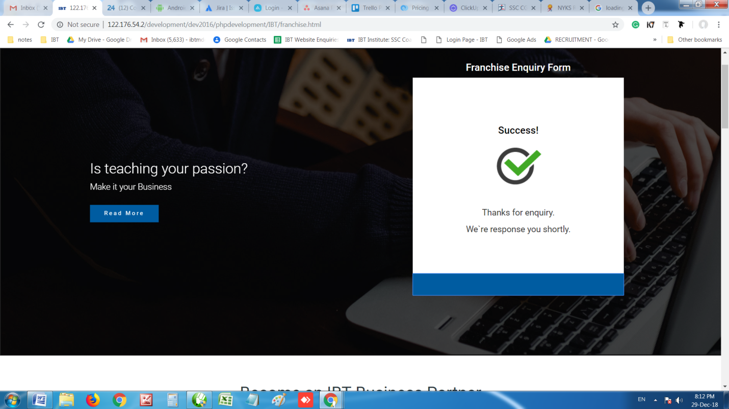
Change text
“Thanks for submitting a franchise enquiry. Our team will contact you shortly.

Send sms to someone who is filling enquiry.
“Thanks for filling franchise enquiry form. Our Team will contact you shortly – IBT Franchise Team”

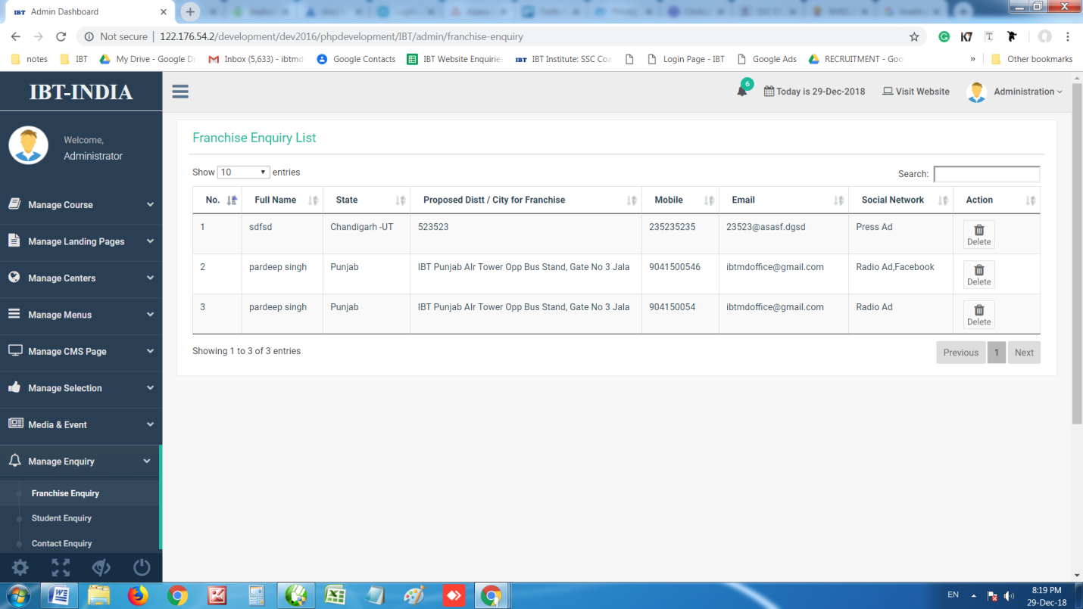
Date and time is missing

Send mail at ibtenquiry@gmail.com

Give download option as excel

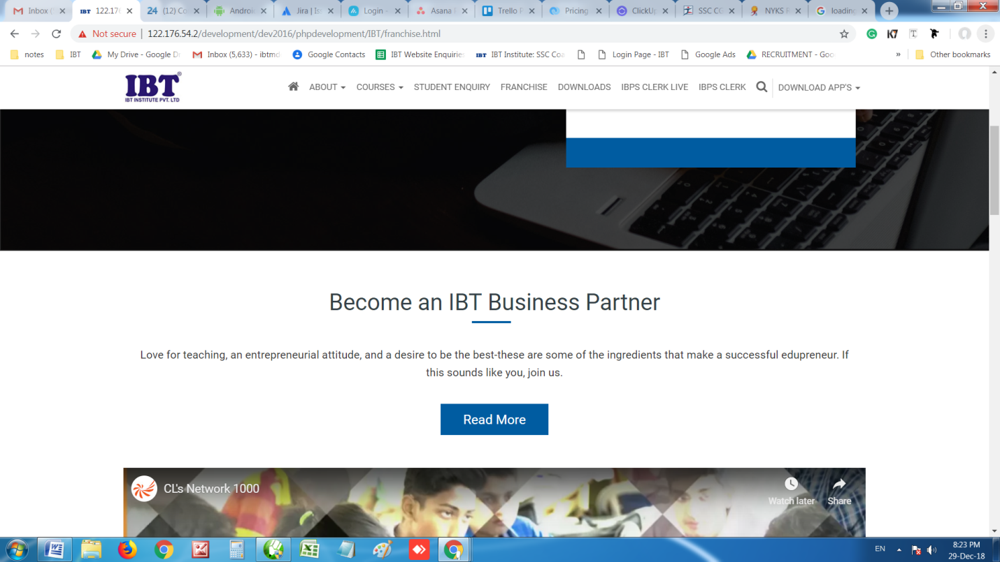
Reduce font size and make it same as shown below. Do the same for all headings in this page

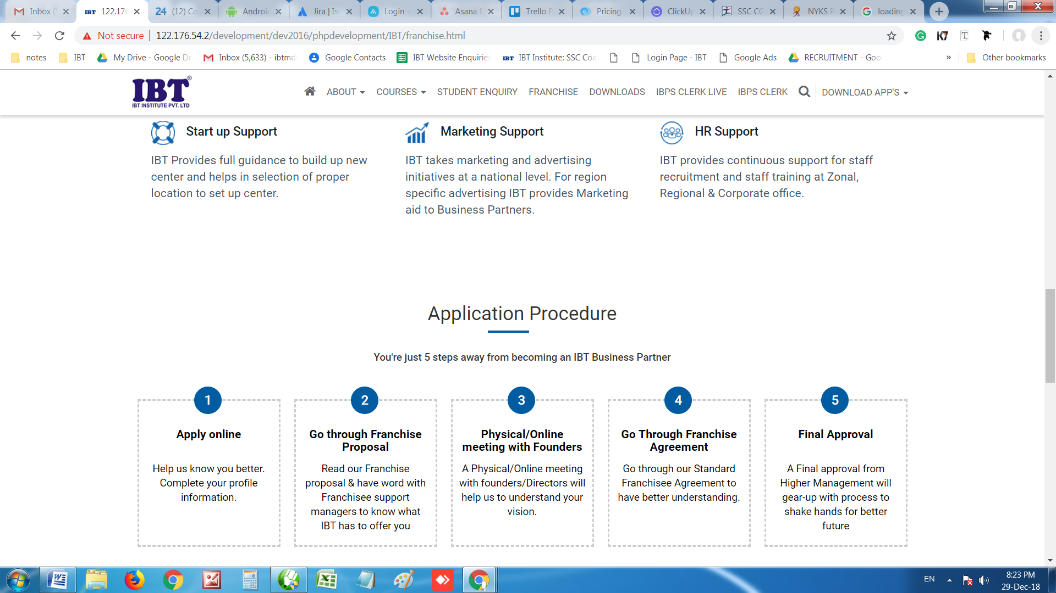
Reduce space

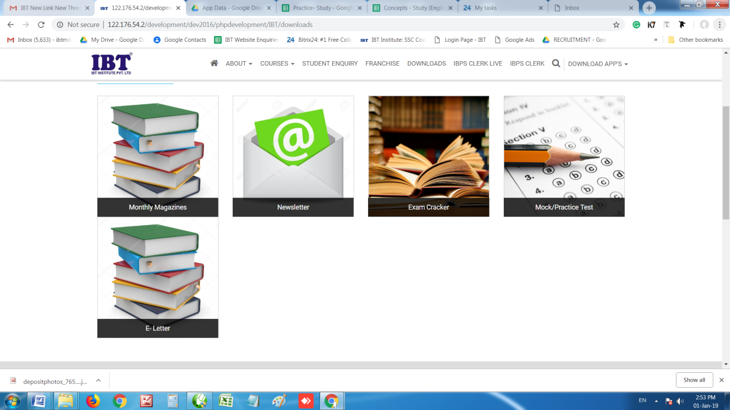
Maintain GAP
Use some animations by changing box color once cursor come

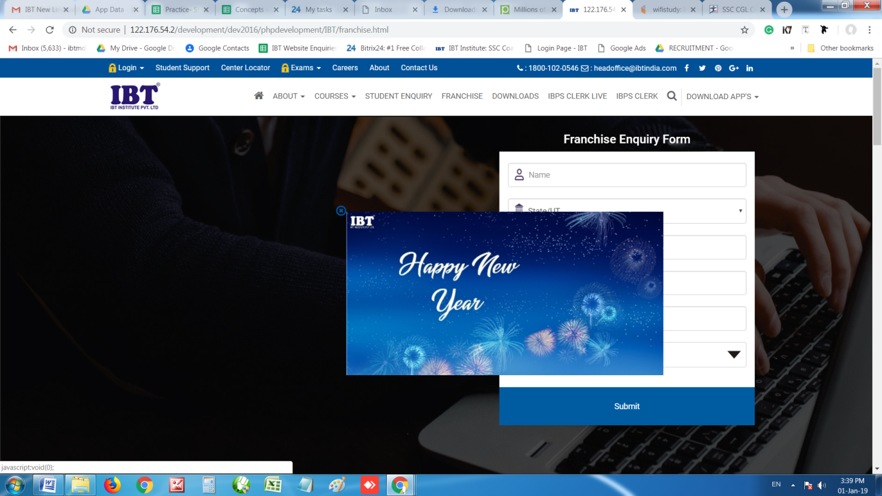
- Pop- up not in center
- Show cross in blue color by default and than change it to red color once cursor comes

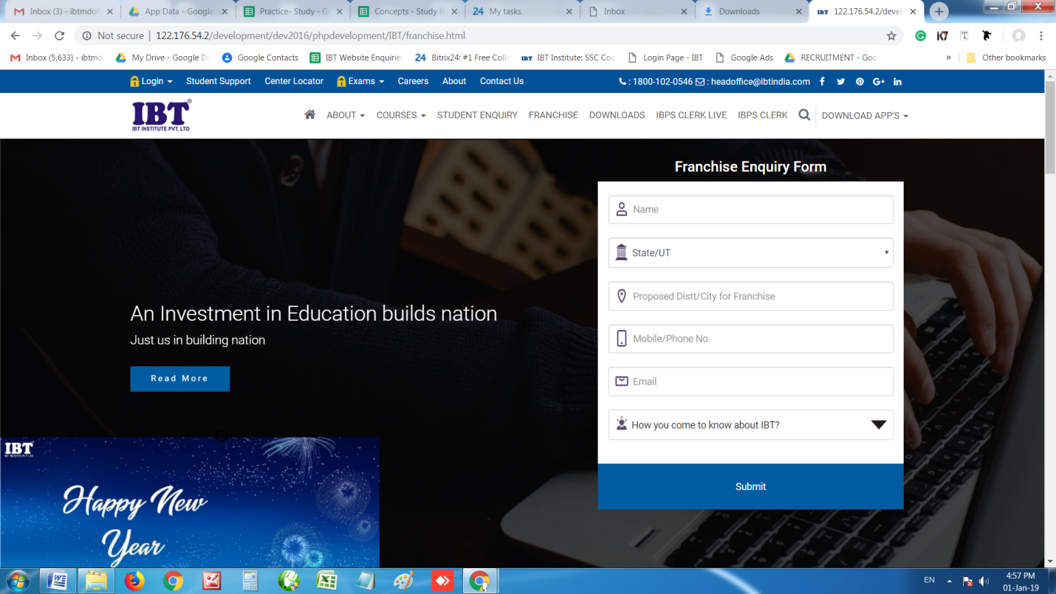
- Pop- up not in left and even not properly displayed. The same is the issue when we put it on right

- No option to manage URL. The same data is coming in Manage Pop-ups

Check this url why Data is not displaying-
http://ibtinstitute.com/ibtindia/ibt-ctet-coaching-chandigarh
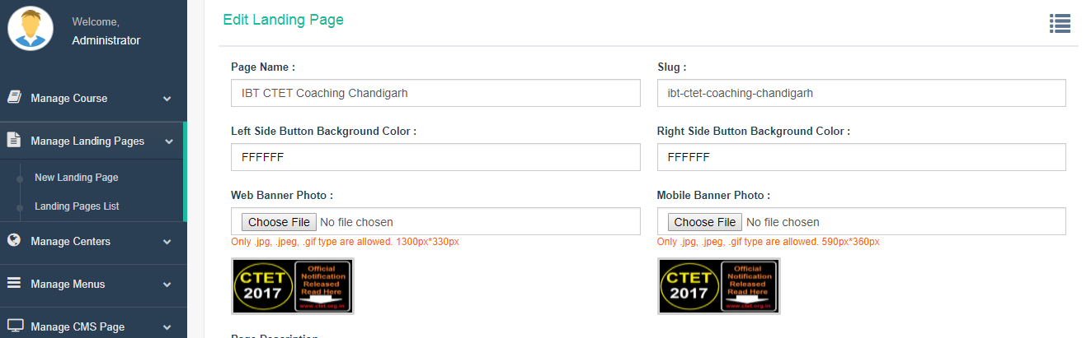

Table Data Display issue
I backend this is looking fine in display this not looking good!
