RESUME

KRISHNA BISWAS
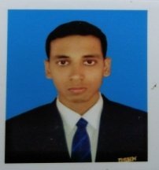
Add + Post- Raghunandanpur
Dist- Nadia, West Bengal (741503 )
Email :biswask993@gmail.com
Mobile no : +916297678532, 9735923941
Personal Details:
Father’s Name : Shankar Biswas
Languages : English,Hindi
Date of Birth : 23/01/1994
Religion : Hindu
Hobbies : Playing Cricket
Marital Status : Unmarried
Gender : Male
CAREER OBJECTIVE
The enhance my knowledge and capabilities by working in a dynamic organization that prides itself in gining substantial responsibility to new talent.
Educational Qualification
- Hotel Management From 3 years Degree Course From,Maulana AbulKalam Azad University Of Technology,West Bengal(2016)
- High school From West Bengal Board Of Secondary Education(2010)
- West Bengal Council Of Higher Secondary Education(2012)

Computer Skills
- Ms-Word, Ms-Excel, Ms Power Point, Internet Operating.System & basic Knowledge of Word, Microsoft Office ,Internet , Email , Windows , All Typing ,
WorkExperience
- 6months industrial training fromThe Big Boss HotelKolkata 2015.
- 1 year job from Khasiat Caterers Mumbai 01/08/2016-30/09/2017.
- 6 months working from Tuli Imperial Hotel Nagpur 20/01/2018-01/07/2018.
- 1 year working fromSayaji Hotel Ltd Bhopal10/08/2018-16/06/2019.

