PRIYANKA KUMARI

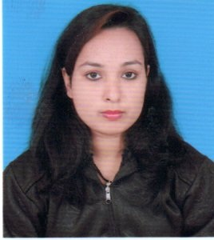

D/O- DHANANJAY KUMAR MISHRA
ADD- Bye Pass Road Daltonganj
Near Rampur Palace, planed –D Abadganj
Dist – Palamu, Pin-822101.
State – Jharkhand, INDIA .
Mobile :- 6206818041, 7858901701
E-mail :- priyankatiwary0206@gmail.com , priyankamishra050197@gmail.com
Objective

- To work in a challenging environment that builds up confidence and invokes my creativity to utilize the best of my abilities and also to gain leadership qualities in order to contribute my best efforts towards growth and welfare of the organization.
Area of Interest

- Computer, Learning New Skills etc …..
Academic Details

COURSES | COLLEGE / SCHOOL | YEAR | % (MARKS )
B.TECH ( C.S.E) | D.A.V.I.E.T COLLEGE DALTONGANJ | 2016-2020 | 73 %
DIPLOMA ( C.S.E ) | G.W.P BOKARO | 2012-2015 | 68 %
10 th | GYAN MANDIR (J.A.C ) | 2011 | 78 %
Computer Knowledge / Experiences

- Yes ( MS WORD , BASIC EXCEL )
- PROGRAMING LANGUAGE- HTML , CSS , etc
- 2016 -2019:- K.K MERMORIAL SCHOOL DALTONGANJ
Desig. Computer Teacher & official work .

- 2019- 2021:- ANANAD MAHINDRA WORKSHOP DALTONGANJ
Desig. Relationship Manager

- 2021 – 2022:- TRUVISORY KODE-CORE PVT. LTD. RANCHI .
Desig. Customer Support Executive .

- 2022 - 2023:- WEB- PULSE SOLUTION PVT. LTD RANCHI
Desig. Business Development Executive

- FROM JAN2023 ROHIT SECURITY PVT. LTD RANCHI
Desig. Front Office Executive

Personal details

- Date of birth : 5th Jan 1997
- Gender : Female
- Father’s Name : Dhananjay Kumar Mishra
- Nationality : Indian
- Marital Status : Married (2022)
- Languages Known : Hindi, English
- Hobby : Listening Music, Playing Games etc.

Declaration affiliated to

I hereby declare that all statements above mentioned given are true and correct to the best of my knowledge and belief. I hope you will consider my C.V and my ability.

If given a chance to prove myself, I assure you that my all entreasure would go to word the benefit and betterment of the organization.

Date:

Place:

(Signature)

