M
MANTHAN JOSHI
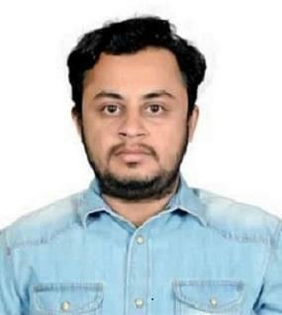

Barmer, Rajasthan

manthanjoshijaipur@gmail.com

8279257690

Willing to give the best out of me. My style of teaching and my approaches will definitely help the students to learn concepts of all topics.

WORK EXPERIENCE

TEACHER OF MATHS

I taught many of students from class 6th to 10th. I also taught my juniors aspirants of ssc and banking.

I have cleared SBI JUNIOR ASSOCIATE preliminary examination 2 times.

I can teach maths and reasoning to ssc , railway and banking aspirants.

Recently I started teaching on youtube. I am attaching the link of my work as a demo.

- percentage demo (full lecture )
- percentage 1
- percentage 2

EDUCATION

10th- 2006 61% RBSE
12th- 2008 61% science mathematics
RBSE

BTech 69%
College- BMIT Jaipur
University- Rajasthan Technical University, Kota.
Branch - Electronics and communications Engineering.

Industrial experience- Industrial Trainee in cairn energy pvt ltd Barmer
In 2012. worked on CCTV camera plantation.

