. | 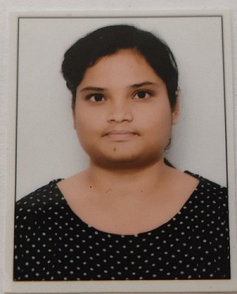  Contact  Skills  - Problem Solving Adaptability  - Team building and handling  - Strong Work Ethic  - Time Management  - Critical Thinking  - Handling Pressure  - Leadership  Interests  - Exploring New places  - Astrology  - Food Lover  Languages  English, Hindi, Punjabi,Dogri  I quit my job to prepare for banking exams. It’s been 3 years since I am preparing for bank exams. I am good at reasoning and quant. I know how to attempt max. questions in limited time. I have cleared 3 IBPS PO pre, 3 SBI clerk pre, FCI grade 3 exams and Qualified in ESIC UDC 2022. I have attached the available results of the mentioned exams. Please go through it.  NIHARIKA RAI |  |  | CAREER OBJECTIVE  To gain employment with an organization that offers me a consistently positive atmosphere to learn and implement new technologies for the betterment of the organization, use my skills in the best possible way for achieving the organization’s goals and solve problems in an effective as well as in creative manner in a challenging position.  PROFESSIONAL QUALIFICATION  - B.Tech in CSE from SHAHEED BAHGAT SINGH STATE TECHNICAL CAMPUS, FEROZPUR, PUNJAB.  EDUCATIONAL QUALIFICATION  EXPERIENCE  6 Months experience as a CRO in Rana Motors (authorized dealer of hero motors).  4 Months experience as a CRO in Karan Motors (authorized dealer of force motors).  1 year experience as a CCE in Tata Business Support Service.
  NIHARIKA RAI
   | H no.301,Lane no.6, Friends Avenue, Majitha Road AMRITSAR,INDIA
   | 8284964199
   | Niharikarai93@gmail.com
  COURSE | YEAR | NAME OF INSTITUTE | BOARD | %AGE
  B.TECH | 2014 | SBSSTC,  Punjab | PTU | 66
  XII | 2010 | Govt. Senior Secondary School Jammu | JKBOSE | 50
  X | 2008 | Ankur Vidhyalya  Public High School,  Jammu | JKBOSE | 71
.
