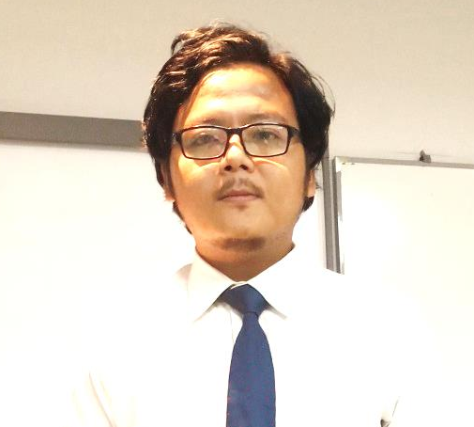
NABIN RAI – Sales & Marketing / BD
Address – Khaprail Bazzar,New champta fulbari Basti,Siliguri,Dist: Darjeeling
Siliguri – 734009 – India
Mobile: +91 7595973424
E-Mail: nabinr281@gmail.com
LinkedIn URL: https://www.linkedin.com/in/nabin-rai-16a91896/
Best time to call: 9am to 7pm

Personal Details:-
Gender: Male
Nationality: Indian
Marital Status: Married
Date of Birth: 7th June 1990

Business Development | Sales & Marketing Management | Inside sales | Key Account Management | Brand Promotion | Client Relationship Management | Team Lead

Seeking a challenging position with an organization where demonstrated skills in sales & marketing, business development, brand management & operations management can be used to increase profitability & promote growth for the company

PROFESSIONAL SUMMARY

Professional Summary: Result driven and dedicated professional with more than 9 years of rich experience in Sales & Marketing, Business Development, and Team Leader in Education industries. Being sales & business professional I am expertise in all core business functions with prominence on Sales & Marketing/Revenue Generation /Business Development, Project Management, Innovation & Business Excellence, Team Building and Productivity / Performance Improvement.
- Conversant with implementing various sales strategy to maximize revenue
- Skillful in implementing strategic plans for operations aligned with business strategies, thereby achieving corporate goals and set targets
- Efficient in developing and nurturing business relationships for attaining maximum sales potential
- Focused on establishing excellent productive client relationships, working to identify their needs, quickly resolve issues and to assure their business needs are met
- Ability in implementing competitive strategies for generating sales and increasing revenue towards achievement of turnover & bottom line targets

KEY RESPONSIBILITY AREAS
- Responsible for achieving the sales targets of assigned leads through Inside sales. Identification of new customers, Build and maintain relationships with students and parents and key customer associates.
- Developing a marketing and sales team to implement strategy & delivering on objectives. Design, implement & facilitate an effective sales and marketing strategy. Carrying out effective research & intelligence into competitor product & other trends.
- Understand end customer requirements and provide inputs to the product development team. Provide market intelligence and information to the product development and core team for better up-gradation of the existing products
- Define, track and improve key sales metrics and monitor those metrics. Collate & analyze daily/weekly/monthly data for maximizing revenue by calling students and parents.
- Maintaining CRM for data management and better updation of sales funnel and working on target to close them.

Personal Attributes: Leadership and strong people management skills with cross-functional exposure gained from working in key roles as Branding & Promotion (Sales), Public relations/Business Development, Sales Officer, exhibiting the capability in setting up new markets, channels, building & maintaining healthy business relations with key stakeholders, and accomplishing business and financial objectives

SKILL SET

- Sales & Marketing  - Business Development  - Revenue Generation  - Customer Relationship  - Branding & Promotions | - Sales Estimates & Planning  - Planning & Administration  - Operations  - Customer Service  - Team Leadership

Functional

Technical
- Operating Systems: Windows.
- Applications: Microsoft PowerPoint, Microsoft Word, Microsoft Excel, Basics

LANGUAGE SKILLS
- Proficient in English, Hindi, Bengali, Nepali.

EDUCATION
- Masters of Business Administration (Marketing) from Bengal Institute of Business Studies, Kolkata, India (2015)
- Bachelor of Commerce from BNS College, Bhilai, India (2012)

CAREER CONTOUR

DESIGNATION | EMPLOYER | DURATION
Dual Touch Point Mentor (UPSC) | Unacademy | April 2022 - April 2023
Sr. Business Development Executive | Unacademy | Nov 2020 - March 2022
Business Development Officer(Sales) | TIME Institute | June 2018 – Nov 2020
Sr. Sales & Marketing Executive. | Aakash Institute | Oct 2014 – May 2018
Sales Executive (Retail) | Madura Fashion & Lifestyle(Peter England) | April 2014- September 2014

NOTABLE ACCOMPLISHMENTS

- PERFORMANCE AWARD 2017 for best performance in the region (Aakash Institute)
- Promoted from Co-ordinator (sales) to Sr. co-ordinater (sales) -Aakash Institute
- Invited 260 student in Aqua Regia (Science Quiz) from different school – TIME Institute
- Becoming UPSC Mentor in unacademy from Sr. BDE post.

