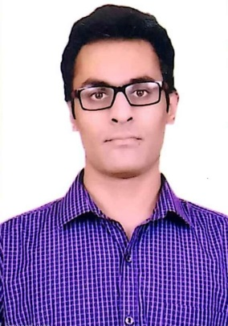
SKILLS:
- Auto CAD
- MS Word
- MS PowerPoint
- C, C++ Programming
- Team Player
- Confident
- Eye For Detail
- Quick learner
- Punctual
- Good Communication Skill.
- Good Mathematical Skills
LANGUAGES:
English and Hindi

Professional Summary:
Good decision- making individual with civil engineering skills. Coming with the ability to ensure that projects are done according to the plan through steady evaluation of the project design to avoid complication or deviation.

Training Projects:
- Underwent 45days training with NIIL Infrastructure in AGRA, Project was to study the “Analysis Of Foundation and Super Structure”, where I have learned about:-
- Laying of foundation.
- Leveling

- Underwent 35days training with Anant Estate in AGRA, Project was to study the “Analysis Of Super Structure”, where I have learned :-
- To read Drawings.

3. Final Year B.Tech Project- Design and Estimation of a 3BHK Residential Floor.

Extra-Curricular Pursuits:

- Worked as Coordinator(Sponsorship) in College fest
- Presented a project on Permeable Concrete on Innovation day 2015.

Academic Qualifications:
- B.Tech.(Civil Engineering)- Hindustan College of Science and Technology, APJAKTU, Mathura(2017)

- XII (PCM)- St. Mary,s Senior Secondary School, Banda, UP (2013)

- X (Sc., S.Sc., Maths, Hindi, English,Computer)- La Martiniere College, Lucknow,(2011)

Declaration:
I hereby declare that all the information furnished above is true and genuine to the best of my knowledge.

PHONE: 8737-8598-50
ADDRESS: Agarwal Nursing Home, Aliganj, Banda-210001
LINK: http://linkedin.com/in/manas-agarwal-3a11a9114
EMAIL: agarwalmanas31@gmail.com

