Address: 53, Raja Road, Sukchar  Behind Subhadrishti Marriage Hall  Kolkata – 700115  Phone No: 8910288560 / 7278651610  Email Id: payelsaha5@yahoo.in | 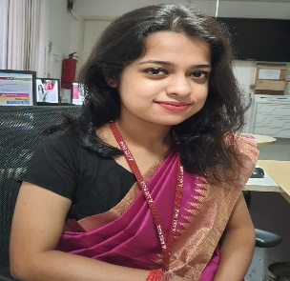
PAYEL SAHA
Objective |  | Assistant Manager at Axis Bank Ltd with a good team work , collaboration and communication skills is looking for a rewarding opportunity as a faculty member where I can utilize my skills and knowledge efficiently to engage all learners and to also foster a fun and fascinating learning environment.
Skills, ABILITY & EXPERIENCE |  | - 2016-2017: Completed my Industrial Training in Food Production, F&B Service, Housekeeping and Front Office from ITC SONAR.  - 2018: Worked in La Cuchina, an authentic Italian Restaurant in Hyatt Regency.  - 2019-Present: Currently working as an Assistant Manager in Axis Bank and dealing in Sales and Operations.
Education |  | St. xavier’s Institution  ICSE- 2013- 81.40%  ISC- 2015- 86.25%  B.SC in hotel and Hospitality Administration from ihM KOLKATA (NCHMCT)  75%  B.SC IN HOTEL AND HOSPITALITY ADMINISTRATION FROM IGNOU  76%  Post Graduation diploma in banking service from amity university  86%
Communication |  | I am well versed in English, Hindi and Bengali
QUALITIES |  | - CLASS MANAGEMENT  - COMMUNICATION  - CONFLICT MANAGEMENT  - LEADERSHIP  - RELATIONSHIP BUILDING  - STUDENT COUNSELLING

