- GENERAL
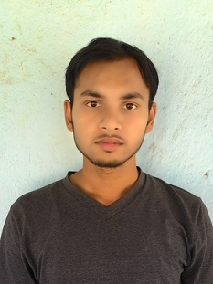
Affix
Photograph
  - Name: PRINCE KUMAR_________________________________________

Date of Birth: 1 0 0 2 1 9 9 4 DD/MM/YYYY

Father’s/Mother’s Name: TARKESWAR PRASAD

Height: 163 cms Weight: 55 kg
Power of Glasses L ___0___ R ___0____

Address for Correspondence: 10/1, BARABAGAN LANE , POST ALAMBAZAR, KOLKATA-700035

E-Mail Id: psonukumar95@gmail.com Cell No: 7278329080

Work Experience
- 2.5 years of experience as an RF engineer in Reliance Jio Infocomm Limited.

2. EDUCATIONAL QUALIFICATIONS
2.1 Secondary & Higher Secondary
Examination | Board / Institution | Year of Passing | Marks
Examination | Board / Institution | Year of Passing | Obtained | Out of (Total) | %
10th Std | CBSE | 2009 | 416 | 500 | 83.2
12th Std | CBSE | 2011 | 435 | 500 | 87
B.TECH | NIT DURGAPUR | 2016 | 8.01 | 10 | 75.01

3. SCHOLASTIC ACHIEVEMENTS
A) got participation certificate in under 16 and under 19 in cricket at cluster level
B) conference out from ssb 2011
C) Qualified NTSE.

4. ACADEMIC PROJECTS
A)Had done project on swarm robotics from IIT MANDI.

6. SKILLS AND CAPABILITIES
A) Capable of making people understand very easily
B) hardworking, can perform under pressure, can learn new things quickly
7. POSITIONS OF RESPONSIBILITY
A) was school team captain in under 16 cricket tournament.

8. EXTRA CURRICULARS
A) listening music
B)playing cricket

I hereby declare that the information given above is true and correct.
DATE: 01-02-2019 SIGNATURE: 