CURRICULUM-VITAE

PRASHANT KUMAR SHARMA

Email :- pkkvmzn@rediffmail.com, pkkvmzn@gmail.com

PH:- +919871629289, 7351378245

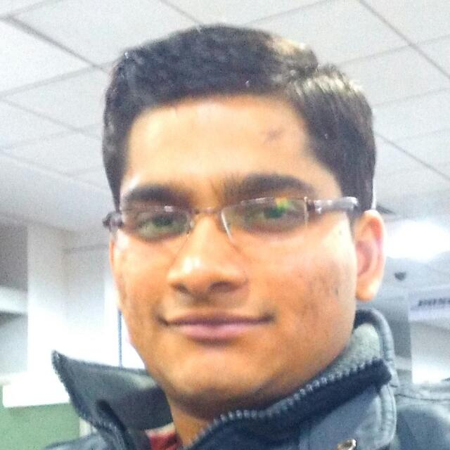

OBJECTIVE

Seeking a suitable responsible position in an organization that can provide me an opportunity to prove myself and polish my skills through challenging tasks.

ACADEMIC RECORD

Course | year | Institution | Board / University | % Obtained
B.Tech( E.&I.) | 2011-2015 | College Of Engineering Roorkee | UTU | 75.74*
Class XII | 2011 | Kendriya Vidyalaya, Muzaffarnagar | CBSE | 66.8
Class X | 2009 | Kendriya Vidyalaya, Muzaffarnagar | CBSE | 85
E.I. - Electronics and Instrumentation * - Honors

ACADEMIC PROJECT

The objective of this project was to design a simple and easy method to operate speed control unit for a D.C. motor. For speed controlling MY Team used PWM technique and for providing stability we designed PID controller in a software called LABVIEW. Interfacing to the driver circuit and feedback was provided with the help of NATIONAL INSTRUMENT DATA AQUISITION DEVICE called as myDAQ.
INDUSTRIAL EXPERIANCE

I have done Industrial training from SIGNAL AND TELECOM DEPARTMENT of DELHI METRO RAIL COPORATION (DMRC). The
training includes Telecommunication, Automatic fare collector and Information Technology used in DMRC. I studied all the
three with both practical and theoretical insight of the equipment used and usage.

WORK EXPERIENCE

.

- Currently Teaching Maths,English,Reasoning to Banking SSC and Railway students on freelancer basis.

- Worked as a Senior Analyst (Senior software engineer) at Capgemini Technology Services India Limited from march’17-nov’17.

- Worked as a System Engineer at Capgemini Technology Services India Limited from jan’16-feb‘17.

- Worked with Concentrix (IBM) daksh in its internal IT TEAM for APPLE (IOS devices) as an associate from jun’15-jan’16.
.

ACADEMIC ACHIEVEMENTS

- Secured 3rd POSITION in my batch of Engineering.
- Presented paper on 'AUTOMATION OF CELL TOWER GENERATOR USING PLC–SCADA in NATIONAL CONFERENCE OF EMERGING TRENDS IN ENGINEERING SCIENCE AND TECHNOLOGY.
- Secured 2nd position in BHARTIYA SANSKRITI GHYAN PARIKSHA - 2006 in S.D. public school.

SKILLS

- IT Skills –SCCM basics, windows troubleshooting.
- Technical Softwares: Express PCB, Mat-lab (basic), Labview (basic).
- Operating Systems: Windows, Macintosh, Android, Ubuntu 14.04lts.
- Other Softwares: Microsoft Outlook, Microsoft office, Active Directory (A.D.).
CULTURAL ACHIEVEMENTS

- Volunteer of the INTERNATIONAL NGO' THE KARUNA CLUB 'registered at Chennai.
- Volunteer of the NATIONWIDE CANCER CONTROL PROGRAMME IN 2009.
- Organised a CULTURAL FEST 'THE NON-VIOLENCE DAY' ON Gandhi Jayanti in College.
HOBBIES

HOBBIES

- Reading the poems.
- Playing badminton.

STRENGTH

- Optimist.
- Self-Motivated.

PERSONAL DETAILS

Father’s name : Mr. Fazal Ilahi Ansari
Date Of Birth : 10th Nov’1992
Gender : Male
Nationality : Indian
Languages known : English, Hindi, Arabic, Urdu

Father’s name : Mr. ANIL KUMAR SHARMA
Mother's name : Mrs. SAROJ DEVI
Date of Birth : 30/06/1994
Gender : Male
Nationality : Indian
Languages known : Hindi, English

DECLARATION

Father’s name : Mr. Fazal Ilahi Ansari
Date Of Birth : 10th Nov’1992
Gender : Male
Nationality : Indian
Languages known : English, Hindi, Arabic, Urdu

I hereby declare that information furnished by me is correct and I bear the responsibility for the correctness of above mentioned particulars.
Prashant Kumar Sharma SIGN:

