Resume

NAME – RANITA GHOSH
Mobile No. 8420693539

Career Objective:

I would like to reach on the boom point of CARRIER by learning and implementing my knowledge and potentiality and facing challenges in every phase of life with ROBUST OPTIMISM and to be recognized as a Good Human Being.

Educational & Technical Qualifications:
Name of Examination | Institute |  | Affiliate | Year of passing | Percentage Obtained
B.SC (HONS. IN ECONOMICS) | BIJOY KRISHNA GIRL’S COLLEGE, HOWRAH |  | UNIVERSITY OF CALCUTTA | 2012 | 48.25%
HIGHER SECONDERY |  | SHIBPUR BHABANI BALIKA VIDYALAYA | W.B.C.H.S.E | 2007 | 60.6%
SECONDERY |  | SHIBPUR BHABANI BALIKA VIDYALAYA | W.B.B.S.E | 2005 | 64.25%

Technical Skills: CERTIFICATE IN COMPUTER APPLICATION
Skill Category | Skill Name | Institute | Year of passing | Proficiency
HEADSTART | MS-OFFICE, INTERNATE,E-MAIL | CMC LTD. | 2013 | GRADE B

Skills: Quick adaptability and enjoy to learn new things

Experience: More than two years working in George School of Competitive Exams (GSCE) as a Back office staff. Working as a Content Developer cum Proofreader of General Studies, making Books, Study Materials and Mock tests of various exams, like WBCS, all other exams of WBPSC, SSC, RRB, IBPS, SBI etc. At present incharge of study material department, finalizing materials and mock tests. Also have knowledge of student counseling, making schedule for mock exams & conduct exams.

Personal Details:

DOB – 01/10/1989
Father’s Name- LATE BISWANATH GHOSH
Postal Address: 3/A/5B OLABIBI TALA LANE, P.O.- SANTRAGACHI, P.S.-CHATTERJEEHAT, DIST.-HOWRAH, STATE- WESTBENGAL, PIN- 711104.
Permanent Address: SAME AS ABOVE
Language Known: BENGALI, ENGLISH, HINDI
Hobby: READING BOOKS & LISTENING SONGS

Declaration:
I do hereby declare that all the above furnished information is true to the best of my knowledge.

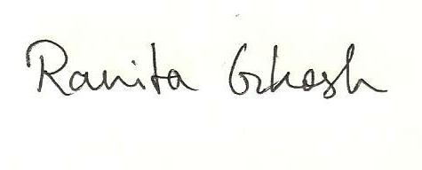

Date: 26/04/19
Place: HOWRAH Applicants signature

