RESUME

Name: Manish Yadav
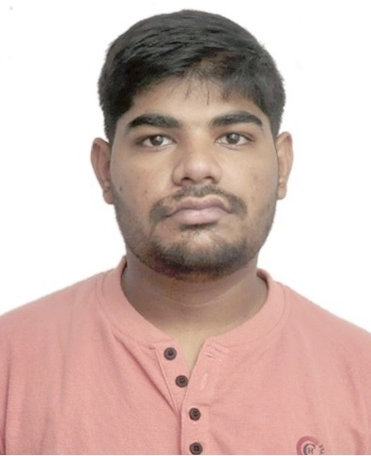
Address:
House No- 1253/1,
Sector – 30B, Chandigarh
Pin code: 160030

Mobile : 8528817315
E-mail : mn.yadav913@gmail.com
PERSONAL PARTICULARS:

- Nationality: Indian
- Date of Birth: 09-Dec-1999
- Sex: Male
- Place of Birth: Chandigarh
- Marital Status: Unmarried
- Category: GENERAL

EDUCATIONAL QUALIFICATIONS:

- Post Graduate Diploma in Computer application
- Session: 2020-2021
- University: Panjab University
- Percentage: 86.80%
- Bachelor of Science
- Session: 2017-2020
- University: Panjab University
- Percentage: 65.25%

- Intermediate and High School:
Course | Session | Board | Percentage/CGPA
Intermediate | 2016-17 | CBSE | 69%
High School | 2014-15 | CBSE | 8.0 CGPA

SKILLS:
COMPUTER LITERATE, ENGLISH TYPING SPEED ON COMPUTER: 32 WORDS PER MINUTE

LANGUAGES KNOWN:
- ENGLISH
- HINDI
- PUNJABI

