NAME :- | DARSHAN KUMAR | 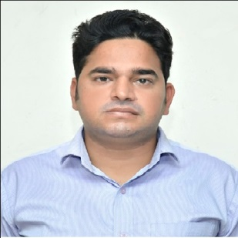
ADRESS :- | VILLAGE DABOH  DISTT TEH. AND P/O SAMBA
E MAIL ID :- | Darshankumar704@gmail.com
MOBILE NO :- | 8492862099 7006636108
MARITIAL STATUS:- | UNMARRIED
RESUME

PERSONAL DETAIL:-

EDUCATION QUALIFICATION:-
SR.NO. | DEGREE | BOARD | YEAR | PERCENTAGE
1 | 10TH | J&K BOARD | 2006 | 45.4
2 | 12TH | J&K BOARD | 2009 | 47.2
3 | B.E | JAMMU UNIVERSITY | 2013 | 56.56

WORK EXPERIENCE :- FRESHER
I hereby declare that the information provided above is true to the best of my knowledge.

DATE:- SIGNATURE:-

