CURRICULUM VITAE

NAME : JUHita mukherjee 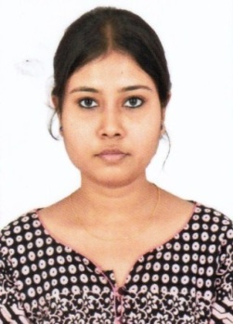

FATHER name : anil mukherjee

PERMANENT Address : 3/5/A/1 DR C.C GHOSHAL LANE
P.O.-KONNAGAR
Dist-Hooghly
Pin-712235
West Bengal
Date of Birth : 24-05-1993
CONTACT NO. : 08697467154

Academic qualificationS :
EXAM | BOARD | YEAR | PERCENTAGE
MADHYAMIK | WBBSE | 2008 | 64.50
HIGHER SECONDARY | WBCHSE | 2010 | 59.20
Graduate (B-TECH) | WBUT | 2014 | 65.00

EXPERIENCE : FRESHERS

SEX : Female

NATIONALITY : Indian

RELIGION : Hindu

MARITAL STATUS : Unmarried

LANGUAGE KNOWN : Bengali, Hindi, English
EMAIL ID : juhita.mukherjee2405@gmail.com

I hereby declare that all the above information is complete, true, and correct to best of my knowledge. If given an opportunity I promise to give the best abilities to the organization.

Date : 05/11/2019

Place :- KONNAGAR
(juhita mukherjee)

