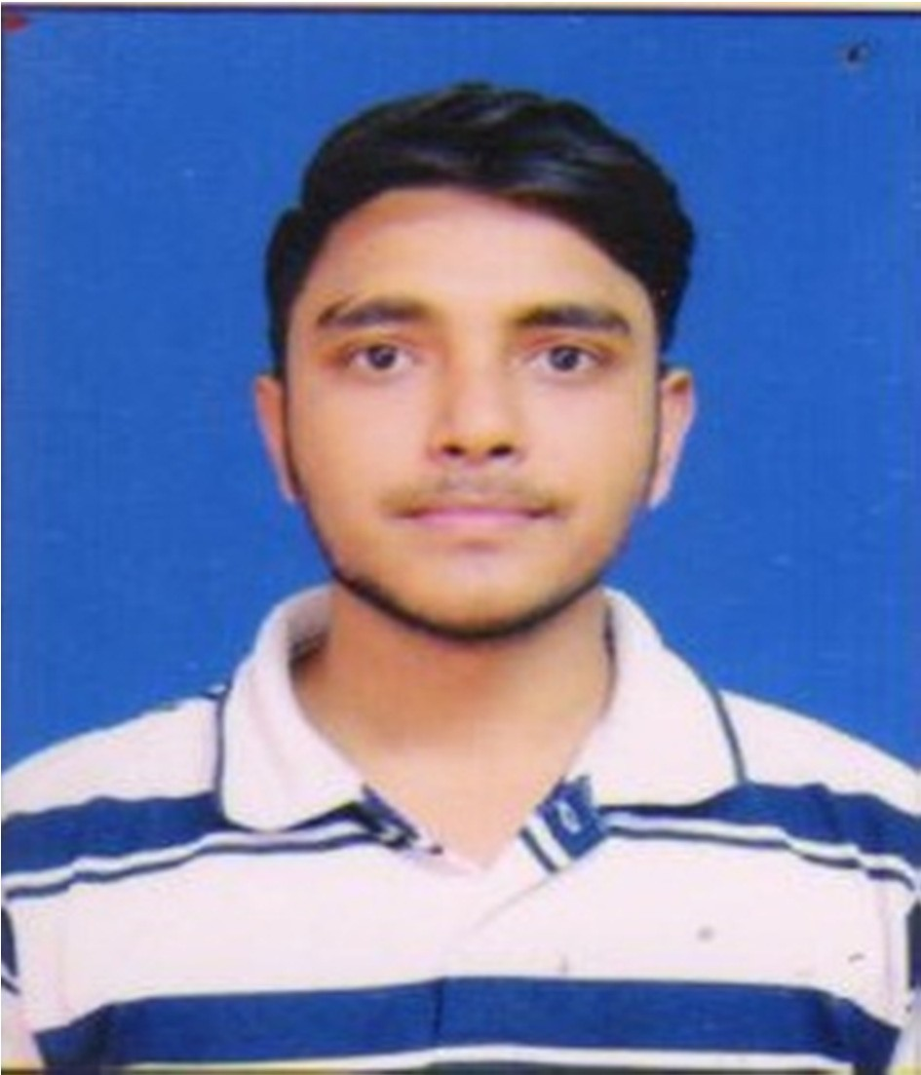Resume

9

Dinesh Giri giridinesh882@gmail.com
+91-9643696539

CARRIER OBJECTIVE :

To secure a promising position in the organization of repute that offers ample opportunity for growth in term of due recognition and added responsibilities.

Year | Institutions | Degree/Certificates | Board/Unive  rsity | Percentage/CGP  A
2019 | Delhi University(SO  L) | Bachelor of Commerce(Hons.) | Delhi University | 58%
2019 | D.I.C.S | Financial accounting | NIELIT | 79%
2019 | D.I.C.S | Diploma(computer software) | NIELIT | 79%
2016 | GOVT.  Sarvodaya Bal Vidyalaya  School | Senior Secondary | C.B.S.E. | 64.6%
2014 | GOVT. Sarvodaya Bal Vidyalaya  School | Secondary | C.B.S.E. | 8.0

ACHIEVEMENTS

IBPS RRB -- Probationary officer scale 1 qualified (Pre + Mains)
ICICI BANK -- probationary officer (SELECTED)
BYJU’S -- business development associate (SELECTED)

TECHNICAL SKILL

Operating system: Window 7, 8

STRENGTH
- Result oriented
- Ability to work under pressure
- Good communication skills
- Analytical skills

HOBBIES
  - Playing chess

PERSONAL DETAIL
Father’s Name : Mr. Rishi Giri
Date of Birth : 27-2 -1998 Gender : Male
Nationality : Indian Languages : Hindi, English
Address : X-1888 Street no-11 Rajgarh Extension Delhi-110031

Declaration :
I hereby declare that all the information provided by me in this application is factual are correct to the best of my knowledge and belief.

Place: Delhi (Dinesh Giri)

