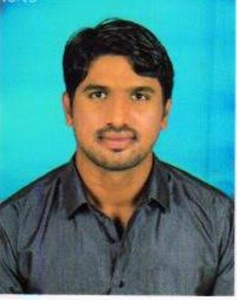
SATISH.M

ACCOUNTS/ /AUDIT

9060600283 satish.m9283@gmail.com

OBJECTIVES:-

To achieve continuous growth in my career and to stand corporate world this suits my qualification and area of interest and opportunity to strengthen my knowledge.

ADDRESS:-
A D D R E S S

SATISH.M S/O LATE SR MANIKYAM
14TH WARD KHB COLONY
NEAR MAREMMA TEMPLE
SANDUR (Tq)
BALLARI (Dist) -583119

EDUCATIUONAL DETAILS:-
E D U C A T I O N

Name of Course | Name of University | Year of passing | Merit (%)
M.COM | VSK University Bellary | 2011-2013 | 73.00 %
B.B.M | Gulbarga University Gulbarga | 2008-2011 | 70.00 %
PUC | Karnataka Board Examination | 2006-2008 | 50.00 %
SSLC | Karnataka Board Examination | 2005-2006 | 55.86 %

EXPERIENCE:-

- One year six month (05-01-2014 to 27-07-2015) Experienced in
“Data Entry Operator” at M/s BASAVESHWARA ENTERPRISES, Sandur.

- 10 months (01.08.2015 to 30.06.2016) Experienced in “Assistant External Auditor” at M/s C.A SEENAM BHAT & CO, Hospet.
Nature of Work:
- Physical Fixed stock verification at JSW
- Vendor documentation verification
- Commercial Documents filing

- Currently working as, ‘Assistant Accountant’ at M/s JSW Energy Ltd, Torangallu (from date 01.07.2016 to till) under contract of M/s Seenam Bhat & Co, Hospet.
Nature of Works:
- SAP handed,
- SAP vendor reconciliation/Miro.,etc
- Vendor reconciliation/payments/advance
- Bank reconciliation statement checking,
- Excel working,
- C-form issued
- E sugam etc

COMPUTER SKILL:-

: Excel Expert
: BASICS OF COMPUTERS
: TALLY 9.0
: HARD WARE
: SAP
: TYPING KANNADA & ENGLISH

PERSONEL DETAILS:-

FATHER’S NAME : (LATE) S.R MANIKYA
DATE OF BIRTH : 10-02-1991
NATIONALITY : INDIAN
GENDER : MALE
CASTE : S.C (BHOVI)
MARITAL STATUS : BACHELOR
LANGUAGES KNOWN : ENGLISH, KANNADA, TAMIL & TELUGU
(READ/WRITE/SPEAKS)

DECLARATION:-

”I conform that information provided by me is true to the best of my knowledge and
Belief.”

Date: Yours truly,
Place: Sandur (SATISH M)

