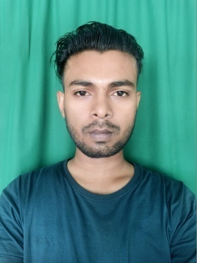  CONTACT DETAILS:  ✆ 7640848151  ✉ vsahani984@gmail.com  PERSONAL DETAILS:  Name : VIKASH KUMAR SAHANI  Father Name : KISHORI SAHANI  Mother Name : KAMLI DEVI  D. O. B : 26/02/1999  Gender : Male  Nationality : Indian  Marital Status: Unmarried  Languages Known: English, Hindi, Bhojpuri.  PRESENT ADDRESS:  C1-2, Guru Nanak Pura, Near Nirman Vihar Metro Station, Opposite V3S Mall, Laxmi Nagar, New Delhi, Delhi 110092  PERMANENT ADDRESS: Vill-Sahtha,PO-Sahtha,PS-Bhagwanpur, District Vaishali, State Bihar 844123.  HOBBIES:  Sports  Listening to music  - Dancing & Drawing  SKILLS:  - Written and communication skills.  - Ability to deal with people diplomatically.  - Willingness to learn.  - Able to Work independently and with the team.  - Proficiency in: Fundamentals , Window 7,Dimensions Of IT, MS Office (Word, Excel, PowerPoint) Tally-9, Email, Internet, Adobe Photoshop, Ms-Access, Page Maker, C++,SQL Server, Visual Basic, Overview Of Hardware. | OBJECTIVE  To secure a challenging position in a reputable Organization to expand my Learning, Knowledge and Skills.  QUALIFICATION  ➢ B.Com [Accounts and Finance] from JN College Pasighat, Affiliated with RGU with a Percentage of 53.79 in 2020.  ➢ XII from Kendriya Vidyalaya School Pasighat, (CBSE Board) with a Percentage of 56.8 in 2017.  ➢ X from Kendriya Vidyalaya School Pasighat, (CBSE Board) with a Percentage of 55.1 in 2015.  OTHER QUALIFICATION  Advanced Diploma In Computer Application(ADCA)  WORK EXPRIENCE  8 (Eight) Years Experience In Computer Operator (CYBER CAFÉ).  5 (Five) Years Experience In Stationary Items Sales (CYBER CAFÉ).  ABOUT MY SELF  I am very Practical Person with an Amiable Disposition and Strong Cultural values. I strongly believe in Accuracy and Precision in whatever I do. I believe I have good communication skill that would provide transparency and productivity in the Organization.  STRENGTH  - Communication  - Self Motivated  - Organization Skill  - Flexibility and Adaptability  - Learning Agility  - Decision Making Skills  - Creativity  - Team Work  - Loyalty  - Leadership  - Responsible  - Listening  DECLARATION  I hereby declare that all the details furnished above are true to the best of my knowledge and belief.  PLACE:  DATE: (Vikash Kumar Sahani)
RESUME

