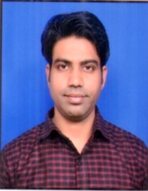
AMIT SINGH
+91 9897330368
Email Id: 460216amit@gmail.com

OBJECTIVE
To be associated with an organization that provides a challenging work environment and prove my excellence at
Every step in my long term career goal.
Highly efficient and passionate for learning a new concepts , ideas , techniques aim to.
Area of exposure
- Proficient in developing skills in students and providing them a growing path.
- Self motivation, an initiative with a high level of energy , patience and tolerance.
- Ability to adapt new environment quickly
- Teamwork
Qualification
- M.A. (Geography) in 2019 from Chattrapati Sahu ji Maharaj University Kanpur.
- B.Ed in 2014 from MJPRU Bareilly.
- B.Sc(Biology) in 2009 from MJPRU Bareilly.
- Intermediate in 2006 from U.P. Board.
- High school in 2004 from U.P. Board.
Area of interest
- Writing Poems.
- Share trading.
- Astrology.
Working experience
- 3 years working experience as GS faculty at Mahendras, Selection point, AITC.
Computer knowledge
- Basic knowledge of computer application.
Personal knowledge
Name : Amit Singh
Father’s name : Subhash Chandra katheria
Mother’s names : Shashi lata katheria
Date of Birth : 11April 1990
Marital status : Unmarried
I hereby declare that the above mentioned information is true and the best of my knowledge.
Date:
Place: AMIT SINGH

