RAJARSHI CHAKRABORTY
Mobile:7001154545
rajarshi.pcmt.ece@gmail.com
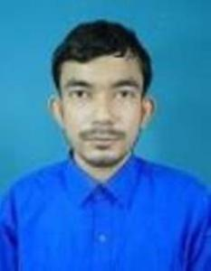 | Sarapul,Swarupnagar,North 24 Pargana,West Bengal,743286

Education
B.Tech 2014
West Bengal University Of Technology
Electronics and communication Engineering

work Experience

Aspiring Minds Assessment Private Limited (Now SHL)
Technical Support Executive
June,2015 to January 2016
- Operation and System Analysis
- Worked with Windows server and as network Administration
- Intracting with college Hr and Administration and Skill Trainer for the Assessment

CADC
January 2016 to December
- As IT Skill Trainer
Freelance Starting September 2018
- Worked as- Content Creator and Moderator on Prepez and Social media daily

Freelance May 2021
- Design work on Upwork project

JOB SKILLS
- Cleared Various Bank Examinations
- Worked as a Freelancer Content Creator
- Data Processing
- MS Office-Windows 365
- Ability to work in a team
- Excellent Communication skills(Speaking,Reading and Writing English/Bengali/Hindi)

LANGUAGES
- English
- Bengali
- Hindi

DECLARATION
I hereby declare that all the information and facts given above are true to best of my knowledge and belief

Date- 24.07.2022 Your’s Faithfully
Place- kolkata 

