RESUME 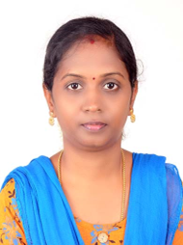

RAMYA A
Email Id: ramya12490@gmail.com
Mobile: +91 9080230294
Address: No.22, Block.17, New Police Quarters,
Joint commissioner Office road,
St.Thomas Mount,
Chennai-600016.

Objective:
Seeking innovative and challenging career in a growing organization which gives me an opportunity to utilize my skills & knowledge and provides me an opportunity for career growth.

Academic Profile:
- BE Electronics Communication Engineering from Sethu Institute of Technology,Kariapatti in 2011.
- 12th from RC Higher secondary School,Virudhunagar in 2007.
- 10th from KSG Govt.Hr.Sec School, amatur in 2005.

Exams Cleared

- SBI JA Prelims : 2021, 2022
- IBPS Clerk Prelims : 2021, 2020 ,2022
- IBPS PO Prelims : 2022, 2021, 2020

Working Experience:
- Worked as teaching staff at HI-TECH solutions private limited,Madurai for one year
- Took Tution for school students for last one and half years

Skills:
- Good communication skills
- Quick learner
- Ability to work independently

Personal Information
Father’s name : Alaguchamy P
Date of birth : 12 April 1990
Gender : Female
Marital Status : Married
Nationality : Indian
Languages Known : English and Tamil
Hobbies : Hearing Music,Gardening

Declaration:
All the above information is correct up to my knowledge and I bear the responsibility of the correctness.

Place: Chennai
Date: 26/04/2024 Ramya.A

