

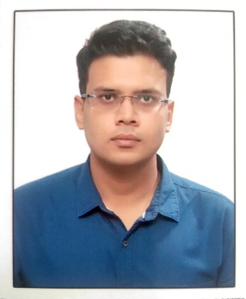
Harshitg93@gmail.com

Harshit Gupta
Quant Faculty & Mentor (AAO)
+91-9999518458

ABOUT ME
WORK EXPERIENCE
1.5 Years
I have been mentoring and teaching quants for 1.5 years and have a special interest in this field.

AGE
26


Education

Bachelor, Technology Graduated; July 2015
Faculty of Engineering & Technology Marks 83%
Jamia Millia Islamia Division 1
Delhi
10+2 Completed, July 2011
Kendriya Vidyalaya Marks 90%
CBSE Board Division 1
New Delhi, Delhi
10 Completed, July 2009
Kendriya Vidyalaya Marks 90%
CBSE Board Division 1
New Delhi, Delhi

Career Highlights

- Secured All India Rank 99 in SSC CGL 2016 - AAO.
- Worked as Bank PO in PNB.
- Cleared IBPS PO, Clerk etc.

- Got 95.81 percentile in CAT 2015.
Skills

- Quantitative Aptitude
- Logical Reasoning
- Good Communication Skills


Work Experience

April 2019 – Current
Quant Faculty
SOMP
SOMP is Strategy Oriented Mentorship Program and I have been its integral part since its inception and member of core team.
- I head its SSC programs and mentorship process.
- Designing and plan making.
- Teaching quants.
- Devising quick quants solving techniques.
- Guiding aspirants for time management skills.


Languages

- Hindi

- English
Personal Interests

- Playing Chess | - Solving Sudoku
- Listening to Music

Personal Details

Father’s Name: Mr. Harshit Gupta Marital Status: Single
Birthday: February 6, 1993 Nationality: Indian
Gender: Male

