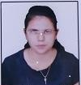
Raj C. Salame
Electrical Engineering
rajsalame93@gmail.com / 91-9604678010

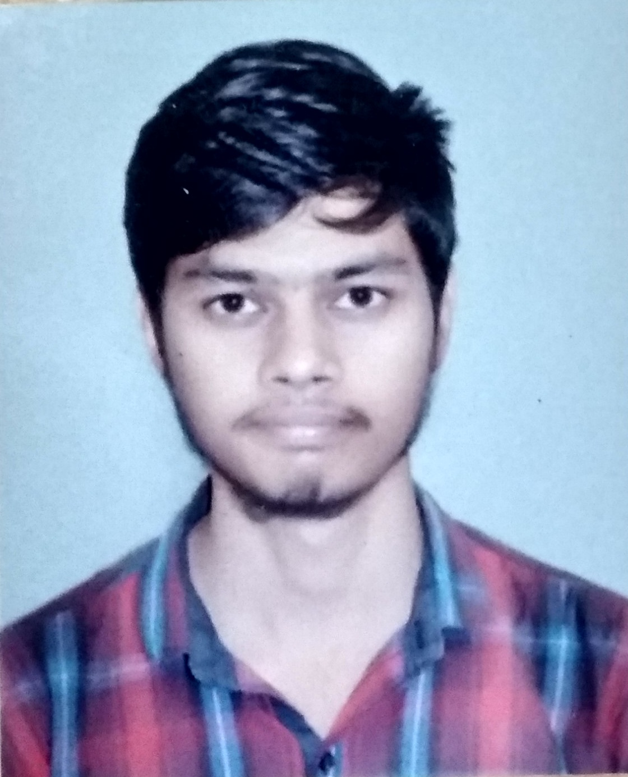

To work in challenging and fast paceenvironment and expand my knowledge and to assisting continued organization.
ACADEMICQUALIFICATION

Sr.no | Examination | Institute | Board/University | Percentage | Year of passing
1. | BE (Electrical) | TGPCET | RTMNU | - | 2020
2. | XII (General) | Lokmanya Tilak College, Bramhapuri | Nagpur Board | 72.31% | 2016
3. | X (General) | N. H. High School, Bramhapuri | Nagpur Board | 80.80% | 2014

KEYPROJECTS

Major Project– Title : “Optimisation of wind farm with Solar PV Panels using GIS tools” .

TECHNICALKNOWLEDGE

Mat Lab, MS-CIT.

ACHIEVEMENTS

Second price in Wrangale (debate) competition in priyadarshani Bhagwati college of Engg. (2019) Participation in AutoCAD Workshop, Nagpur (2017)
First price in interdepartmental Chess competition (2018-19)

CO-CURRICULARACTIVITIES

Participated in international paper presentation competition – Government Polytecnic Nagpur 2019 Participated in Aqua ROBO race in Datta Meghe college of Engg and Tech. and Research, Wardha Participated in Born psycos in Govt. college of Engg, Nagpur.
Member of Forum body and NSS.

OTHER INFORMATION

 |  | Skills | Adaptable, Self - Motivating, confidence, communication skills, Work in a Team, Hard-working, positive attitude, Flexible.
 |  | Languages | English , Hindi , Marathi
 |  | Date of Birth | 27th April 1999
 |  | Address | Sundar Nagar, Bramhapuri, Chandrapur-441206

DECLARATION

I hereby declare that all the details furnished above are true and correct to the best of my knowledge and belief.Supporting documents shall be available on request.

Place: Nagpur

Raj C. Salame

Signature

