Pratyusha Mada
Address: 7th Cross Street, VIshwapriya Nagar
Bangalore - 560068
Ph No: +91-9449822487
Email : pratyushashankar7@gmail.com

Skills
Social Media Organic Marketing, Social Media Paid marketing, Content Writing, Leadership, Empathy, SEO on page, SEM, SMS Marketing, Email Marketing, Digital Marketing strategy and plan, content planning, website planning, Google Analytics, Google search console

Experience

December-2020 - PRESENT

Hyva IT Solutions, Bannerghatta-Bangalore - Digital Marketing Team Lead
Projects worked on:
- BS International School: https://bsinternationalschool.com/
- On Page SEO - Keyword research, blog content planning, Assigning website developers their respective tasks for the On-Page factors of the website.
- FB organic: Planned & made their content calendar deck, Designed the theme of posteres, Optimised their FB URL and page.
- Client requirement: Leads & SEO ranking
- Digital Marketing strategy.
- Digital marketing monthly and annual reporting and analysis.

- FB Paid ads:
- Please view the following screenshots of the paid advertisements I ran for BS International School:

- 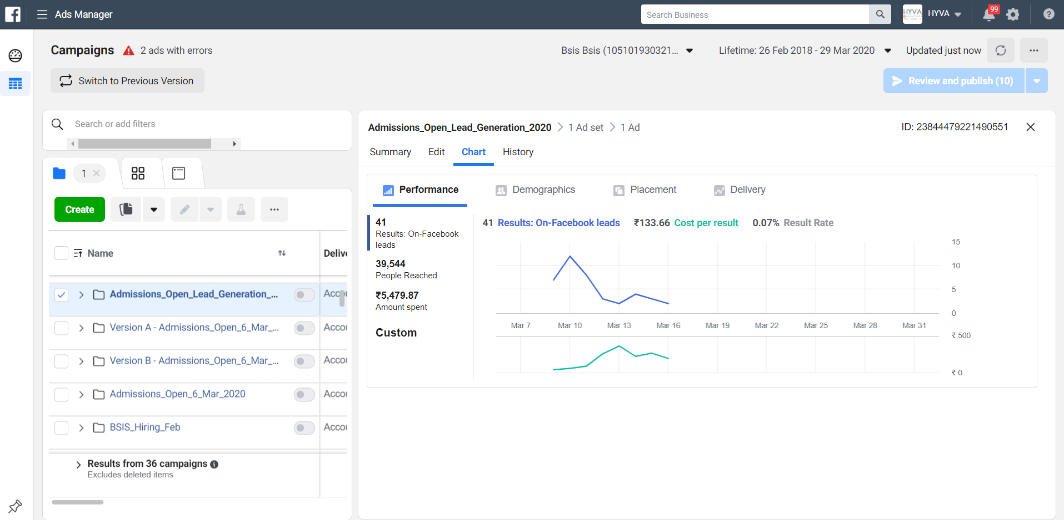
- No:of leads: 41
- Amount spent= ₹5,479.87
- Messaging advertisement:
- 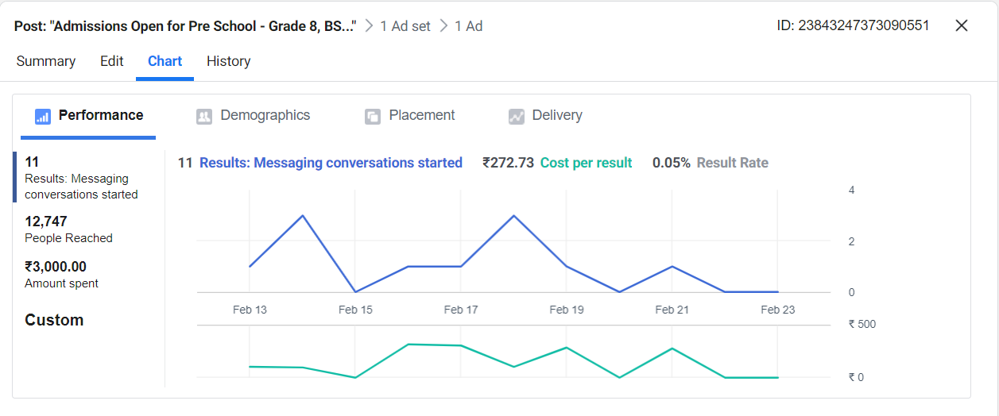
- Messaging conversation: 11
- Amount spent: 3000
- CPR: Rs. 272.73
- Lead generation advertisement:
- 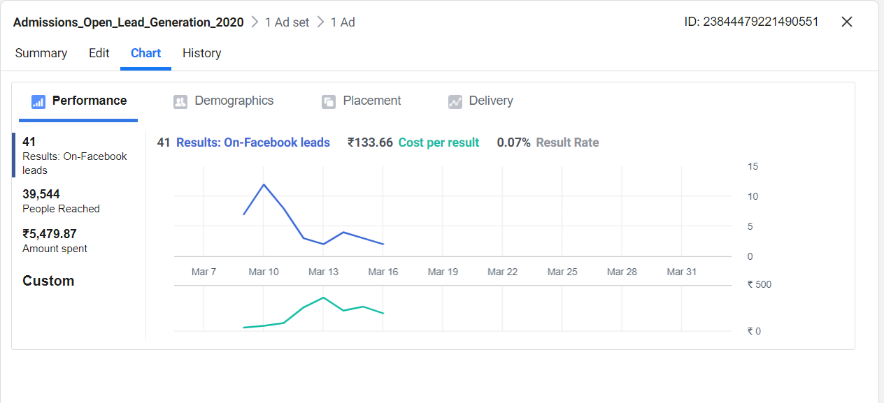
- No:of leads=41
- Amount spent=Rs.5,479.87
- Cost per lead= Rs.133.66
- Hiring for Teachers advertisement:
- 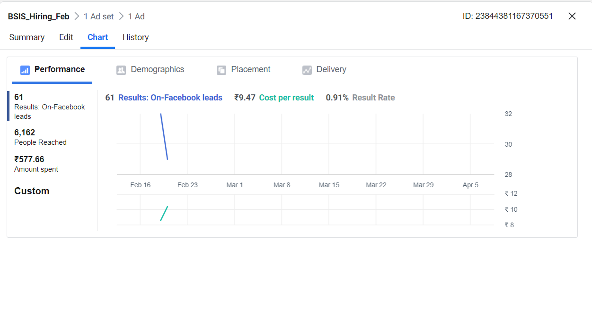
- No:of leads= 61
- Amount spent= Rs.577.66
- Cost per lead=Rs.9.47
- Admissions Open-Call Campaign
- 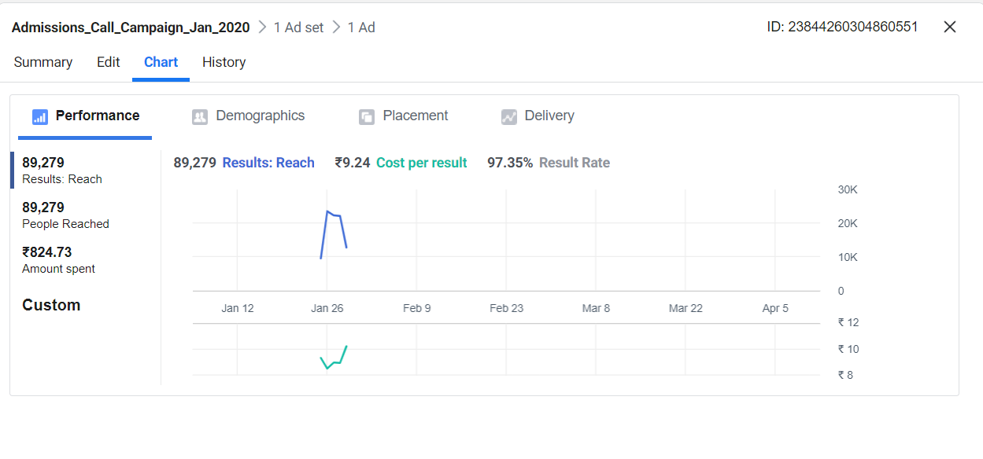
- Reach=89,279
- Amount spent= Rs.824.73
- Cost per result=Rs.9.24
- Admissions Open - Lead generation-Video Ad
- 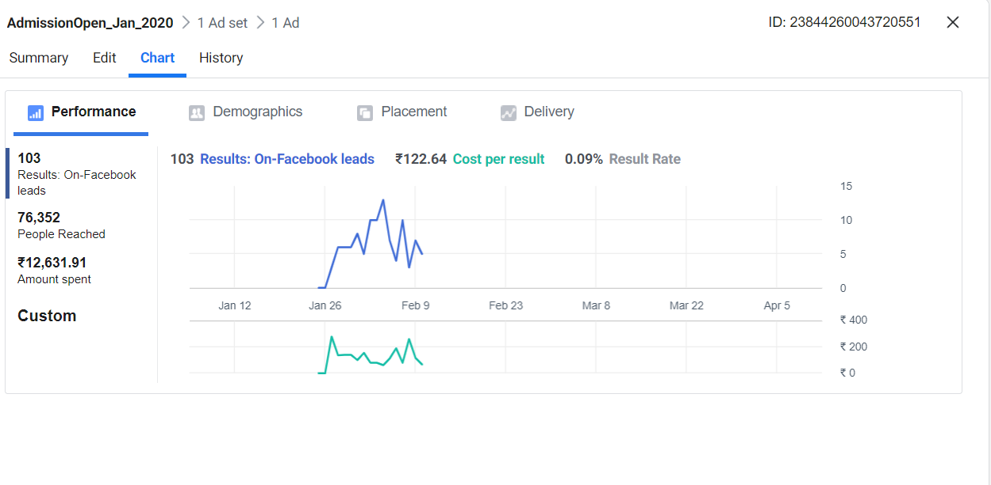
- No:of Leads=103
- Amount spent=Rs. 12,631.91
- Cost per result= Rs.122.64
- Lead generation Campaign:
- 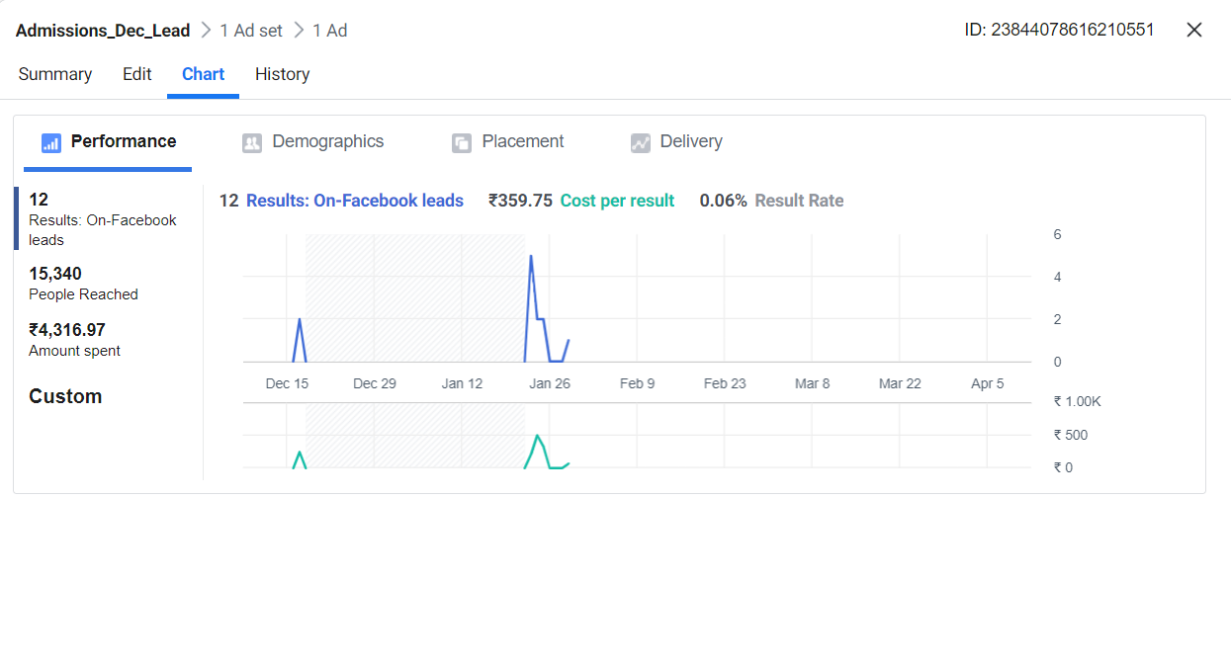
- Results= 12
- Amount spent= Rs.4,316.97
- Cost per result=Rs.359.75
2. Saideep Hulas
Client requirement : Lead generation and site visit.
Facebook Paid Advertising Campaigns:
Lead Generation Advertisements:

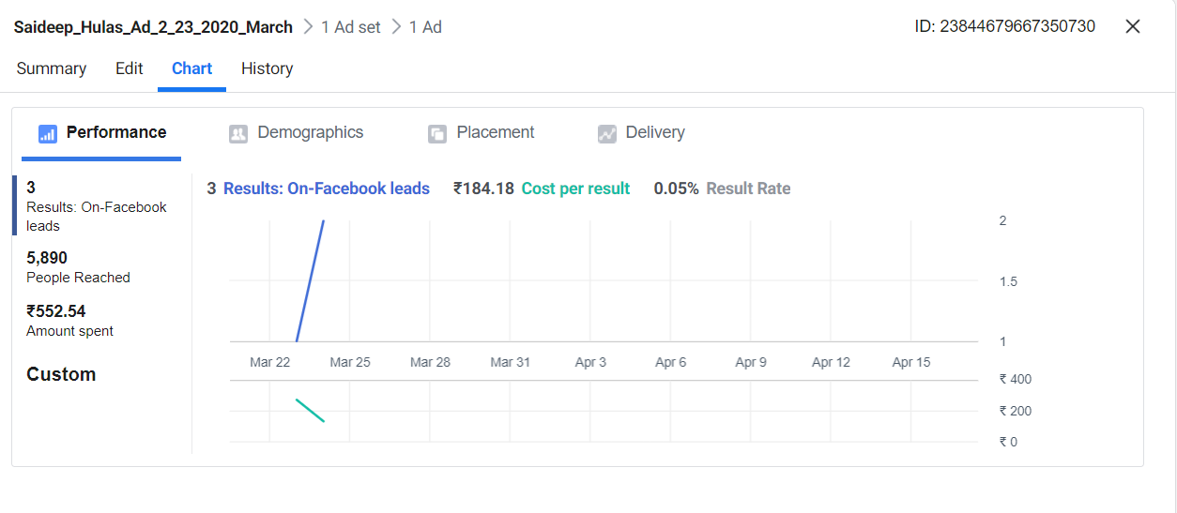
- No:of Leads=3
- Amount spent=Rs.552.54
- Cost per result= Rs.184.18

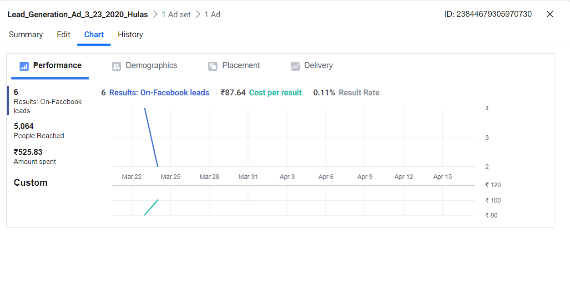
- No:of Leads=6
- Amount spent=Rs.525.83
- Cost per result= Rs.87.64

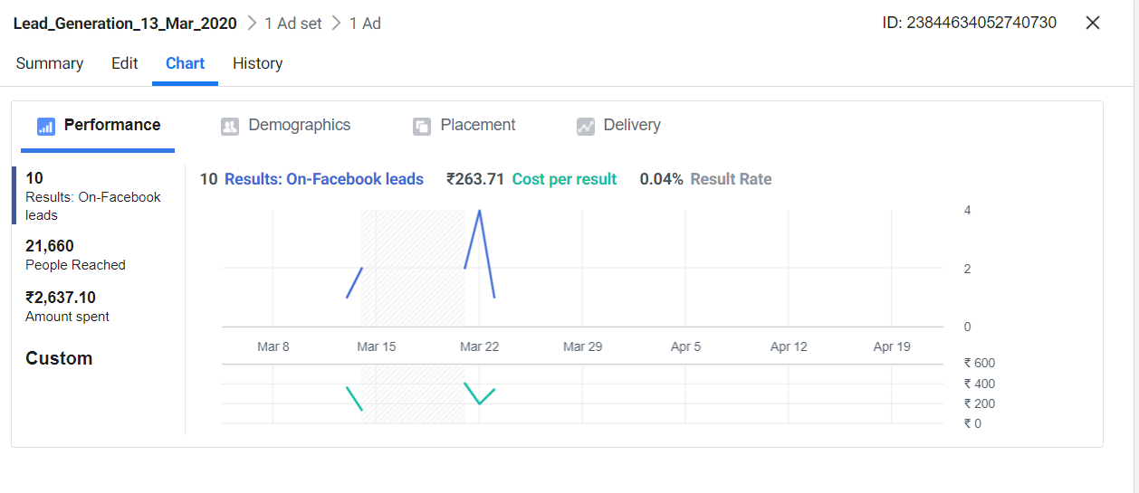
- No:of Leads=10
- Amount spent=Rs.2,637.10
- Cost per result= Rs.263.71
4.
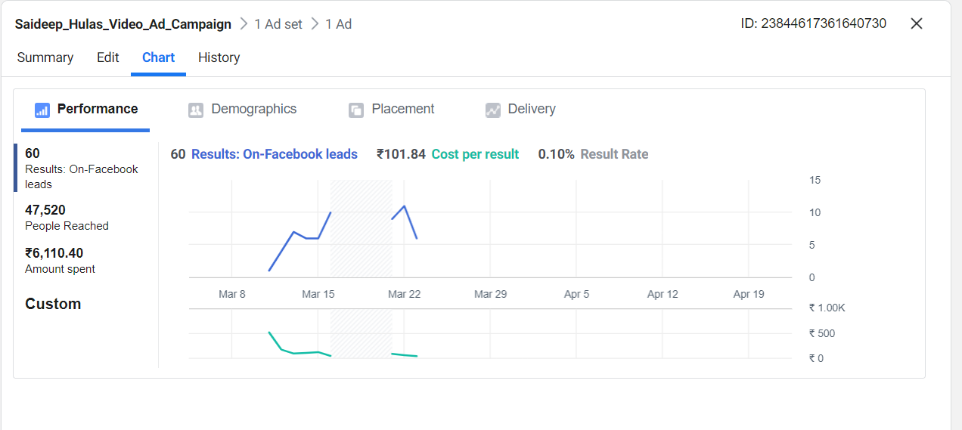
- No:of Leads=60
- Amount spent=Rs.6,110.40
- Cost per result= Rs.101.84
5.
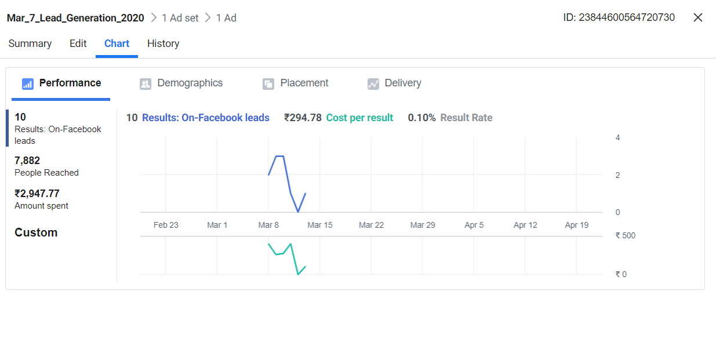
- No:of Leads=60
- Amount spent=Rs.6,110.40
- Cost per result= Rs.101.84
6.
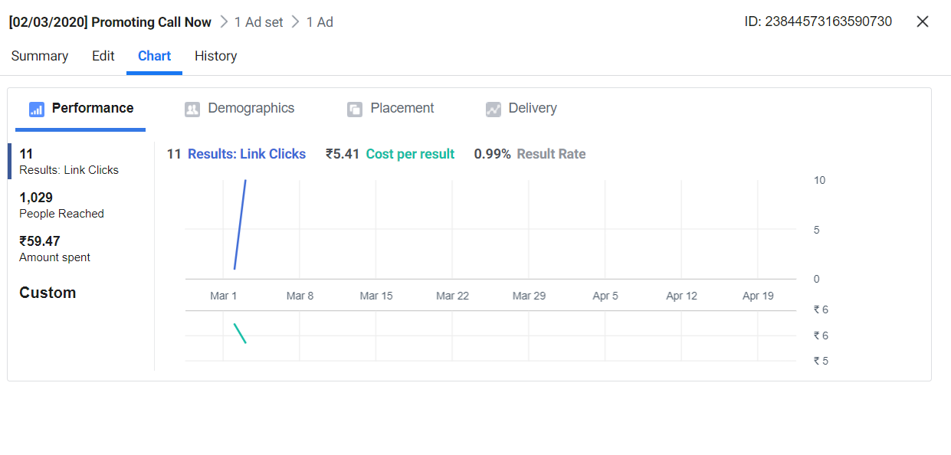
- No:of Leads=11
- Amount spent=Rs.59,47
- Cost per result= Rs.5.41
7. Promoting local Business
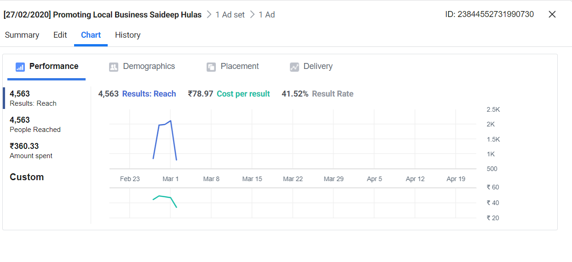
- Reach: 4,563
- Amount spent=Rs.360.33
- Cost per result= Rs.78.97
3. Hyva Primus
Lead generation campaigns:

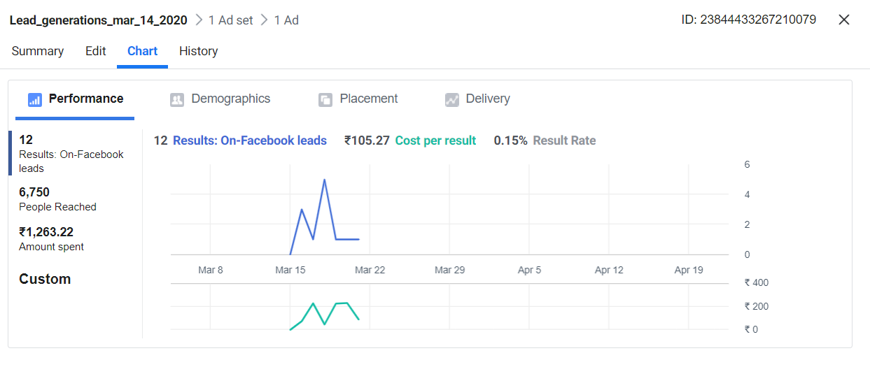
- Leads : 12
- Amount spent=Rs.1,263.22
- Cost per result= Rs.105.27
2.
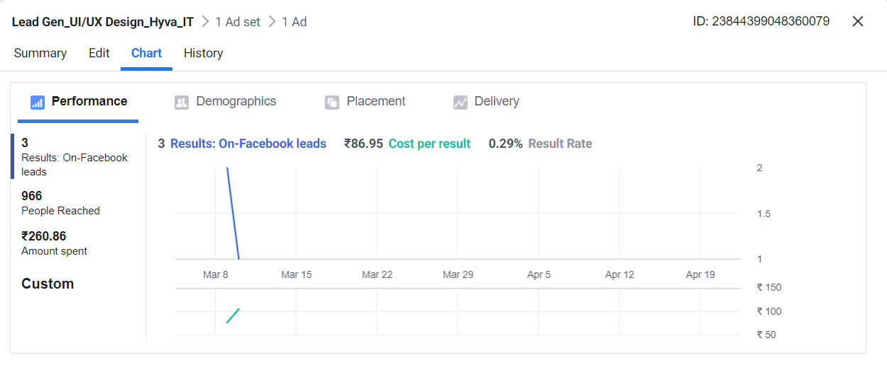
- Leads : 3
- Amount spent=Rs.260.86
- Cost per result= Rs.86.95
3.
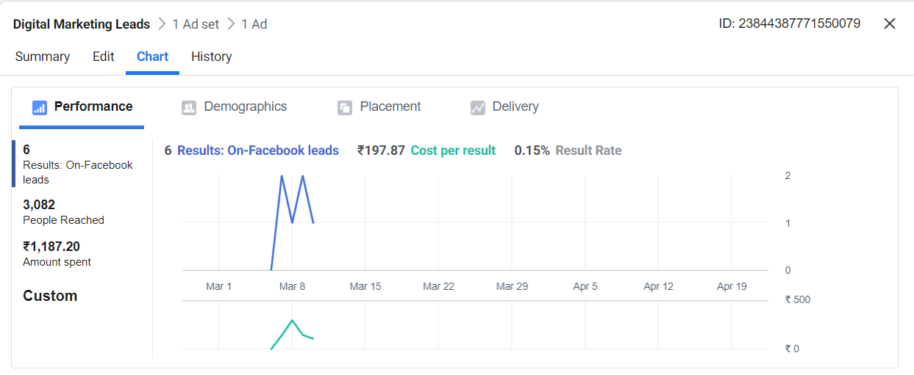
- Leads : 6
- Amount spent=Rs.1,187.20
- Cost per result= Rs.197.87
4.
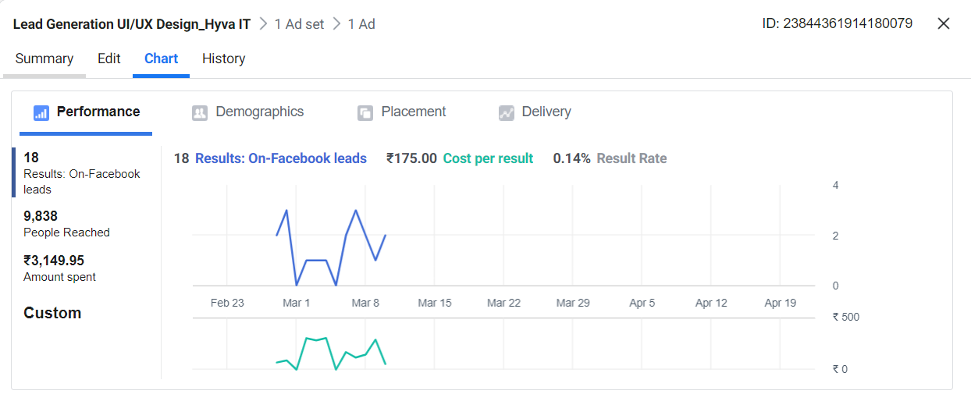
- Leads : 18
- Amount spent=Rs.3,149.95
- Cost per result= Rs.175.00
5.
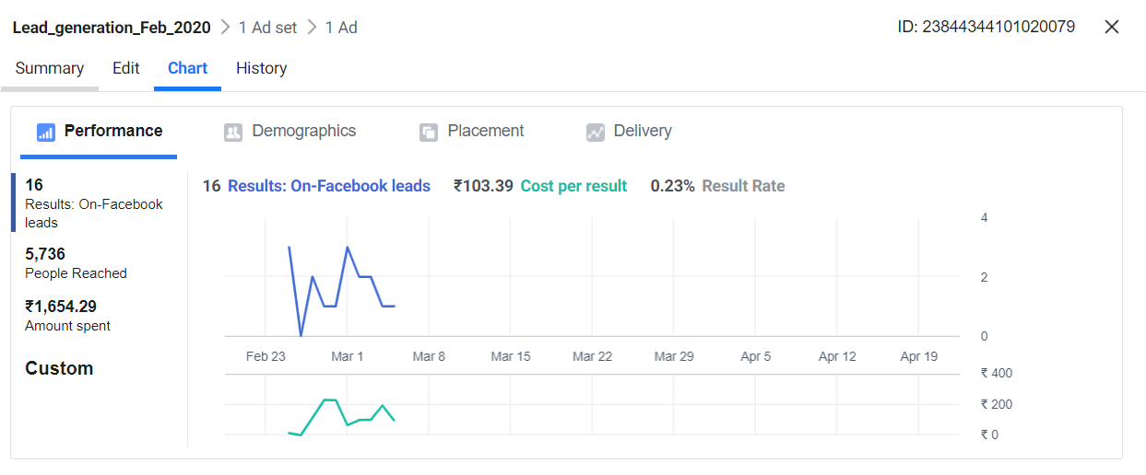
4.
Sudeshna Dairy
- Godown for Rent
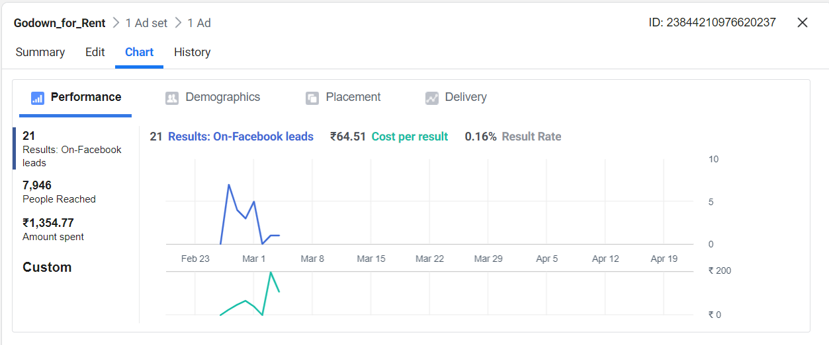
- Leads : 21
- Amount spent=Rs.1,354.77
- Cost per result= Rs.64.51
2. Murrah Buffaloes for sale
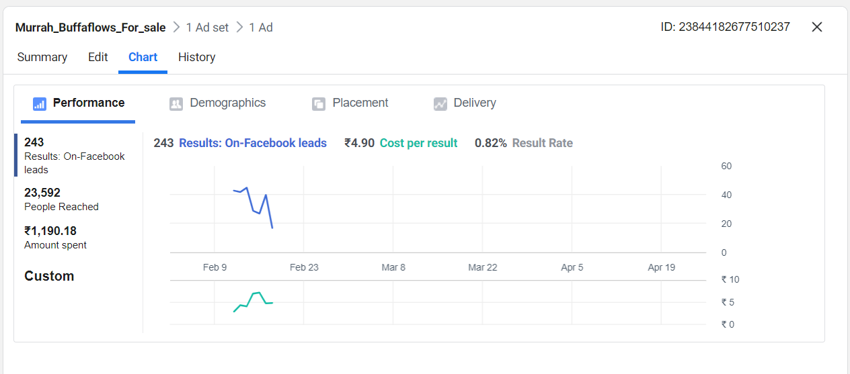
- Leads : 243
- Amount spent=Rs.1,190.18
- Cost per result= Rs.4.90
3. Reach Advertisement
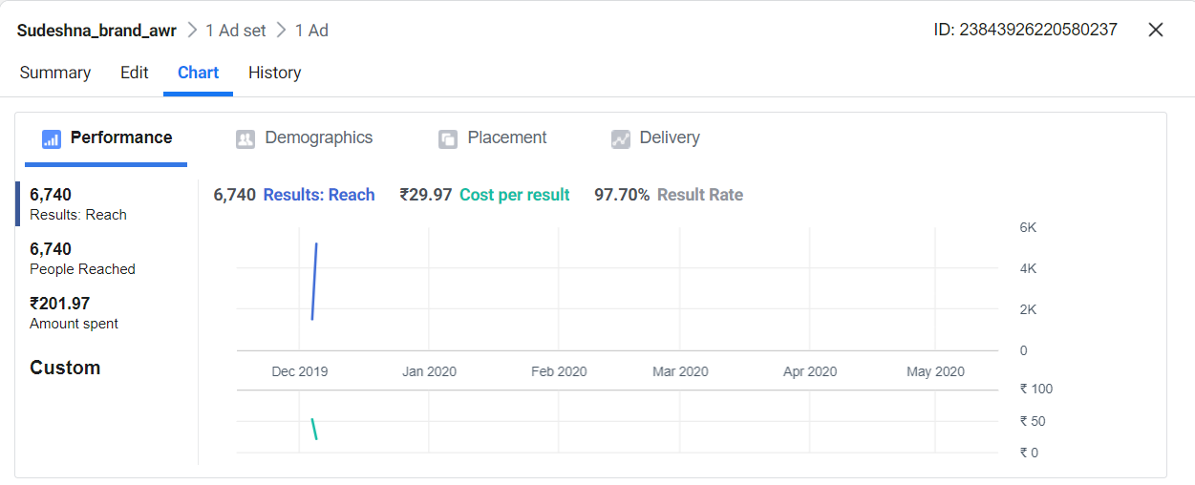
- Reach: 6,740
- Amount spent=Rs.201.97
- Cost per result= Rs.29.97
4. Promoting Call Campaign
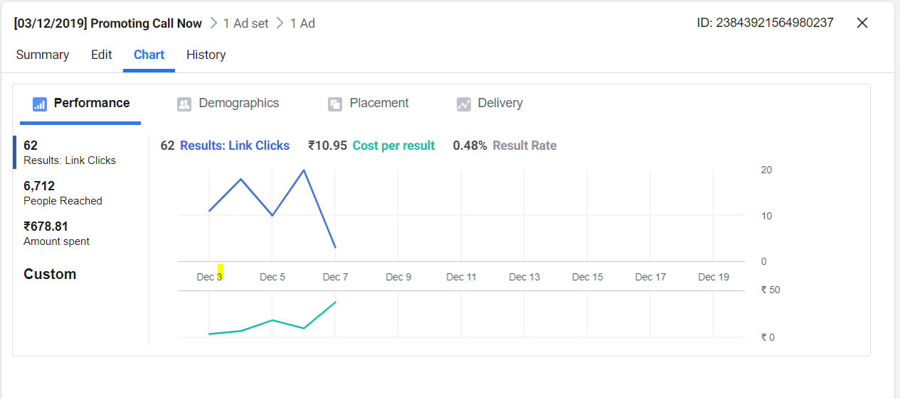
- Link clicks: 62
- Calls: 55
- Amount spent=Rs.678.81
- Cost per result= Rs.10.95
5.
Creative Build
- Lead generation:
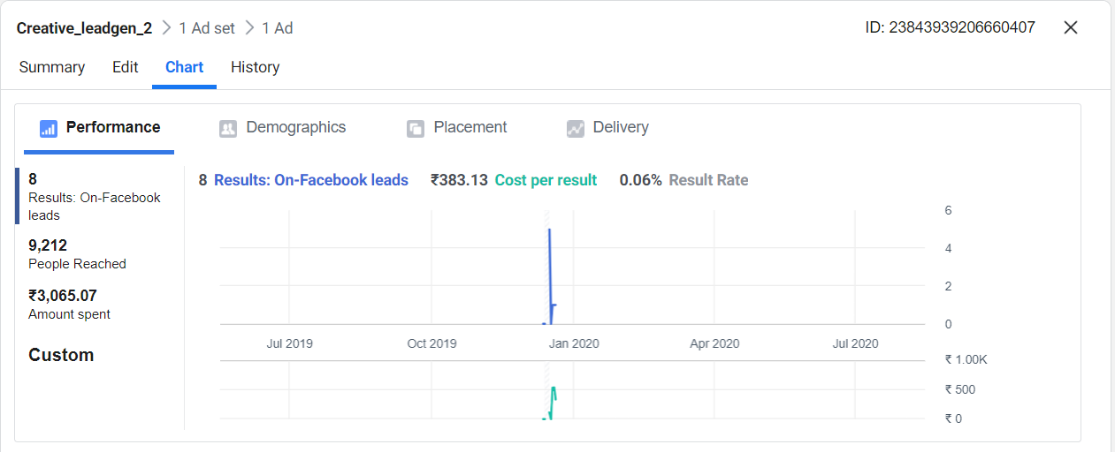
- Leads: 8
- Amount spent=Rs.3,065.07
- Cost per result= Rs.383.13
2. Promoting Call Now Campaign:
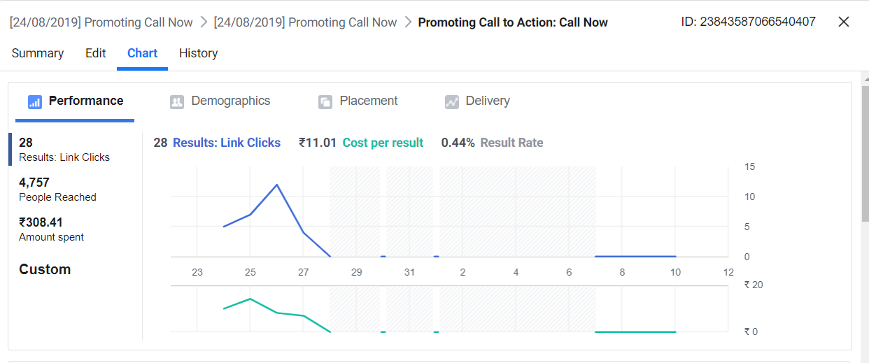
- Leads: 28
- Amount spent=Rs.308.41
- Cost per result= Rs.11.01

6. The Painted Sky, HRBR Layout, Bangalore - Digital Marketing Manager
Increase the revenue of the company. Successfully made sales of more than 1,41,000 INR. Handled the end to end digital marketing operations. Actively involved in planning and managing of advertisement campaigns online. Managing the on page and OFF page SEO. Strategising the social media content and adverts.
Paid Advertisements:
Design Thinking Advertisements:
Platform: Linkedin
- Design Thinking Course Advertisements
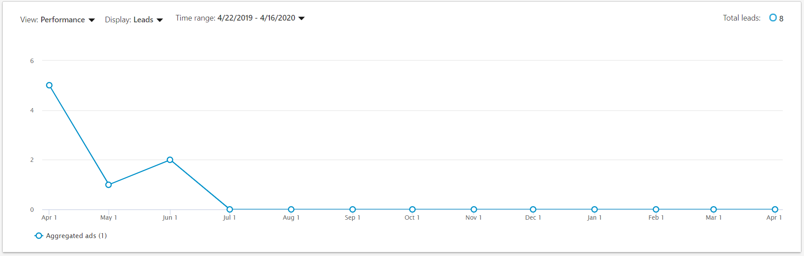
- No:of leads: 8
- Amount Spent: 2000
- Average cost per lead: 250
2. DT101: Design Thinking for beginners event campaign
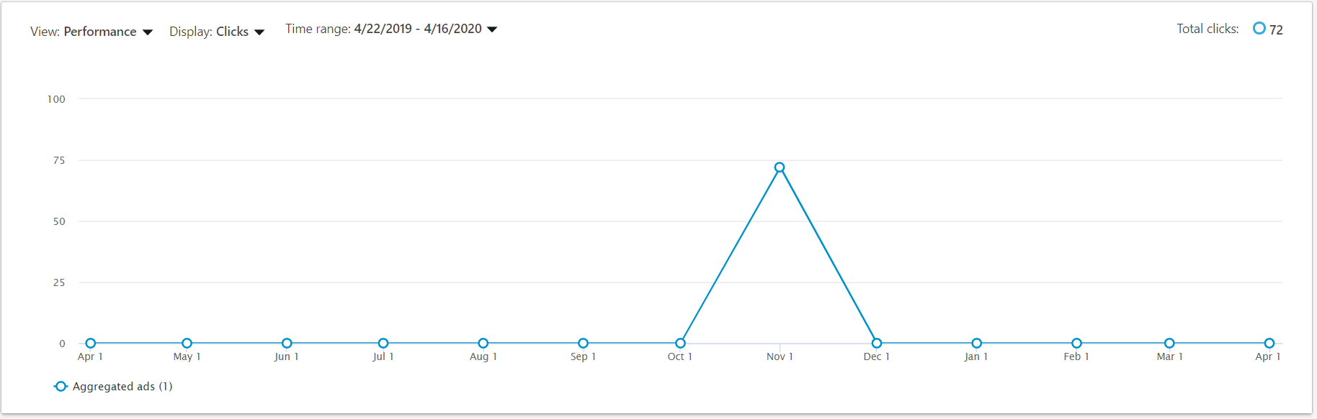
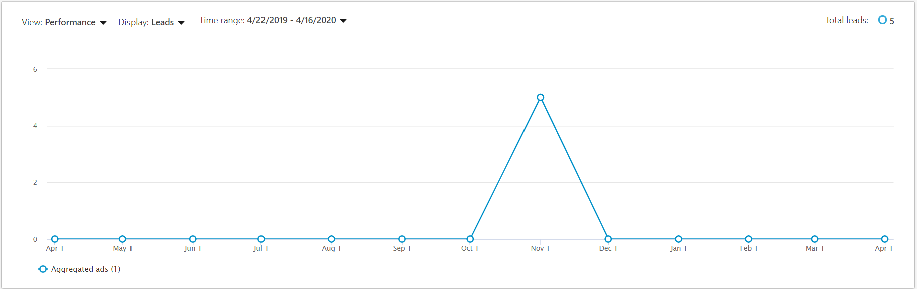
- No:of leads: 5
- Amount Spent: 2000
- Average cost per lead: 400

7. DIGITAL MARKETING MANAGER AT THE ORION SQUARE:
Worked on successful online presence of the brand. Worked on lead generation with google Ad words and social media advertisements and lead closure for the event:Let's unwaste with Takuto. Sold more than 15 tickets in ten days.

8. DIGITAL MARKETING SPECIALIST AT SKILLIGY:
Developed initial plans and strategies to launch the brand online. Strategized content and created the content decks before the brand launch. Gave input ideas to the graphic designer.Planned and created the advertisement calendar with the team.Searched keywords relevant to campaigns which were run. Scheduled targeted email marketing programs. Managed a team of marketing professionals during the planning and building phase to ensure the success of marketing campaigns.Directed and assisted an interview for famous dancers Tejas Dhoke & Ishpreet Dang

Education

MONTH 20XX - MONTH 20XX

College Name: CMRIT, Bangalore - ECE
I have completed my degree in Electronic and communication Engineering in the year 2018-2019.

